The Next Generation for Manufacturing Competitiveness?

***Investigating the Influence of Industry-Driven Outreach on Children Career Perceptions***

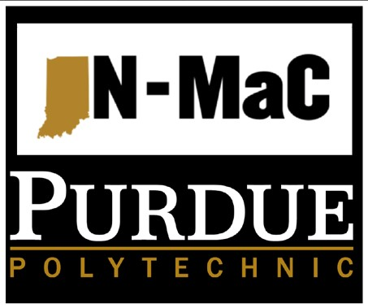

# Sascha Harrell, MS

Director of Workforce Development & Education, IN-MaC

**Greg Strimel, Ph.D.**

Assistant Professor, Technology Leadership & Innovation

# Women in Manufacturing Summit

**September 11, 2019**

The Problem?

**Talent Gap & Future of Work** • Over 2.4M Jobs Unfilled (now - 2028)

* Reports = Manufacturers Citing:
* Shifting Skill Sets
* *Misperceptions of MFG Jobs*
* Retirements
* Reports = Recommend:
* Starting Early
* Address New Skills
* Replace with Automation

What Are We Doing?

* Went Early/ New Skills: –Industry Partners

–Innovation Studios

–Robotics in MFG Camps

–MFG Week

–Micro-grants

* Emotional Based
* 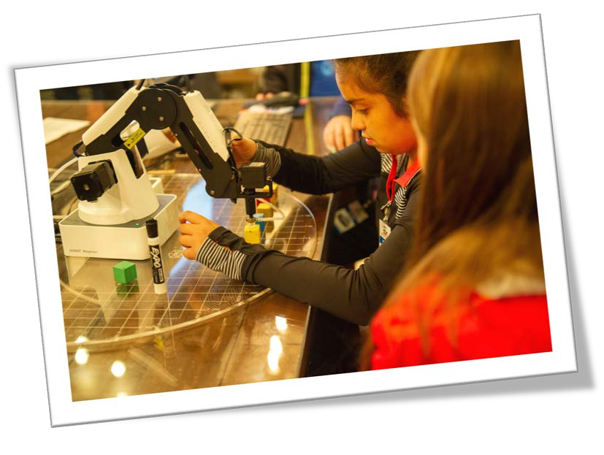***Research:* Does this influence career perceptions?**

Example: Robotics in MFG Summer Camp

* Weeklong
* Industry-led
* K-2, 3-5, & 6-8

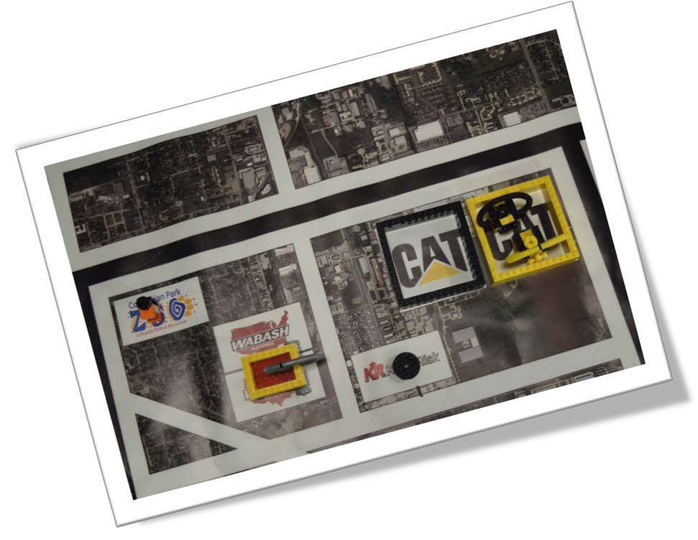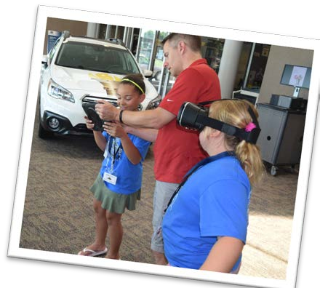

* Number of Students
* 40 (Ages 8 -15)
* 23 (Ages 5 – 8)

**Does this influence career perceptions?**

Data Collection

Pre & Post-Instruments

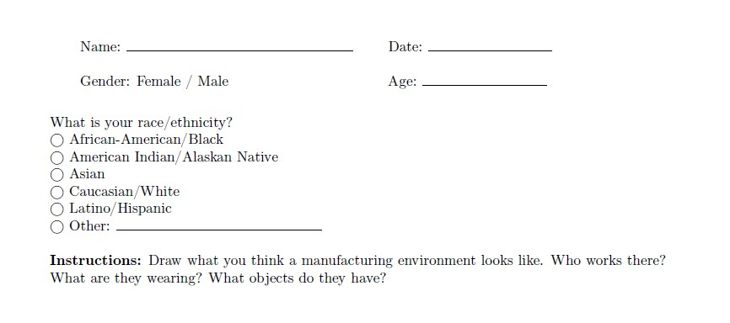

* Draw a Manufacturer Test
* Career Perception Survey

A Perceptions Gap?

* Pre-Camp data:

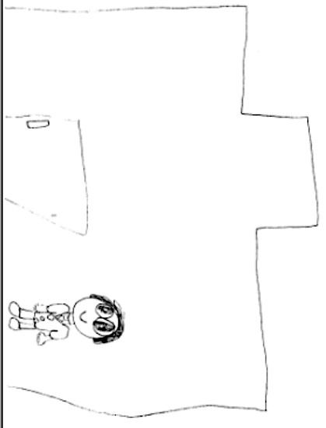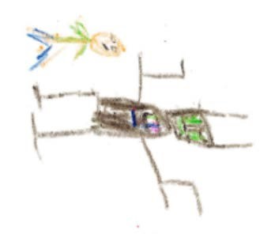

* “Draw-A-Manufacturer” PreTest
* Unoccupied, block buildings.
* Limited people
* Limited Production Processes
* Basic hand tools
* Science fiction-oriented robots

A Perceptions Gap?

Pre-Survey Data:

|  |  |
| --- | --- |
| • **57%** - K-2nd | Not interested in a MFG-related career |
| • **21%** - 3rd-8th | Have been encouraged to explore MFG |
| • **71%** - K-2nd | Viewed Jobs as Unsafe |
| • **65%** - 3rd-8th | Viewed Jobs as Unsafe |
| • **86%** - K-2nd | Viewed Jobs as Dirty |
| • **73%** - 3rd-8th | Viewed Jobs as Dirty |

* A lot of available jobs in manufacturing
* Manufacturing careers require a college degree

The Influence?

**Post-Data Suggests** - Children Career Perceptions can be Influenced Through Industry-driven Outreach Initiatives.

* “Proceed with Caution” • Influence can be perceived as oppositional to talent pipeline development goals
* Influence - “not consider” a career in MFG
* Left the experience perceiving the MFG as unsafe & dirty.

However…

Participants had little to no preconception of manufacturing

* Post-Survey – Shows a more accurate perception (1st Look)
* Post-Drawings

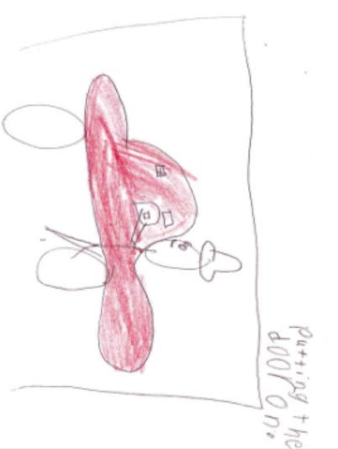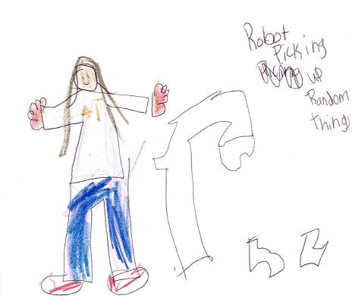

* Activities happening within
* Attention toward the human element
* Increased emphasis on safety
* Increased depiction of industrial robots

We Learned….

* Training & Pre/In-Service Teachers

–Study with Pre-Service Teachers

* Appropriate Setting
* Context
* Age-Appropriate Language
* 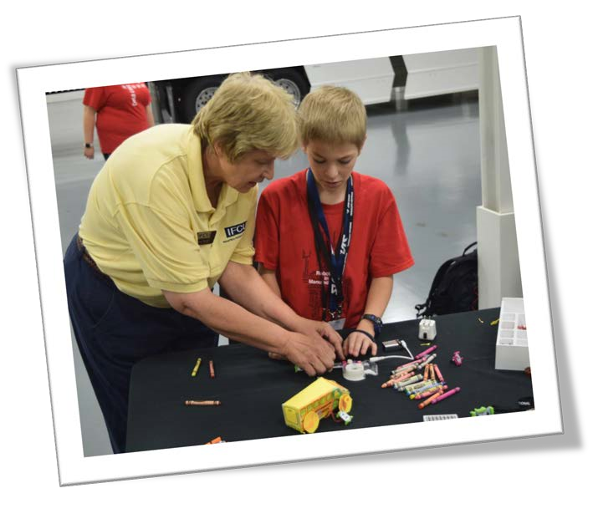Orient Children to the Environment

Safety Example

•

Share, don’t scare!

•

These

environments are

intimidating for

young children

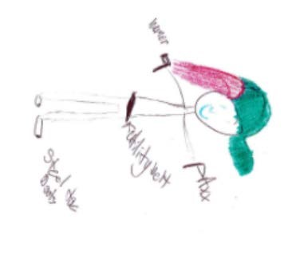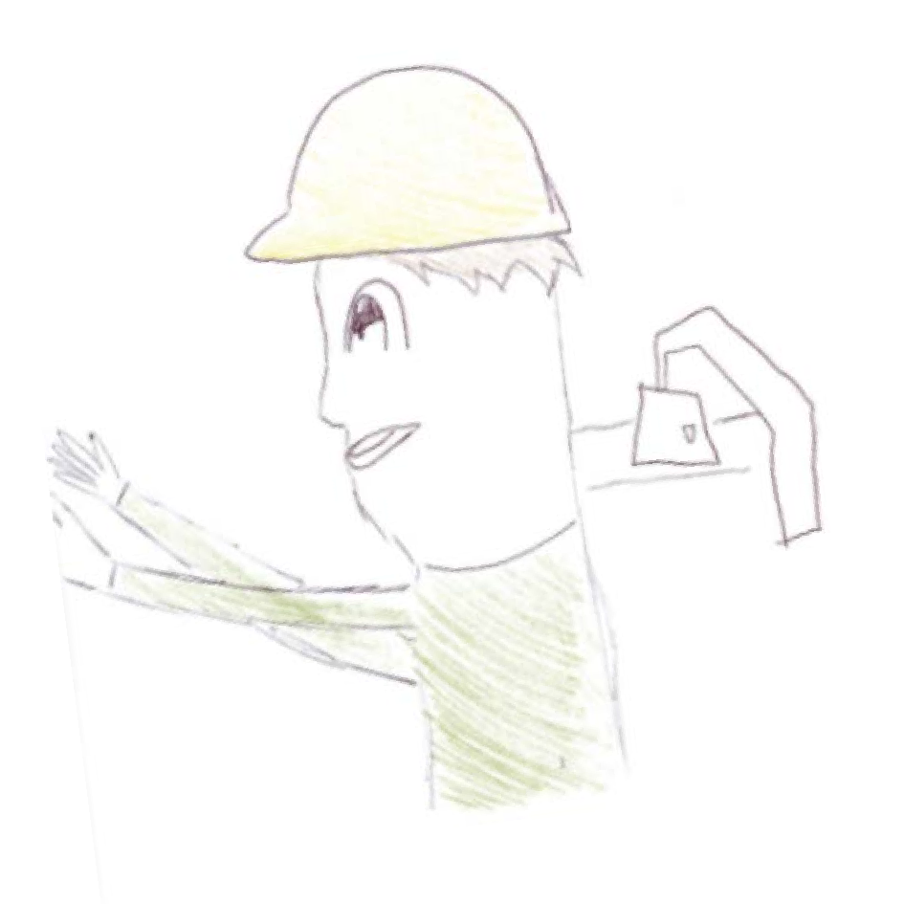

We Moved Forward…

**Manufacturing Week**

* 627 students (K-12)

K-5

•Workshop

6-8

•Expo

9-12

•Tours

* Workshops, Expos, Tours
* Lean
* Continuous Improvement
* Problem Solving
* Leadership

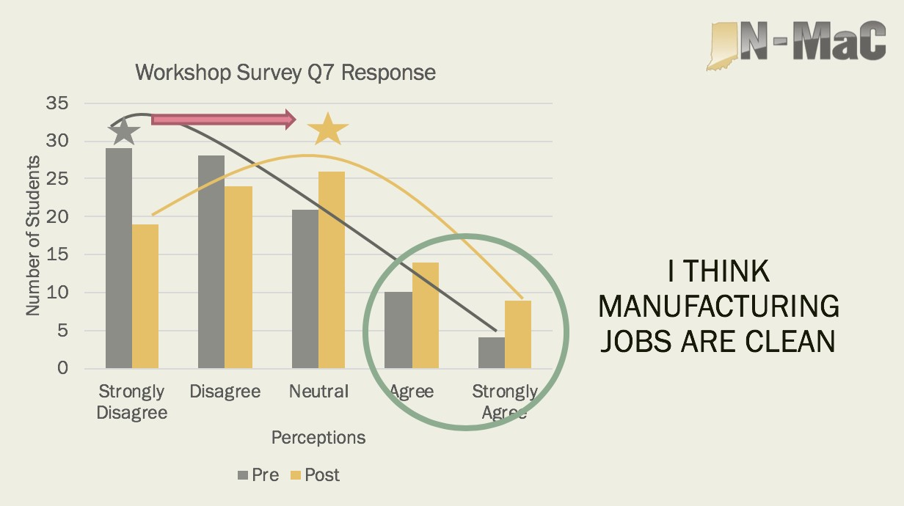Changed Perceptions

More Data = Statically Significant Changes-Positive

Changed Perceptions

* 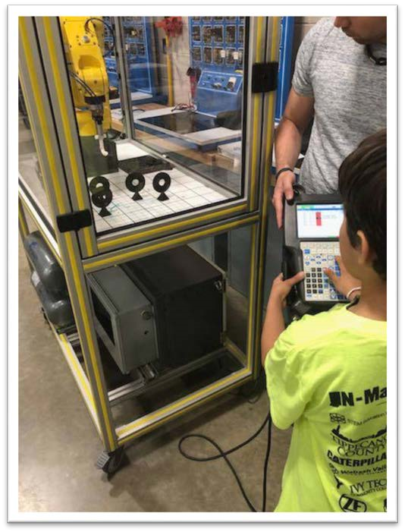Other Examples:
* Clean & Safe
* Felt encouraged to pursue MFG careers
* Creativity & innovation is Encouraged
* MFG jobs pay well
* Only High School Diploma

Greatest Changes Across Grades….

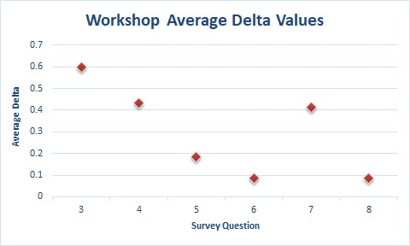

I would consider a career in

manufacturing

Greatest Changes Across Grades….

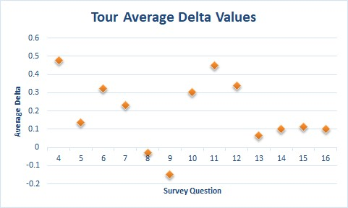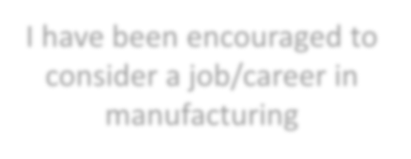

I have been encouraged to

consider a job/career in

manufacturing

We Learned More….

* Real-world Association/Language • Personal Stories
* 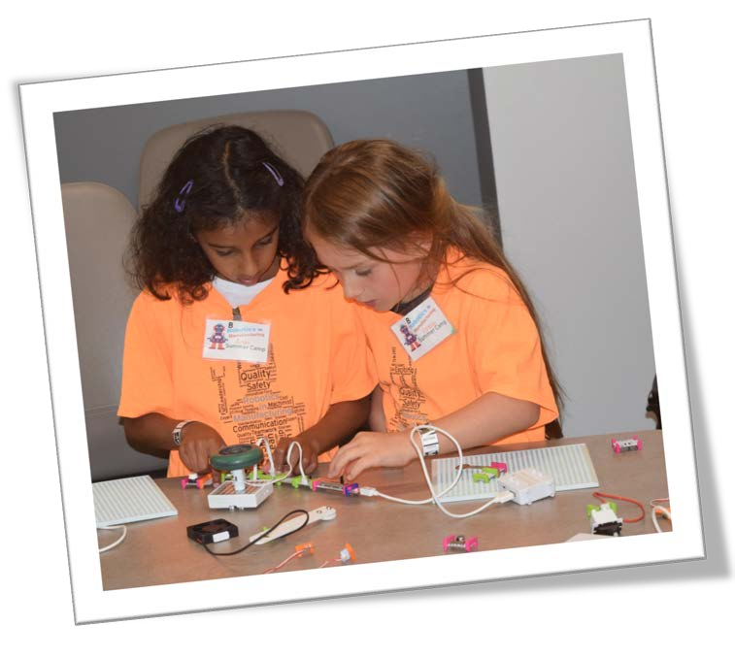Authenticity to Everyday Careers
* (Design it, Produce it, Move it, Support it)
* Group Size
* Age & Interest
* See the Full Process

Moving Forward Again….

•

Data Informed

Decisions

•

Regional

Expansion

•

More Data

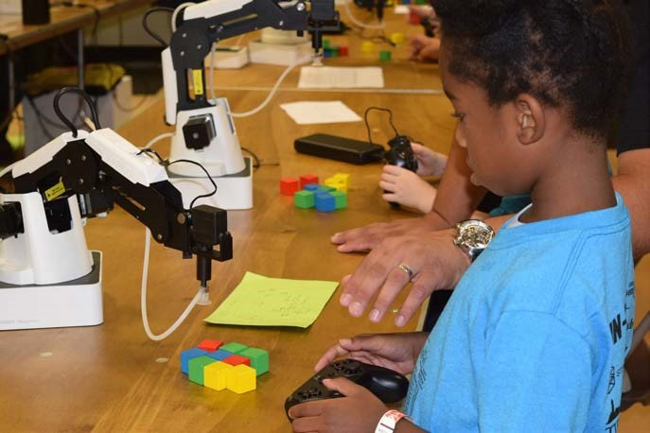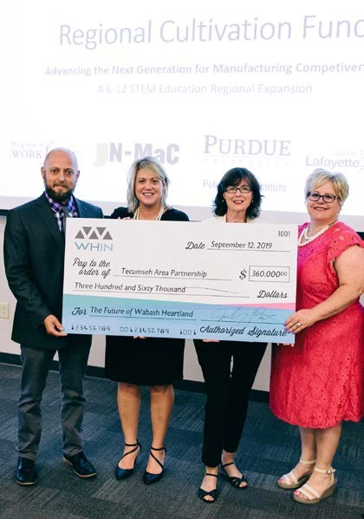

Support

