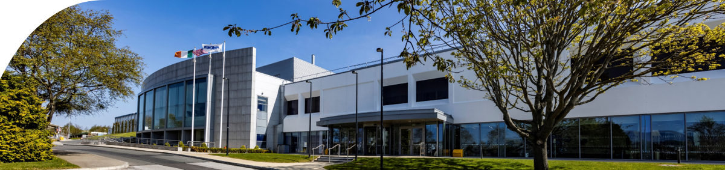

Short Description – About Amgen at ADL:
Amgen has proudly operated in Ireland for over 25 years, with Amgen Dun Laoghaire (ADL) established in 2011 as a key manufacturing site within our global network. Today, more than 1,250 employees across Ireland are dedicated to advancing science and delivering high-quality medicines to patients worldwide.
At ADL, our teams play a critical role in biologics manufacturing, operating a state-of-the-art facility that supports the production of life-changing therapies for patients across global markets. The site is focused on high-quality, reliable drug substance manufacturing, underpinned by advanced technologies, operational excellence, and a strong culture of safety and compliance. ADL combines scientific expertise, innovative manufacturing processes, and digital advancements to ensure consistent supply and the highest quality standards. Continuous improvement, sustainability, and talent development are central to how we operate, enabling us to remain a strategic and agile partner within Amgen’s global manufacturing network.
Beyond manufacturing excellence, ADL remains deeply connected to our community through education, sport, and local partnerships. We are proud sponsors of the Amgen Irish Open, the KPMG Women’s Irish Open, the Aer Lingus College Football Classic, and grassroots sport through Cuala GAA, reflecting our commitment to supporting local communities and inspiring future generations. We also actively support educational and innovation initiatives such as the UCD Biotech Program and the Stripe Young Scientists & Technology Exhibition (YSTE), helping to foster scientific curiosity, nurture emerging talent, and strengthen Ireland’s future STEM ecosystem.
Short Description – ADL Site Tour:
Visitors to Amgen Dun Laoghaire (ADL) will experience a state-of-the-art biologics manufacturing facility that has been a cornerstone of Amgen’s presence in Ireland for over 25 years. Established in 2011, ADL plays a vital role in our global manufacturing network, where highly skilled teams produce life-changing therapies for patients around the world. During a tour, guests will see how advanced technologies, digital innovation, and rigorous quality systems come together to ensure safe, reliable drug substance manufacturing. They will gain insight into our culture of operational excellence, continuous improvement, and sustainability, as well as the talented people who drive our success.

