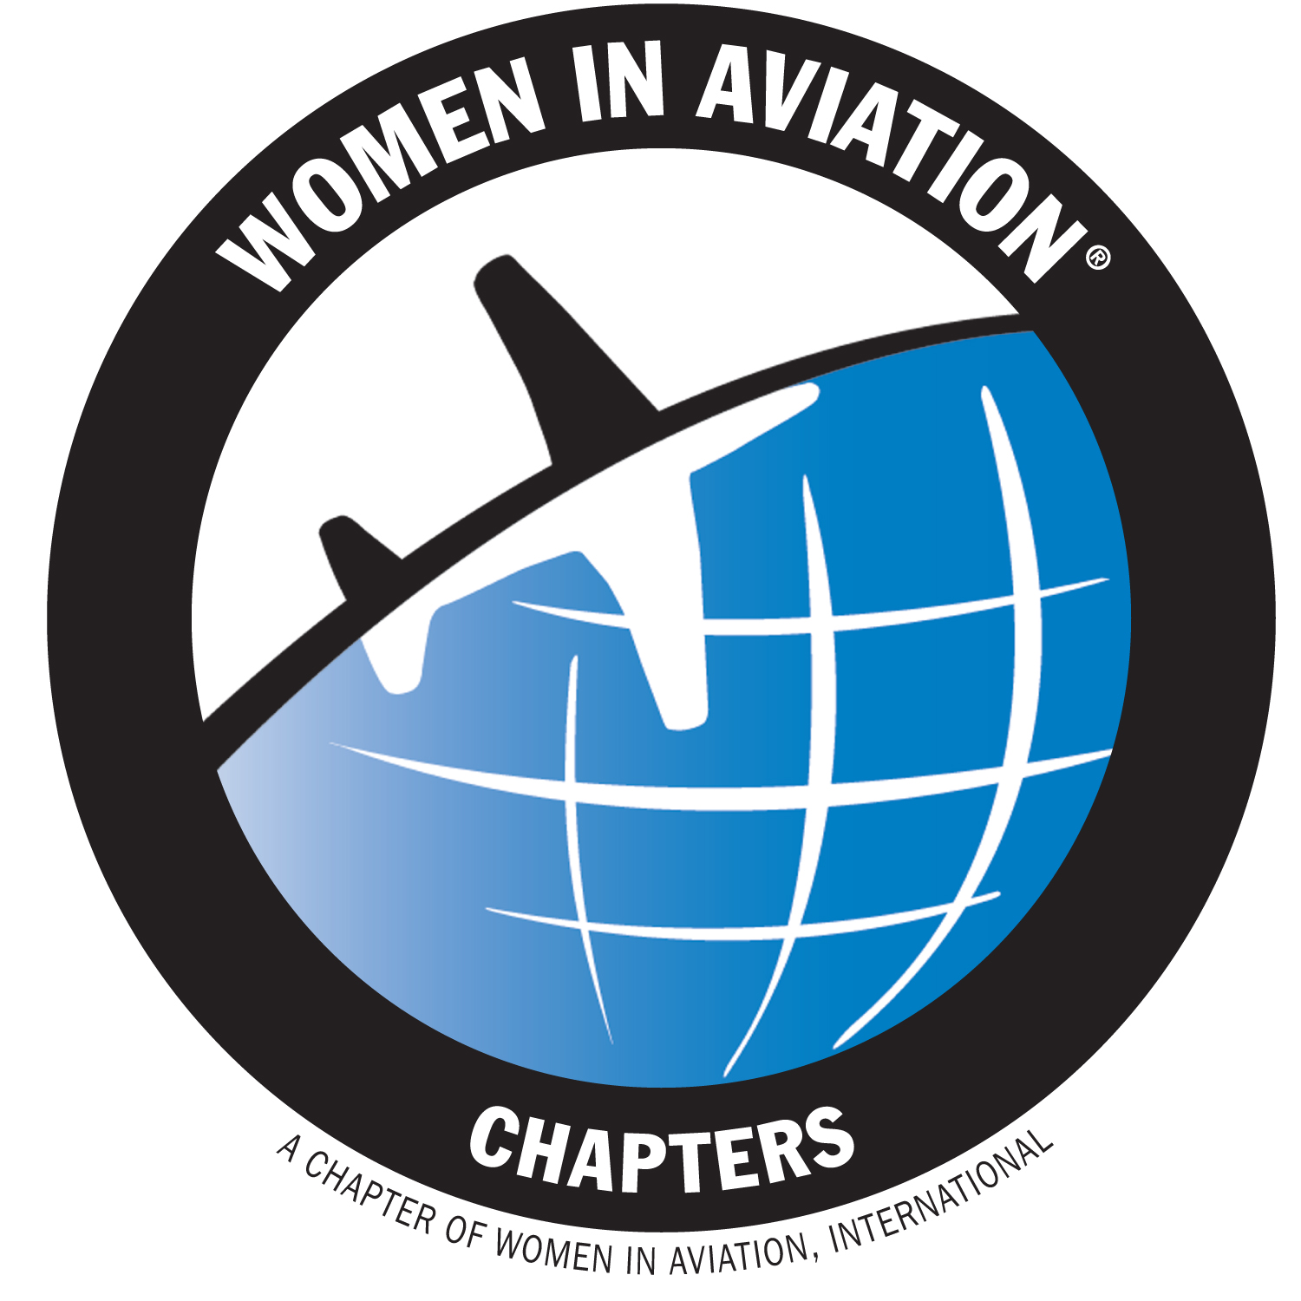
2023
Things to do & stuff to know!

2023 WAI Conference February 23-25, 2023
Chapter Events:
Chapter Connect Reception February 22, 6:30pm-7:30pm
Chapter Leadership Workshop February 23, 8:00am-11:00am
Chapter Fundraising Tips, Tools, and Strategies February 23, 2:30pm-4:30pm
Plan and Host an Outstanding GIAD Event February 24, 1:45pm-3:15pm
Start a WAI Chapter February 24, 3:30pm-5:00pm
Plan and Host an Outstanding GIAD Event February 25, 10:45am-11:45am

Sun ‘n Fun March 28-April 2

Chapter Connect Webinars @1pm ET (register in advance)
Aww, do I HAFTA? (Yes, you do!): Reviewing Annual Chapter Reports March 17
Hosting a “Next Level” Girls in Aviation Day April 14
#HONORTHEWASP May 12
Running Up That Hill: Becoming a Better Leader May19
Teamwork Makes the Dreamwork: Effective Team Leadership June 16
We Just Disagree: Conflict Management and Resolution Techniques July 14
R-E-S-P-E-C-T: A Chapter Mindful of Diversity, Equity, and Inclusion August 18
Dare to Dream: How Scholarships Change Lives September 8
Hey… Where’d You Go?: Recruiting and Maintaining Volunteers October 13
Show Me the Money!: Effective Fundraising November 17
I’m Willing to Share This With You: Effective Delegation Strategies December 15

Submit Chapter News
May/June issue March 10
July/August issue May 19
September/October issue July 7
November/December issue September 15
January February issue November 17
Annual Chapter Report &
Administrative Fee Due April 30

Honor the WASP Memorial Day

EAA AirVenture Oshkosh July 24 – July 30

Girls in Aviation Day 2023 September 23

Start Filing 990N ePostcards October 1

