Click or tap here to enter text.

Email address

Click or tap here to enter text.

Click or tap here to enter text.

Click or tap to enter a date.

Click or tap here to enter text.

Click or tap here to enter text.

Click or tap here to enter text.

Agency

Agency Address

**DRE PROGRAM:**

The Drug Evaluation and Classification (DEC) Program has received national acclaim for its success in identifying the drug-impaired driver. Officers trained as drug recognition experts (DREs) are frequently called upon to differentiate between drug influence and medical and/or mental disorders. The training is an extremely valuable tool in combating the adverse impact of drug and alcohol impaired driving in our communities.

The DRE School is extremely demanding. To receive certification as a DRE, three phases of training must be completed. The following summarizes each phase:

Click or tap here to enter text.

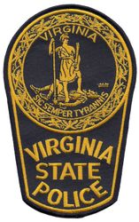

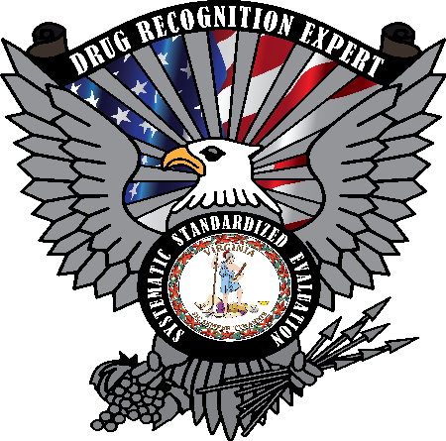

**Virginia Drug Evaluation and**

**Classification Program**

Mobile Phone Number

Current Assignment

Hire Date

Last Name

First Name

**Date of Basic SFST training (MM/DD/YY):**

Click or tap here to enter text.

Click or tap here to enter text.

**ACADEMIC TRAINING:**

This portion of training is typically conducted over ten days. It includes the DRE Pre-school (16 hours) and the DRE School (64 hours). It includes courses in physiology, vital signs, standardized field sobriety testing (SFST), and extensive information on each of the seven categories of the drugs of abuse. The training includes **three written examinations, a practical SFST proficiency examination and five written quizzes**.

Students must achieve a **minimum of 80%** on the three examinations, and must demonstrate proficiency in administering the SFST in order to progress to the certification phase.

**CERTIFICATION PHASE:**

After successfully completing the academic portion, the students must complete the certification phase.These requirements include conducting a minimum of 12 drug influence evaluations while under the supervision of a DRE instructor; identifying subjects under the influence of three of the seven drug categories; and attaining a 75% toxicological confirmation rate. The student shall opine 12 correct evaluations. In addition, the student must maintain a progress log, rolling log and submit a curriculum vitae (CV). Finally, the student must pass a comprehensive final knowledge examination, obtain the written endorsement of two certified DRE instructors and the DRE State Coordinator. DRE certification is valid for two years. In order to maintain certification, DREs must conduct a minimum of four evaluations every two years including two enforcement evaluations, submit an updated rolling log and updated CV. The DRE shall attend eight hours of approved recertification training annually.

**To be considered for DRE training, the applicant must meet the following criteria:**

Must have a minimum of two years of law enforcement service. Must be in "good standing" with your agency.

Must be assigned to patrol and/or traffic enforcement duties (Those not assigned to patrol/traffic duties may be considered for the DRE training on a case by case basis.)

Must be SFST trained and proficient in its use.

Must have an endorsement/recommendation letter from your Chief, Sheriff or Commander (attach recommendation to the application.)

Must have an endorsement/recommendation letter from your local prosecutor (attach recommendation to the application.)

Must submit no less than two (2) enforcement DWI arrest report **narratives** for review (attach report narratives to the application.)

**To assist in the selection of quality personnel for the DEC Program, please complete the following information:**

**Number of DWI arrests in the last 2 years:**

**Summarize your prior assignments related to, or of interest to, the DRE Program:**

**Summarize your formal education, work or practical experience, and training that may be related to, or may be of interest to, the DRE Program (EMT training, college, etc.):**

**How do you expect DRE training to benefit you and your department?**

**Is there anything else you think would assist in your selection as a DRE?**

Click or tap here to enter text.

Click or tap to enter a date.

Click or tap here to enter text.

Click or tap here to enter text.

Click or tap to enter a date.

Click or tap here to enter text.

**I acknowledge that I have read the listed requirements and understand the commitment I am making to become a DRE.**

**Applicant's Signature & Date**

**I have read the listed requirements and I recommend this officer for DRE training. (It is required that a DRE Instructor Sign Off on the applicant's SFST proficiency)**

**DRE Instructor's Name**

**Date**

**DRE Instructor's Signature & Date**

**I have read the listed requirements and I recommend this officer for DRE training.**

**Supervisor's name**

**Date**

**Supervisor's Signature & Date**

(01/2025)