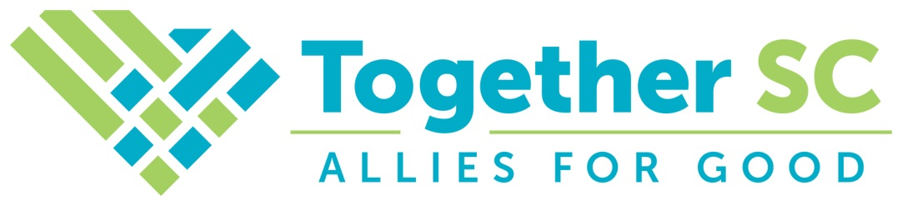

**POLICY CATEGORY: 4. DAILY OPERATIONS**

**POLICY TYPE: 4.A. OPERATIONS AND EVALUATION**

**POLICY TITLE: 4.A.2 *Membership***

Approved by Board – 6/27/24

The viability of any nonprofit organization is directly dependent upon its ability to maintain funding, and member dues are a significant portion of funding for Together SC. All policies and procedures relating to membership must be fair, uniform, and applicable to all members of Together SC. Policies and Procedures regarding membership terms and conditions not specified by the Board are under the authority of the President.

The Board’s expectations around membership are as follows:

**Membership Terms**

Membership in Together SC is based on a rolling membership year and memberships are effective for one full year after payment.

**Membership Qualifications and Dues Structure**

Together SC has various classes and types of membership as determined by the Board and the Bylaws. The Bylaws provide for two classes of membership: Voting and Nonvoting. Each class has a number of member types. The current Board-approved structure for membership qualifications and dues is as follows:

*Voting Members:*

* Nonprofit Members: Nonprofit Members must be charitable nonprofit organizations registered with the SC Secretary of State, and have been determined by the IRS to be a Public Charity under Section 501(c)3 of the Internal Revenue Codes, and who submit dues according to this schedule, based on the member organization’s annual revenues in the previous reported year:
  + Less than or equal to $50,000 - $50.00
  + More than $50,000 but less than $100,000 - $100.00
  + $100,000 or more but less than $200,000 - $200.00
  + $200,000 or more but less than $500,000 - $300.00
  + $500,000 or more but less than $1,000,000 - $500.00
  + $1,000,000 or more but less than $5,000,000 - $700.00
  + $5,000,000 or more but less than $10,000,000 - $900.00
  + $10,000,000 or more but less than $25,000,000 - $1,100.00
  + $25,000,000 or more - $1,300.00
* Philanthropic Partner Members: Philanthropic Partner Members must be organizations that meet the qualifications for Nonprofit Membership, and are community, corporate, or private foundations, or United Ways, which make grants to charitable nonprofit organizations in South Carolina, and who submit dues according to this schedule:
  + Organizations with total grants distributed to nonprofits in South Carolina in the previous reported year:
    - Less than $100,000 - $250.00
    - $100,000 or more but less than $750,000 - $500.00
    - $750,000 or more but less than $3,000,000 - $750.00
    - $3,000,000 or more but less than $7,500,000 - $1,000.00
    - $7,500,000 or more but less than $10,000,000- $1,250.00
    - $10,000,000 or more - $1,500.00

*Non-Voting Member Class:*

* Consultant Collaborative Members: Individual consultants or firms who provide services primarily to the charitable sector and who submit dues of $250.00.
* Corporate Allies Members: Companies who do not necessarily provide services to nonprofit organizations, and who are involved in philanthropic engagements with South Carolina’s charitable sector, and who submit dues according to their gross annual revenues in the last reported year, as described in this schedule:
  + - Less than $5,000,000 - $500.00
    - $5,000,000 or more but less than $10,000,000 - $1,000.00
    - $10,000,000 or more - $1,500.00
* Academic Partner Members: Academic Partners are departments of public or private institutions of higher learning in South Carolina, that offer educational courses, degree, or certificate training for professionals and volunteers working in the nonprofit field and who submit dues of $250.00.
* Government Partner Members: Government Partners are state, regional, or local government agencies in South Carolina which either function similarly to private nonprofit organizations, or which support nonprofit organizations through funding or other resources and who submit dues of $125.00.
* Associate Members: Associate Members are any other individuals who submit dues of $50.00.

**Membership Dues Amendment**

In accordance with the Bylaws, the Board may amend membership and/or renewal fees, without prior notice. In the case of membership renewal, any fee amendments will be reflected in the notice, and members wishing to renew their membership shall be subject to the amended fees.