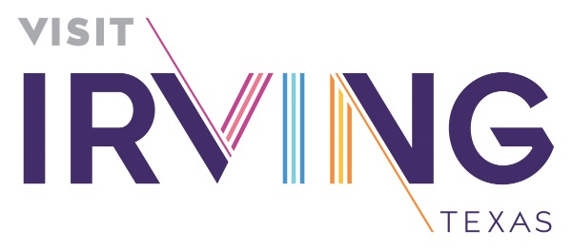

2018-21 Strategic Plan - Board Mandate

“As accomplished as the ICVB Staff is, it will take more than the paid professionals to move the ball across an ever-shifting goal line. It will require the influence of the Board, both individually and collectively, to open doors and socialize innovative concepts for those that don’t yet fully comprehend the power of the Visitor Economy on the vitality of the City of Irving…”

The Board’s Mission

The Irving CVB Board will take ownership of the opportunities on its horizon, doing everything in its power to move the visitor vision of the destination forward by proactively putting the ideas, desires and priorities on every table it can.

Executive Committee

Conducts performance evaluation of the executive director and makes recommendations for performance priorities and weightings; also serves as Finance committee

Standing Monthly Meeting: Friday prior to each full board meeting, 9 a.m. at the ICC unless otherwise notified.
- Chair – Clem Lear
- Vice Chair – Ron Mathai
- Committee Members: David Cole; Debbi Haacke, Rick Lindsey, Greg Malcolm
- Staff Liaison: Maura Gast
- Committee Support & Communications: Carol Boyer

Board & Business Development Committee
Bylaws, Governance (Organizational & Board), Legislative Issues, Organization-impacting ordinances, Strategic Planning
2018-21 Strategic Plan Responsibilities
GOAL: Increase the ICVB’s Competitiveness in the marketplace
- Pursue Legislation to Enable Irving Hotels to Develop a Tourism Public Improvement District
- Actively Oppose Legislation that is destructive to Irving’s Economic Viability, and its Visitor Economy
- Evaluate Boar Development Committee title to More Accurately Reflect its Total Focus
- Analyze other Innovative Revenue Streams

Standing Quarterly Meetings: Mar. 15, June 7, Sept. 13, Dec. 6; all meetings at 9 a.m. at the ICC office unless otherwise notified.
- Chair – Debbi Haacke
- Vice Chair – Karen Cooperstein
- Committee Members: Clem Lear; Ron Mathai; Bob Bettis; Beth Bowman; David Cole; Rick Lindsey; Joe Philipp
- Staff Liaisons: Maura Gast and VP/Finance & Admin
- Committee Support & Communications: Carol Boyer

Community Engagement Committee
High Spirited Citizens, Open Houses, Community Conversations, Hospitality Industry Annual Meeting, National Travel & Tourism Week
2018-21 Strategic Plan Responsibilities
GOAL: Enhance the Community’s Awareness and Appreciation of Irving as a Visitor Destination
- Celebrate the Culture of the City through supporting local artists
- Develop a Strategy to Encourage Residents to be Brand Ambassadors
Standing Quarterly Meeting: Jan. 15, Apr. 2, July 9, Oct. 1; all meetings at 11:30 at the ICC unless otherwise notified
Chair – Rick Lindsey
Vice Chair – Karen Cooperstein
Committee Members: Clem Lear; Ron Mathai; Bob Bettis; Bob Bourgeois; Beth Bowman; Jo-Ann Bresowar; Julia Kang
Staff Liaisons: Maura Gast and Diana Pfaff
Committee Support & Communications: Carol Boyer and Carol Stoddard

Destination Development Committee
Convention Center, Signage, Hotel Development, Visitor Amenities, Industry-Impacting Ordinances
2018-21 Strategic Plan Responsibilities
Advocate for Destination-Defining Development
GOAL: Increase the ICVB’s Competitiveness in the marketplace
- Encourage the Development of Iconic Attractions
- Encourage the Activation of the city’s Waterfronts with new Experiences
- Encourage the Development and Support of Tournament-Grade Sports Facilities & Events
- Support the Development of other destination magnets
GOAL: Endeavor to Enhance the Visitor Experience
- Support the Strategic Development of Festivals and Events
- Advocate for enhanced infrastructure amenities
- Support R-AB Zoning initiatives that better reflect current and emerging trends to encourage more Destination Attractions & Dining
- Support the Expansion of Unique Retail Options throughout the City

Standing Quarterly Meeting: Feb. 5, May 10, Aug. 6, Nov.5; all meetings at 11:30 at the ICC unless otherwise notified
- Chair – Greg Malcolm
- Vice Chair – David Cole
- Committee Members: Clem Lear; Ron Mathai; Bob Bourgeois; Beth Bowman; David Cole; Joe Marshall; Julia Kang; Jacky Knox; Joe Philipp
- Staff Liaisons: Maura Gast and Lori Fojtasek; Tom Meehan (ICC)
- Committee Support & Communications: Carol Boyer and Brenda Lopez

