


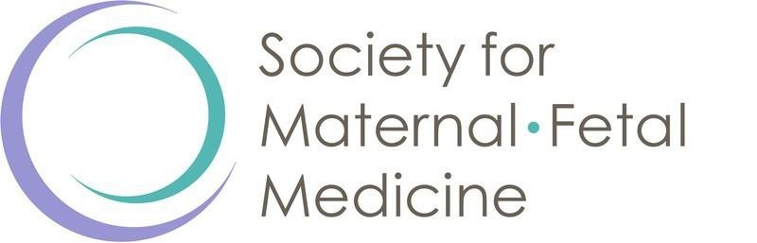

RESIDENCY PROGRAM AWARD FOR EXCELLENCE IN OBSTETRICS

This certificate is hereby granted to

FULL NAME, CREDENTIALS

In recognition of shared commitment to the vision of the Society for Maternal-Fetal Medicine
to improve pregnancy and perinatal outcomes.

