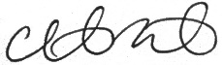



**RESIDENCY PROGRAM AWARD FOR EXCELLENCE IN OBSTETRICS**

This certificate is hereby granted to

*FULL NAME, CREDENTIALS*

In recognition of shared commitment to the vision of the Society for Maternal-Fetal Medicine   
to improve pregnancy and perinatal outcomes.

**SINDHU SRINIVAS, MD, MSCE**

PRESIDENT

**CHRISTINA J. WURSTER, MBA, CAE**

CHIEF EXECUTIVE OFFICER