
Grant Augenstein; Field Manager/Owner
EverReady Carpet Cleaning and Restoration
Grant has been in the real estate and multi-family industry for over 11 years. Grant’s company is the only vendor in his line of work that solely focuses on and services the multi-family industry. With an awesome team and a down to earth and honest approach to business, EverReady has earned the trust of servicing 90+ apartment communities on a day-to-day basis and EverReady has grown 5-fold since their first year in business.
Grant loves his EverReady team and the multi-family and real estate industry. His customers make him eager to serve on the Product and Service Council. He has been an active member of the St. Louis Apartment Association since 2012 and enjoys helping and giving back to the association, Deb & Geri in any way he can.

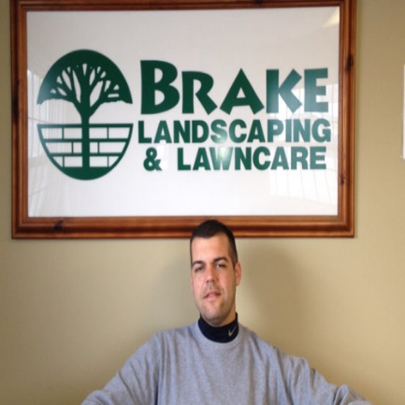
Robert Brake, President, Brake Landscaping & Lawncare, Inc.
As an active member of St. Louis Apartment Association for 17 years by participating regularly in SLAA events and often serving as a sponsor. Robert is proud to be a member of an association that promotes doing business with other members. He works diligently soliciting new members for the SLAA, furthermore encouraging them to take an active role with the association. As a vendor, building relationships is a key component to our business and SLAA provides such opportunities. One being the SLAA golf tournament beverage tent we anticipate sponsoring annually, which opportunely provides us the potential of interacting with clients.
Brake Landscaping offers complete landscape design, installation, and maintenance for the commercial industry. While growing his landscaping business, Robert has relied heavily on fellow SLAA vendors and managers in his daily operations, therefore permitting him the opinion that SLAA is integral in helping new businesses thrive. His distinctive experience operating among vendors and managers establishes him an excellent choice for the council.
On a personal note, Robert has a son that keeps him engaged, in part by contributing time as an assistant basketball coach for the team. The pair spend time at motor cross and bull riding events when in St. Louis. On weekends, riding 4-wheelers and spending time with friends encompass their regular activities.
Robert would be honored to serve on the products and service council.


Sharon Chapman, Owner, Sharon Chapman Design
Sharon has worked in all aspects of the Interior Design industry for over 25 years. She jumped in feet first opening Sharon Chapman Design in May of 2018 working with developers and owners to help design all aspects of 1400 Russell. She wrapped up the project staging all the public spaces, leasing offices and display units. Villages of Twin Oaks, 5300 Centre, EXPO at Forest Park, Ballpark Heights and One Cardinal Way are a few additional projects where her work stands out.
Sharon has also shared her skills in the multi-family industry as a kitchen and bath designer working with many SLAA members creating beautifully remodeled units and updating public spaces in many communities and partnering with suppliers.
Sharon’s love for networking and building lasting relationships is what drives her daily. Giving back, being involved, and creatively thinking outside the box to help solve your dilemma is what she does best. If she cannot help, she will connect you with someone who can! Sharon is also a member of the SLAA membership committee and is eager to help grow SLAA with her connections to the community and lead in the Product and Services Council.

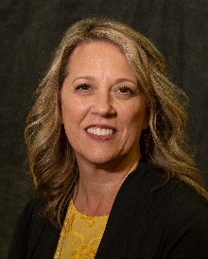
Tracy Deniszczuk, Business Development Manager
Precision Concrete Cutting
Tracy is the Business Development Manager for Precision Concrete Cutting. Prior to this position, Tracy worked for a local management company as the community association manager, where she was able to work with many types of vendors, soliciting and collecting bids, organizing meetings with boards, and facilitating execution with vendors to satisfy community needs.
As a newer member of the SLAA, she sees this as an opportunity to work with those who hold the same value for their residents and communities that she does. She believes that her long history in management and sales promotion lends a benefit to the Council in both commitment, time management, organizational skills and creative thinking, that will help get projects done in a timely manner and provide guidance to suppliers, encouraging participation in organizational activities.
Tracy is a representative of Precision Concrete Cutting in the St. Louis, Northeastern Missouri, and Central Illinois region, and happy to be a supplier partner with St. Louis Apartment Association. Already Tracy has connected with other members and hopes to be a long-time member of the organization going forward.
Tracy would be honored to be elected to serve on the council.

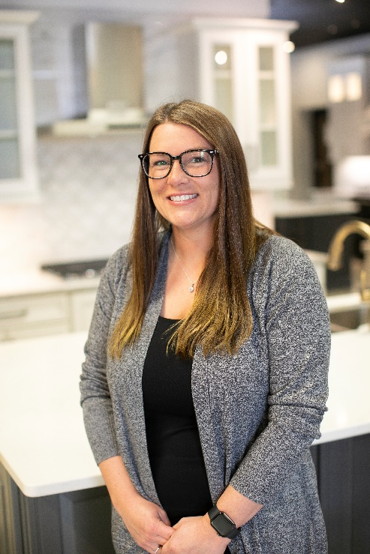
Meghan Estes, Commercial Account Manager, Capitol Group, Inc
Meghan has 16 years of sales experience within the advertising, insurance, and multi-family industries. The skills gained from those industries is what has made her successful in building relationships and understanding what is important to her clients. Her tenacity and eagerness to learn has made her a leader along with her creative/strategic planning skills. She will bring a fresh perspective and help produce innovative ideas to help grow the SLAA and bring more value to our supplier members.
Meghan dedicates her time to the Eastern Missouri Home Builder Association’s Professional Women in Building Council, fundraising for the American Heart Association and fostering dogs for Gateway Pet Guardians.
Why I want to be on the Product/Service Council - I want to help grow the effectiveness of the SLAA for our supplier members. Our supplier members are a vital part of the Association and making connections, referrals, and growing their businesses is important. We are a community and in being a community, we support each and every single member to the best of our abilities. I am a creative, outside the box thinker and will bring new ideas to the council while respecting my fellow peers. Demonstrating good character and having strong principles is important for me and I believe if we have that, it will build a strong foundation for trusting relationships between supplier members and property management/ownership groups.
Thank you for your consideration of electing me to the Product and Service Council.
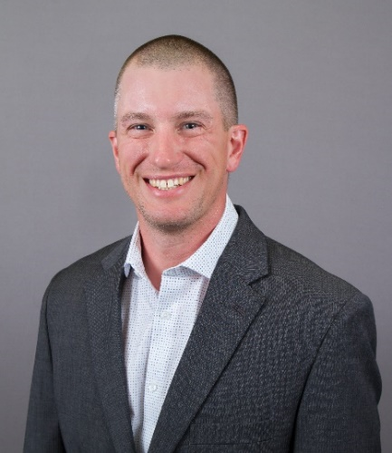
Kevin Laune, Director of Client Relations; Watchtower Security
Kevin began working for Watchtower Security in 2012. In 2013, he became their Director of Client Relations. In this role, he manages a team of Client Service Representatives who serve as the liaisons between Watchtower and their clients across the nation. Watchtower Security provides a fully managed video surveillance service exclusive to the multifamily industry. The company has a long history of high involvement within the SLAA.
Kevin currently serves as President of the Products & Service Council for the 2022-2023 term. He has been a member of the council since 2020. Kevin also continues to serve as the chair on SLAA's Community Awareness committee which he joined in 2013.
Kevin enjoys working with everyone involved in our great association. He would be honored to continue to serve on the SLAA's Products & Service Council. Thank you for your consideration.

George Smith, Owner/Operator, Asset Towing

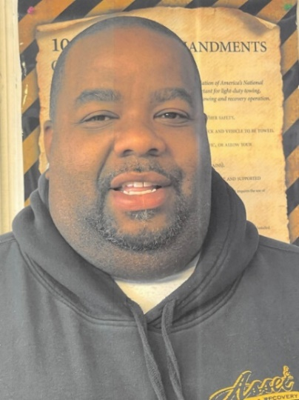
George is the owner of Asset Towing and has been in business for twelve years, and a member of the SLAA for ten years.

George has been involved in the towing industry for 22 years. He is a certified Wreck Master. One of George’s skill sets is being able to listen before responding. George believes that to effectively resolve a client’s issue, you must first listen to their concerns, then respond accordingly. George faces situations head on to get a clear and precise understanding of all parties involved.

Being a member of the council will give George the platform to share his time and talents with new members and guide them to utilize their membership in a way they will see results, assist with event execution and the council’s policies and procedures, as well as following the code of ethics, regulations and principals set forth.

George attributes his involvement with SLAA a direct result of his successful business journey and would be honored to be elected to serve on the Product and Service Council.

