St. Louis Apartment Association’s Fall Expo
Tuesday, October 24, 2023

Important Event Details for Exhibitors
Please read this information very carefully

Expo Display Registration Fee -

Exhibitors have several options from which to choose from. For your information “extreme prime” and “prime” displays” are in areas where we expect heavier traffic. (i.e., front entrance, food, and beverage locations)

Exhibitor cost includes -

8’ x 10’ Display Pipe & Drape
Skirted 8’ table, 2 chairs/trash can Name Badge(s)
Company Sign Carpeted (looks like brown/tan vinyl planks)

Early Bird Savings

You will save $100.00 if your booth registration is received by September 15 @ 5:00 pm. All booth prices will increase by $100.00 on Monday, September 18th.

Exhibitor Setup –

The show is in Exhibit Halls North and South, in the lower level of the Convention Center. Exhibitors will be able to set-up displays beginning at 12:00 Noon on Tuesday, October 24th. When you arrive, exhibitors are asked to use loading docks A, B & C, entrance located on Fairgrounds Blvd. These docks enter directly into the Showroom. The Fall Expo opens to the public from 2:00 – 5:00 p.m.

Exhibitor Shipping Information –

Please note – For shipping/receiving information the St. Charles Convention Center’s Service, see the attached form.

If displays arrive prior to 10/24, a storage fee, ranging from $25.00 - $75.00/per day will apply to all shipments stored by the STCCC.

- Ship to - St. Charles Convention Center, One Convention Plaza, St. Charles, MO 63303.
- Please make sure shipments are clearly marked with your Company Name, October 24, St. Louis Apartment Association’s Fall Expo. Thank You!

Shipping Out –

A shipping form is attached. It is the exhibitor’s responsibility to coordinate the return of your display. At the conclusion of the Expo, you must tear down and pack up your entire display. All coordination and paperwork, including the Bill of Lading must be attached and ready for shipment.

The St. Charles Convention Center will remove from the showroom and store your shipment until the next morning. Please make sure all necessary arrangements are made for removal. Thanks so much!

Expo Time –

The Expo is open to the public at 2:00 pm and concludes at 5:00 pm. Appetizers and a cash bar will be available during the entire event.

Exhibitors are asked not to begin breaking down their booth until 5:00pm.

Exhibitor Attendance Prizes –

Exhibitors are encouraged to provide a substantial attendance prize of your choice, worth a minimum of $30.00. Some ideas – gift certificates, gift baskets, sports tickets, electronics, or weekend get-away packages. Exhibitors need to bring plenty of business cards to distribute to attendees and a container to collect attendees’ business cards. Exhibitors are not allowed to participate in other exhibitor’s giveaways!

Expo Bag -

SLAA is looking for one or three (3) companies to sponsor the Expo bag. Exhibitors and all attendees will receive a complimentary bag at registration. Your company logo will be imprinted on one or both sides of the bag. The cost per sponsor is only $700.00. What a fabulous way to showcase your company!

Helium Balloons –

Helium balloons are not allowed in the Convention Center, for obvious reasons. We thank you in advance for understanding!

Overnight Accommodations near Convention Center
Embassy Suites St. Louis-St. Charles / Hotel & Spa @ 877-868-3385

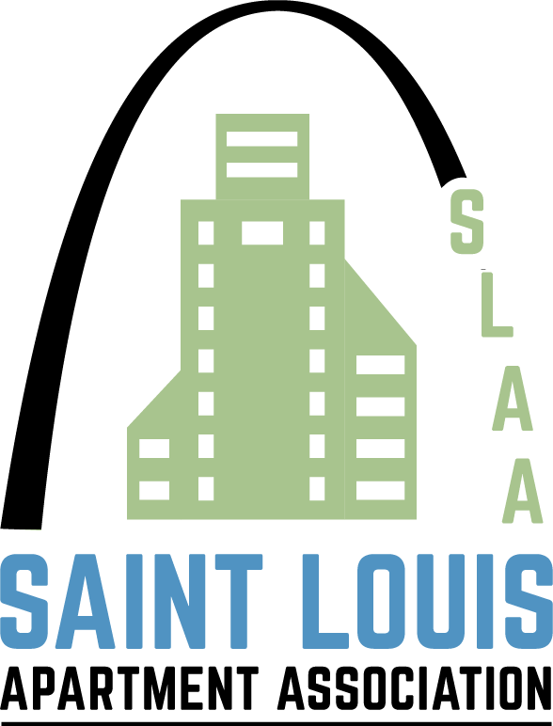

St. Louis Apartment Association Fall Expo
12777 Olive Blvd., St. Louis, MO 63141 Office (314) 205-8844 Fax (314) 205-1410

