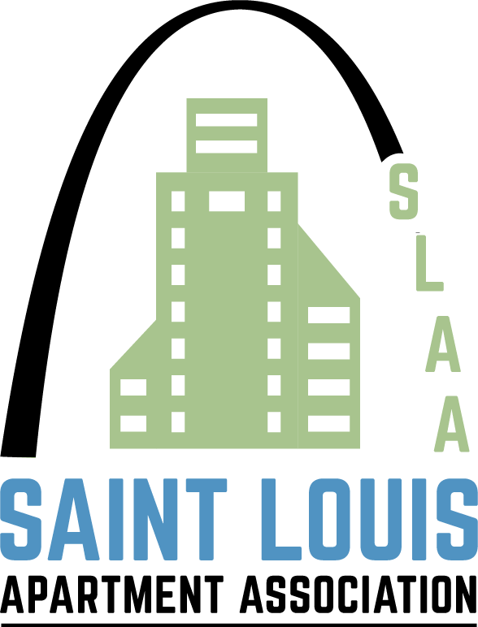
Best of St. Louis Networking Expo

Wednesday, July 10th, 4:00 – 5:00 Networking Reception 5:00 – 7:00 Business Expo

Spazio Westport, 12031 Lackland Road, St. Louis, Missouri 63146

$100.00/for one representative and $50.00/for each additional company representative
Proceeds benefit the NAAPAC.

The SLAA Product and Service Council will be hosting the Best of St. Louis Networking Expo, aka, reverse trade show. The Reverse Trade Show is a highly effective business networking event that provides the opportunity for attendees to meet privately with owners and key decision makers from property management companies.
How it works: From 4:00 pm – 5:00 pm, there will be a cocktail reception with owner/management participants. From 5:00 pm – 7:00 pm owners/management executives will be seated at tables and you will have an opportunity to meet with these decision makers in five-minute intervals over the two-hour session. Your initial appointment will be assigned; after the initial assigned appointment, you will be able to meet with as many decision makers in five-minute intervals as time allows.
The Reverse Trade Show format gives you the opportunity to have immediate contact with buyers from management companies representing over units across the St. Louis metro area.
The Networking Expo/Reverse Trade Show benefits the National Apartment Association’s PAC, so contributions should come from checks or credit cards associated with a personal account.
Unfortunately, corporate contributions are not accepted at this event.
Please see the attached NAAPAC contribution form for additional information. You can complete the form and mail it with your check to the SLAA, 12777 Olive Blvd., 63141, or bring it with you to the event. Personal checks need to be made payable to NAAPAC.
Call 314-205-8844 or e-mail Karen Shymanski at karen@slaa.org with any questions.

Please come prepared with questions and marketing information.

Please choose the top three companies that you would like to visit, rating 1 – 3, with 1 being the most important).

If you have more than one company rep, please indicate their choices as well, or please note that you will be visiting management companies as a team.

_____ 2B Residential (2 tables) (2737 Units)
(1) Carla Powell & Tammy Miller
(2) Naomi Tyler & Mark Milford
_____ Banner Real Estate Group (863 units)
Maggie Sequeira & Sterling Porter
_____ Broadmoor Group (192 units)
John Morrissey, Carrie LaFontaine &
Jake Shields
_____ Fairway Management (1876 Units)
Denise Roemer & Tommy Birch
_____ Greystar (1415 units)
Karin Woodworth, Lauren Baker &
Galen Baxley
_____ The Lipton Group (3250 units)
Sara Daut & Mandi Randell

_____ Maxus (1144 Units)
Carol Lewis

_____ Red Brick (1592 Units)
Angie Hart Hickey & Gerald Keppel
_____ StoneCreek Communities (1198 units)
Ryan Werkmeister

_____ Mills Properties (6339)
Jessica Fiordimondo, Marshall Branco,
Rosanne Lederman

_____ Monarch Investments (5584 units)
Jamie Bryan and Gary Radcliffe

Name(s)____________________________________ Company _________________________________________
Cancellation deadline is 7/5. Due to catering requirements, no-shows will be charged a $25.00 administrative fee.

