￼

**SCAPA Quality Pavement Awards**

Nomination Form

**Eligibility:**

SC Asphalt Pavement Association’s (SCAPA) Quality Pavement Awards recognize asphalt pavements with exemplary quality. All pavements* (i.e. roads, highways, commercial parking lots, airports, trails and paths, etc.) are eligible for a Quality Pavement Award. To qualify for this award, asphalt pavements must have been constructed by a SCAPA member. Additionally, the project must be substantially completed by November 1st, 2025.

*\*Total length of the paving project must exceed 0.50 miles for roadways, and a minimum of 250 tons for other projects.*

SCAPA Members and Owners/Agencies may submit up to 3 projects.

**Instructions**

To be considered for a SCAPA Quality Pavement Award please submit the following information regarding your project:

1. *SCAPA Quality Pavement Award Nomination Form that contains a Project Map and Photo Release.*
2. *SCAPA Technical QC/QA Data Workbook* containing any lab and field data associated with the project.
3. High resolution digital photos of the project (aerial photos and videos can be submitted as well, but it is strongly recommended to avoid submitting aerial-only media).
4. Any other supporting documentation that you would like to submit for consideration by the judges.

Please take this opportunity to assess the paving projects your organization has constructed and submit those you deem worthy of a SCAPA Quality Pavement Award. Owners, please conside*r partnering with contractors when submitting projects to avoid duplicate submissions. Please nominate only a maximum of three (3) projects*. Submit all data via email to [cselkinghaus@scasphalt.org](mailto:cselkinghaus@scasphalt.org) or mail information on a flash drive to SC Asphalt Pavement Association, PO Box 11448, Columbia, SC 29211. **The deadline for submissions is 5PM, Friday, November 7, 2025.** If you have any questions or need additional information, please do not hesitate to contact the SCAPA Office at 803-252-2522.

*All material and photos submitted become the property of the South Carolina Asphalt Pavement Association.*

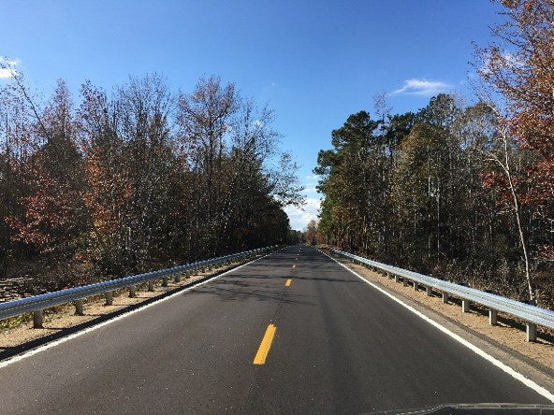**Quality Pavement Award Categories**

* SCDOT Project Category
* Quality Pavement Category   
  (non-SCDOT projects)

When nominating a SCDOT project, please include the project’s technical data that includes (if applicable) QC/QA data, SCDOT Verification Information and Rideability. Also, if the project has multiple roads in a resurfacing or rehabilitation contract, please **select a maximum of two roads** per contract to reduce time to conduct field reviews.

For all other non-SCDOT projects, project narratives and digital media are strongly encouraged to be submitted, as well as any available quality data on the project.

Please attach high resolution digital media, along with any additional lab and field data associated with the project in a USB Flash Drive, or [by web](https://www.scasphalt.org/awards).

Award submittals will be grouped by the judges once all projects are received and evaluated with the nomination form and technical data submitted. Once projects have been reviewed by the judges, some projects may be eliminated or even regrouped into additional categories based on the number and types of submittals for sustainable and innovative projects, and project delivery, etc. Projects are usually grouped based on the type of work required (existing conditions) to complete the project, rural or urban roadways, traffic counts including truck traffic, and overall project difficulty.

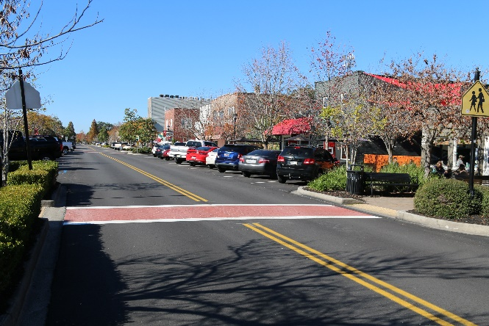A new section was added this year to the narrative section to show any additional accommodations that your project should be recognized with your SCAPA QPA. Please include any additional information in your narrative to showcase your project for further consideration of these commendations.

**Judging**

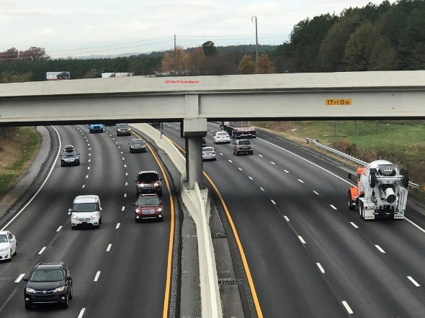

All nominations are reviewed and rated by the panel of judges from organizations such as SCDOT, FHWA, APWA, ACEC, or state educational institutions, which typically narrow the entries down to the top projects with the best technical data. If a project has no technical data available or has some very limited technical QC/QA issues, projects can still be judged.

The top-rated finalists will then be visited for field evaluation, which will look at overall appearance, smoothness, uniform texture, joint construction, etc. The judges will utilize the SCAPA Awards Field Evaluation Rating Guide to assign a score.

The panel will select the projects to be awarded a Quality Pavement Award based on the supplied technical data and appearance of the finished project for nominations in the SCDOT Projects category.

For nominations in the Quality Pavement (non-SCDOT) category, projects will be awarded a Quality Pavement Award based on the supplied technical data (if applicable) and the field evaluation ratings collected during site visits.

Winners will be recognized during the 2026 SCAPA Winter Conference and Trade Show and at the 2026 Partners in Quality Meetings (after being recognized).

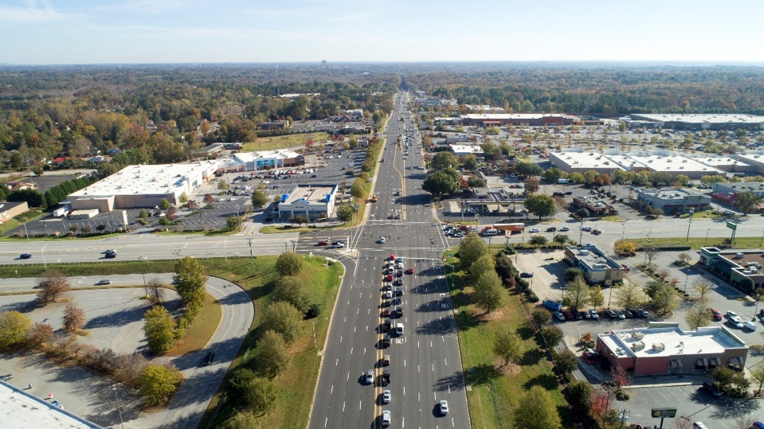

**SCAPA Quality Pavement award submittal - General Information**

1. **Project Name & Contract Title / File Number:**
2. **Project City/County:**
3. **Project Completion Date:**
4. **Total Tons of Asphalt Used:**
5. **Project Location* (street, highway, project limits, mile post, etc.):**

*\* If contract has multiple roads, select a maximum of two for field evaluation*

|  |  |  |  |  |  |
| --- | --- | --- | --- | --- | --- |
|  | New Construction |  | Overlay |  | Widening |
|  | Mill & Overlay |  | Parking Lot |  | Rehabilitation |
|  | Full Depth Reclamation & Overlay |  | Reconstruction |  | Airport |
|  | Racetrack |  | Trails & Paths |  | Recreational |
|  | Preventive Maintenance Thin Overlay (less than 1”) | | | | |
|  | Other (please specify): | | | | |

1. **Type of work that best describes this project. If other, please specify.**
2. **Award Category**

|  |  |
| --- | --- |
| Quality Pavement Award | |
|  | SCDOT Project Category |
|  | Quality Pavement Category (Non-SCDOT) |

1. **Project Narrative**

Provide a detailed narrative of your project (including, but not limited to, pre-existing roadway condition, project dimensions, traffic volume, use of partnering, scheduling challenges, night paving, key subcontractors, etc.). Include any unique commendations that your project deserves special recognition for in your award (check any or all boxes that apply to your project). *Specific mix type and tonnage information will be collected and reported on the technical data worksheet.*

|  |  |
| --- | --- |
| **Commendations (Must Be Mentioned In Narrative)** | |
|  | Project Delivery |
|  | Smoothness |
|  | Versatile Use of Asphalt / Innovative Pavement Design |
|  | Sustainable Practices |
|  | Safety |

**Project Delivery** - The project deserves special recognition for completing ahead of schedule, constructed with minimal traffic delay, minimal construction congestion, and where the owner/agency and surrounding businesses/homeowners were extremely pleased with the expedited delivery of the project. Submit documentation such as but not limited to: Press: Newspaper/Website Articles or Editorials, Letters from owners, agencies, surrounding businesses, elected officials, and project schedule documentation.

**Smoothness** – Rideability values tested by the SCDOT, your organization, or even by the seat of your pants as smooth! The road showed a vast improvement from a newly constructed asphalt surface or overlay that exhibited exceptional smoothness that should be recognized as exceptional.

**Versatile Use of Asphalt (or Innovative Pavement Design)** – The project demonstrated a unique or versatile use for an asphalt pavement and deserves recognition. A project may also incorporate an innovative design concept that showcases asphalt as a product of choice.

**Sustainable** **Practices** - Not limited to in-place recycling, reclaimed asphalt pavement, recycled asphalt shingles, warm mix, ground tire rubber, porous pavement, or other environmentally friendly practices. NAPA Emerald Green Diamond or Energy Star Certified compliance may also be recognized to reduce carbon emissions and provide an asphalt product with a lower than national average GHG, typically found on an Environmental Product Declaration (EPD).

**Safety** – Road prior to construction was a known contributor to traffic congestion and experienced an unusual number of accidents. Construction of a new asphalt pavement dramatically improved traffic flow and made the road much safer and more efficient for the citizens of SC.

**Narrative:**

Type text here

**Project Map (include a general map or strip map of the location of the project)**

**PHOTO RELEASE**

This Photo Release (the “***Agreement***”) is made effective as of ________________, 2025, by and between the South Carolina Asphalt Pavement Association, Inc., a South Carolina non-profit corporation (“***SCAPA***”), and _________________________ (“***Licensor***”).

**RECITALS:**

WHEREAS, subject to the terms and conditions as described herein, SCAPA desires to obtain, and Licensor is willing to grant, a license for rights to use any and all photographs and other images furnished by Licensor to SCAPA, in whatever format (collectively, the “***Materials***”), for marketing, advertising, publicity, business trade or art purposes, or for any other legal purpose, in any and all media outlets (e.g., TV, radio, newspaper, Internet, social media, etc.).

NOW, THEREFORE, in consideration of the foregoing premises and other good and valuable consideration, the receipt and sufficiency of which are hereby acknowledged, the parties hereby agree as follows:

1. Grant of License. Subject to the terms and conditions set forth in this Agreement, Licensor hereby grants to SCAPA and all others acting with its permission (collectively, the “***Licensee***”)an unlimited, perpetual, irrevocable, paid in full, royalty-free, universe-wide license to use the Materials for marketing, advertising, business trade or art purposes, for any other legal purpose of SCAPA, in and through any and all media outlets, including, without limitation, TV, radio, newspaper, Internet, and social media. Any use or distribution of the Materials shall be given credit to Licensor as the source of the Materials.

2. Indemnity. Licensor shall indemnify and hold harmless, Licensee and its respective affiliates, subsidiaries, representatives, employees, directors, officers and agents (collectively, the “***Indemnified Parties***”) from and against any third party loss, liability, claim, damage, expenses (including reasonable attorneys’ fees) incurred by any Indemnified Party as a result of a third-party claim arising, directly or indirectly, from or in connection with the Materials infringing the intellectual property rights of any third party.

3. Limitation of Liability. WITH THE EXCEPTION OF THE INDEMNITY OBLIGATION SET FORTH HEREIN, IN NO EVENT SHALL EITHER PARTY BE LIABLE TO THE OTHER PARTY UNDER ANY THEORY OF LIABILILTY FOR ANY DIRECT, INDIRECT, INCIDENTAL, SPECIAL, PUNITIVE OR CONSEQUENTIAL DAMAGES OF ANY KIND, EVEN IF ONE PARTY OR ANY OTHER PERSON HAS BEEN ADVISED OR SHOULD KNOW OF THE POSSIBILITY OF SUCH DAMAGES.

4. Miscellaneous. The above-stated recitals are true and correct and incorporated herein. This Agreement constitutes the entire agreement between the parties with respect to the subject matter hereof and supersedes all prior oral or written agreements between the parties with respect to such subject matter. The headings used in this Agreement are used for convenience only and are not to be considered in construing or interpreting this Agreement. The terms of this Agreement shall apply to, be binding upon and inure to the benefit of the parties hereto and their respective successors and assigns. In case any provision of this Agreement shall be invalid, illegal, or unenforceable, it shall to the extent practicable, be modified to make it valid, legal and enforceable and to retain as nearly as practicable the intent of the parties, and the validity, legality and enforceability of the remaining provisions shall not in any way be affected or impaired thereby. This Agreement may be executed by facsimile or electronic mail. No amendment of any provision of this Agreement shall be valid unless the amendment is in writing and signed by both parties. No waiver of any provision of this Agreement shall be valid unless the waiver is in writing and signed by the waiving party. No waiver by either party of any breach of this Agreement shall be deemed to extend to any other breach hereunder or affect in any way any rights arising by virtue of any other such occurrence.

The parties have caused this Agreement to be effective as of the Effective Date. This Agreement may be executed in two or more counterparts, each of which shall be deemed an original, but all of which together shall constitute one and the same instrument.

**SOUTH CAROLINA ASPHALT PAVEMENT ASSOCIATION**

By:

Name:

Title:

**LICENSOR:**

By:

Name:

Title: