**Zone 4 Residential 2012 Energy Code Requirements – Chapter 11 (3/16/2012)**

**Quick view of general requirements others may apply, please review chapter 11**

**Thermal envelope**

**(N1102.2.12) Framed cavity walls** shall have insulation free from ***gaps, voids or compression*** and enclosed on all sides **(all walls must be encapsulated)** per appendix E-2.3 at:

* Tubs, showers, stairs, fireplace units, etc… with rigid or air barrier material

**(N1102.4)** **Durably sealed to limit infiltration**

Where the following are present all homes shall be sealed with: caulk, gasketed, weatherstripped, or air barrier/solid material

1. Blocking and sealing floor/ceiling systems and under knee walls open to unconditioned or exterior space.
2. Capping and sealing shafts or chases, including flue shafts.
3. Capping and sealing soffit or dropped ceiling areas.

**(N1102.4.2) Air sealing** has ***2 options*** available either self certification or blower door testing.

**1*-Self certify per checklist in appendix E-1, table N1102.4.2 includes*:**

* Top plate to ceiling or wall drywall
* Top plate penetrations
* Sill plate sealed w/caulk or gaskets
* Window/door jamb perimeter seal
* Air barrier at any exposed edge at floors
* Penetrations through thermal barrier like electrical, plumbing, security, etc…
* Air barrier above garage ceiling at separation line
* Duct boots sealed to subfloor or drywall
* Recessed lights IC and sealed

***2-Blower door test per N1102.4.2.2 (fill out certificate listed in N1101.9) equal to or less than one of two performance measurements:***

1. 0.30 CFM50/Square foot of surface area (SFSA)
2. 5 air changes per hour (ACH50)

**Compliance by one of the following N1101.2**

* Chapter 11 of the NC residential Code
* NC Energy Code
* Rescheck for NC

**R-38 Attic**

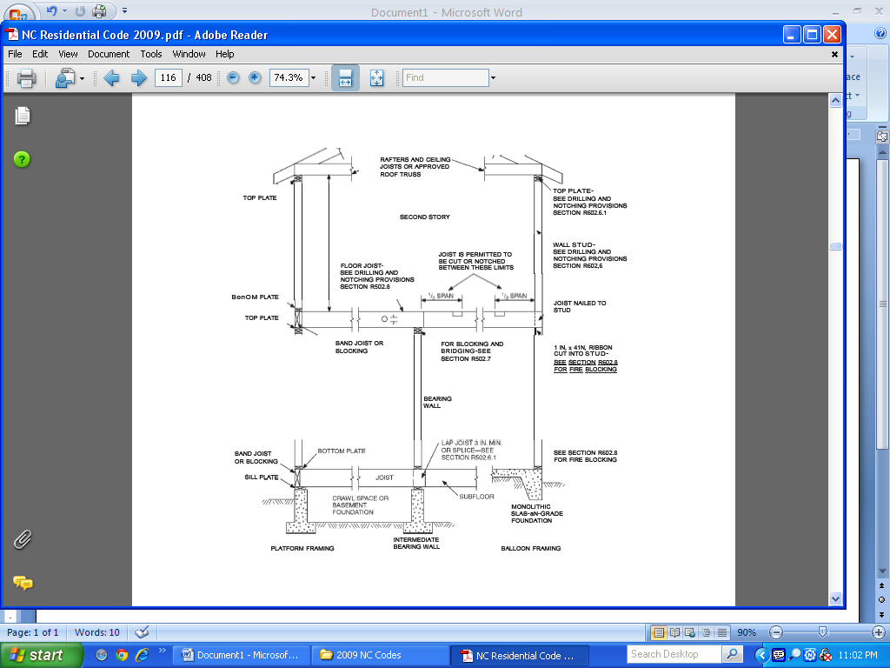

**Basement walls N1102.2.7** Bsmt. walls enclosing conditioned spaces have to be insulated to at least **10’** below grade.

**Site built Fireplaces N1102.4.3** required to have doors to seal firebox, and also comply w/ R100.6

Pull down stairs **R-5** and weatherstripped or

horizontal attic

accesses **R-10 (scuttle holes)**

**Fenestration openings**

-U factor= 0.35 / skylight = 0.60 NFRC100

-SHGC= 0.30 per NFRC200

-Exceptions - 15 square ft from U factor

**(doors/windows combined)**

-1 opaque door exempt from U factor

**Supply & return in unconditioned= R-8, R-4 in semi-conditioned space, in conditioned space= R-0**

**Identification N1101.4**  R-value manufacturer’s label if over 12” wide, loose must have depth markers every 300 sq ft in attic with 1” numbers, foam per installer’s certification

**Fenestration air leakage N1102.4.4**

0.3 CFM per sq ft for windows, skylights & sliding patio doors. For side hinged doors 0.5CFM per sq ft tested per NFRC400 or AAMA/WDMA/CSA and listed/labeled by Mfg.

**Change in space conditioning N1101.2.2** Areas previously not conditioned must meet **all** the requirements of the new code.

**Existing buildings**-**N1101.2 & N1101.3** (additions, alterations, renovations or repairs) Must meet the new code requirements for new work.

Slab insulation **R-10** (none required)

**1 thermostat per each system with at least 1 programmable on forced air systems**

Basement insulation **R-5** on exterior or

**R-10** for masonry/concrete Walls

(Framed cavities **R-13**)

Vertical small attic accesses openings= **R-5**

Full size doors= **R-2.86** or **U-0.35** all require weatherstripping

**R-15 Walls**

Crawl space floor **R-19** Floor

**R-15 Walls**

**Sunroom (Thermally isolated conditioned) N1102.2.11**- R-19 in ceiling, R-13 walls, R-30 floors. Fenestration U factor of 0.40, skylight U= 0.75, SHGC all glazing of 0.40

**Energy certificate N1101.9**-Has been expanded and is required to be posted by installer or certified personnel in the attic.

**Opaque door N1102.3.4** Required to be U=0.35 with 1 side hinge door being exempt

**N1102.2.6 Floor insulation N1102.2.6** Shall be in contact with subfloor with support wires every 18” and no more than 6” from ends (except garages and cantilevers where band is fully insulated)

**Insulation inspections required *(process)***

1. Chases, pipes, electrical wiring and other penetrations must be sealed at frame inspection along with blocking/air barriers as needed for viewing.
2. Wall insulation checked prior to sheetrock, **(optional energy inspection trip for encapsulated areas available at builder’s request).**
3. Final inspection N1101.9 certificate posted, installers certificate posted, self certification air leakage posted or N1101.9 certificate filled out on **blower door** testing.

**Inspections on energy efficiency**

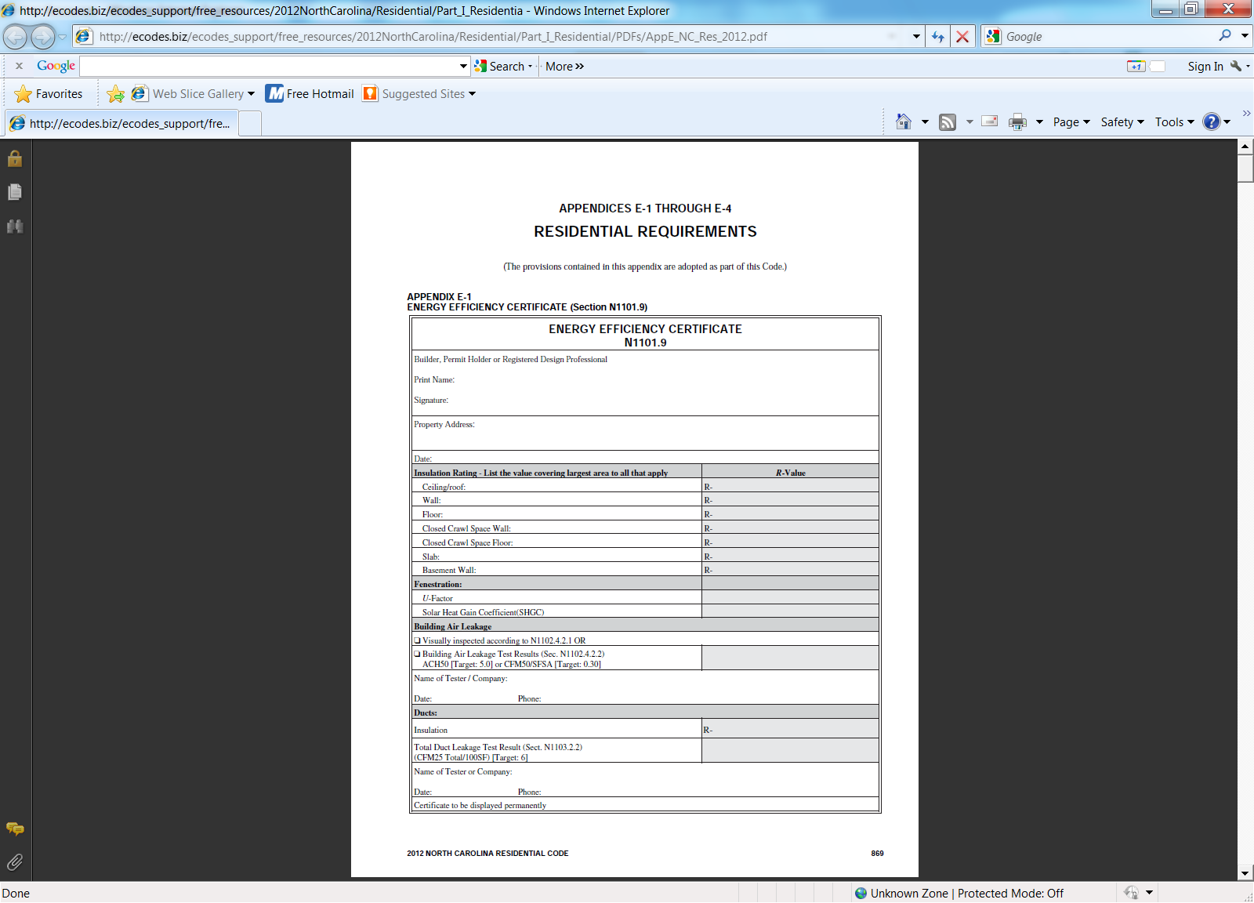

**Recessed lighting N1102.4.5**  Shall be ***sealed*** to limit air leakage, all IC rated and labeled as meeting **ASTM E 283**. Must be sealed (gasket/caulk) between the housing and ceiling/wall covering

**N1103 Systems N1103**

1. **One** Programmable thermostat
2. Heat strip lockout
3. Provide maintenance info
4. **Ducts= R-8 unconditioned**, R-4 semi-conditioned, R-0 interior
5. Ducts, air handler, filter boxes & bldg cavities used as ducts sealed per 603.9 (Mechanical code)
6. **Exceptions from testing**-ducts inside the thermal envelope and partial system installation, replacement, renovation or additions
7. Mechanical system **piping** above 105 degree needs R-3 insulation
8. **Exhaust vents** shall have automatic or gravity dampers
9. **Pools**- on/off switch for heaters, timers switches required, covers required on heated pools

**Energy efficiency certificate (N1101.9)** Must be posted at final inspection in the attic beside installers certificate, kitchen cabinet or other approved location and will contain information on thermal envelope, fenestration used, air leakage testing ***(2 options)*** and duct leak testing performed. Builder, permit holder, designer or contractor completes certificate

**Builder/contractor completes*- Options***

Building air leakage requires **1 of 2** options

1. Visual certification as referenced or
2. a blower door test is performed and tester information is listed

**Lighting equipment N1104.1**  75% of lamps in permanent fixtures shall be high-efficiency lamps **(lamps installed at final inspection)**

**Detailed illustrations on blocking, sealing and air barrier requirements can be found in Appendix E**

**Duct leak test** –***Required*** per **N1103.2.2**

* 6 step test procedure listed
* Performed by permit holder, NC licensed GC, NC licensed Home Inspector, registered Design Professional, Certified BPI envelope professional, HERS rater
* List on certificate N1101.9
* Optional worksheets in appendix E-3C for contractor usage

**(Ducts must be less than or equal to 6cfm per 100ft2 tested at differential of 0.1 inches w. g. (26 Pa) across entire system)**