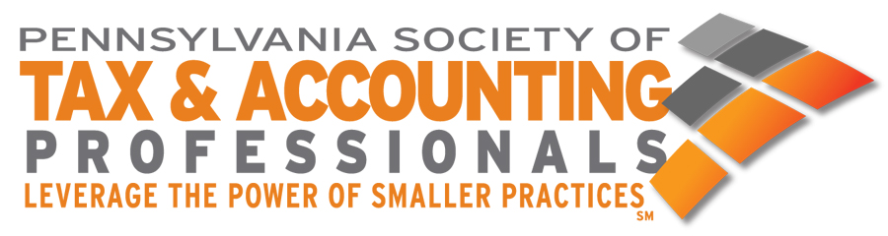

BUXMONT CHAPTER

**PRESIDENT’S REPORT**

**STATE BOARD OF DIRECTOR’S MEETING**

**June 10, 2024**

On behalf of the BuxMont Chapter, I am pleased to present our recent and upcoming events and activities:

**RECENT EVENTS – ALL WEBINARS:**

June 21 Surgent Estate and Life Planning Issues for the Middle Income Client

June 25 Social Media/Marketing in the Digital Age

September 24 Understanding the Multi-Generational Workforce

# September 20 Blockchain, Acct. Expert Witness, Comp/Review/Prep. Update

October Proposed Joint Morning Meeting – BOI, SECURE 2.0

October 22 Employment Law Seminar and Update

October 29 Jennings Business Tax Update

November Ethics

December 4-5 Jennings 1040

December 17 Tune-Up for Tax Season, Board Meeting and holiday celebration.

January 16, 2025 NJ/PA/IRS Update

January 21, 2025 Philadelphia and Local Taxes

Our educational seminars have gone back to in person at the Radisson in Trevose. Attendance is lower than in the past. We are continuing to offer hybrid virtual/n-person for our chapter meetings. Our board meetings are also a hybrid. A Proposal has been made to the Philadelphia Chapter to do a Joint morning meeting October with a live presentation of BOI and SECURE 2.0 and might have a potpourri of other current tax topics.

We now have a Second Vice President, David LaRosa

We wish everyone best of luck in getting through the summer.

Respectfully submitted,

*George Bancroft, Jr., CPA* Buxmont Chapter President