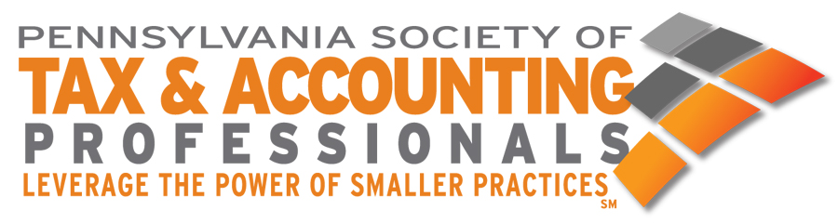
Executive Director’s Report
77th Annual Meeting - June 9-12, 2024
The Grand Hotel – Cape May, New Jersey

Submitted By: Sherry L. DeAgostino, Executive Director

2023-2024 Highlights

Membership & Benefits
- Comparative Report – student membership application change;
- Issued approximately 280 Starbucks cards for 5, 10, 15 and 20 year memberships;
- Novi - Association Management Software/Website Upgrade;
- 2nd year of Verifyle – held live demos in October and December and will have an additional Demo in late June. Dana Shibley attended two 1040 seminars last year and has plans to attend again this year.

Education
- Offered more than 400 hours of CPE online & in-person;
- Free member webinar on September 29th – Cell Phone Security;
- 2024 Fall Tax Seminars;
- Seminar cancellation policy;
- Seminar Attendance Report - Updated

Advocacy
- Day at the Capitol – June 6, 2024;
- PA Department of Revenue
- Fall Tax Seminars – resolution specialists on-site;
- Continued myPATH and issue resolution support;
- Telefile – meeting/letter;
- 2024 Working Together Seminar;
- Issued letters on Repeal of Accelerated Sales Tax Payments and Salt Cap Workaround;
- Meetings with Rep. Greiner, Rep. Pisciotanno, Sen Hutchinson
- Retirement of Kathy Pape – Saxton & Stump;
- Co Sponsored Economic Forum with NFIB;
- Tax Coalition – Stakeholder Group;
- iHeart Radio Show – Maurice Brubaker, EA

