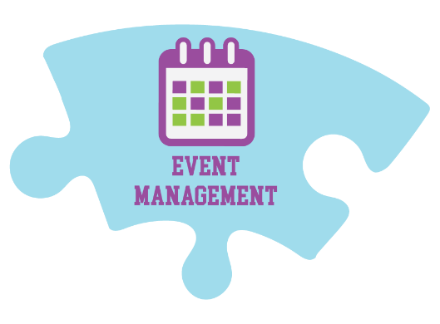
Marketing Analytics

Event Management Course
Professional Booksellers School

Marketing Channels:

- Community and Event Partners
- Press Releases & Media
- Flyers/Posters
- In-Store Displays & Handouts, including QR codes on displays
- Print Ads
- Staff & Customers
- Website
- Social Media
- Email Newsletter
- Online Event Calendars (community bulletin boards, chamber lists, media calendars, Facebook)
- Digital Ads

Where to Post Events Online:

- Your website!
- Social Media (local Facebook groups, cross promotion with other businesses, Facebook events)
- Online Directories (Google My Business, Bing Places, Facebook, Instagram, Yelp, map apps, Chamber of Commerce, Nextdoor, LinkedIn)
- Your newsletter!
- Eventbrite
- Local newspapers may have free online event listings

Lifespan of Social Media Content:

- Twitter: 24 minutes
- Facebook: 105 minutes
- Instagram: 20 hours
- TikTok: Tricky! A video usually takes minutes or within the first hour to go viral or not. The algorithm likes to push older videos.
- Threads: Not a lot of information yet, but likely similar to Twitter

Feed the Algorithm:

- Instagram: Still leaning hard into video
- Facebook: Similar to IG, but really prioritize content that makes people engage/interact
- TikTok: All about video and trending sounds
- Twitter/Threads: Short, quippy content, not overly produced

Marketing Tools:

Social Media Marketing Tools:
- Later
- Loomly
- Hootsuite
- Buffer
- Metricool

Email Marketing Tools:
- Mailchimp
- Constant Contact
- Edelweiss360
- Hubspot

Graphic Creation Tools:
- Canva
- Adobe Photoshop & InDesign
- Pixlr Express (photo editing)
- Easel
- Design Wizard
- Stencil
- Visme
- CapCut (phone app)
- InShot (phone app)

Web Analytics Tools:
- Metricool
- Google Analytics
- Hubspot
- Adobe Analytics
- Open Web Analytics

Terminology:

Pageviews: The total number of times a page was viewed on your site.

Unique Pageviews: The total number of times a page was viewed by users in a single session. A session is a group of interactions — including pageviews, clicks, etc. — that take place on your website within a given time frame.

Traffic Sources: Show where people are coming from to get to your events page. These include things like:

Organic Search: They searched Google or another search engine and found you.

Paid Search: They clicked a paid ad on a search engine.

Referrals: They clicked from another site.

Organic Social: They came to you through a regular post or your profile or link in bio on social media.

Paid Social: They clicked from a paid/boosted social media ad.

Email Marketing: They clicked from a newsletter.

Direct Traffic: They went directly to your page by typing in the URL.

Bounce Rate: The percentage of visitors that leave your website after viewing a single page. This will tell you the percentage of people who look at your event page, then leave your website.

Reach: Represents the number of unique people who saw a piece of your content.

Organic Reach: The number of unique users or followers who see and engage with your content without any paid ads.

Paid Reach: The number of unique users that viewed a post as a result of a paid/boosted ad.

Engagement: A measure of all interactions with your content.

Engagement Rate: Used to assess the average number of interactions your content gets per follower.

Impressions: The number of times your content was seen, including multiple views by the same person.

Interactions: Any form of communication between you and your users, including likes, comments, direct messages, tags, follows, reviews, and shares.

Mentions: Every post that includes a tag/reference to your account.

Profile Views: The count of the number of times your main profile page has been viewed.

Website Clicks: The number of clicks your website received from your social media profile/posts/link in bio.

