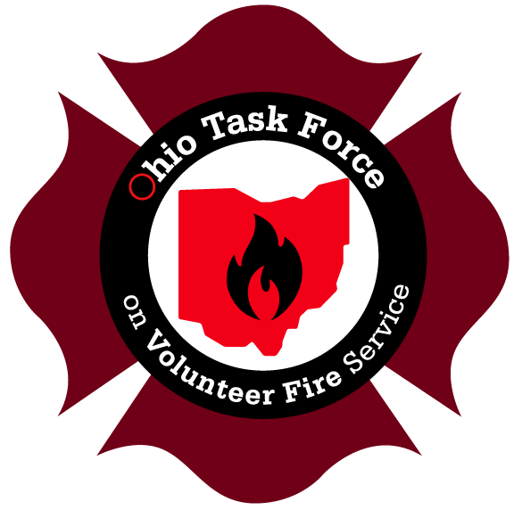

WHAT IS THE IMPACT OF SOME OF THE CHALLENGES AND OBSTACLES THAT EXIST WITHIN THE OHIO VOLUNTEER FIRE SERVICE?

The following comments were provided by volunteer fire department Chiefs. Specific identities have not been provided to protect the privacy of the individual and the specific fire department.

- July 2021- We had an attached garage fire. Several automatic and mutual aid departments couldn't respond. Those that did only had one driver in a tanker and no firefighters. We had at a minimum of 8 fire departments there just to have enough people to extinguish the fire with no relief or opportunity for rehab or safety lines. We lost a 3000 sq ft house as a result. If there would have been a rescue needed, we wouldn't have been able to perform it.

- Manpower is the big one. We had a fire alarm call at a residence. I was home with my two-year-old son. No one else was responding, so I responded with my POV bringing my son. A local paramedic sat in my car with my son so I could handle the fire alarm. Ended up being a false alarm but again it could have been a fire.

- Last year we had over 65 times there were no personnel to respond to dispatched emergencies. Over 75 times only one person was available to respond including at a major residential fire in a multi- family residence. Limited budget with no funds to replace apparatus that are 20+ years old, update 60+ year old fire station with basic necessities, facing increased insurance premiums for home and business owners due to the lack of available volunteers and staffing personnel.

- In northwest Ohio there is a small town about 20 miles southeast of Toledo serving a population of less than 500 Ohioans. The Volunteer Fire Department there was struggling to find volunteers, struggling to complete timely incident reports and struggling to maintain their equipment and facilities. The small but dwindling group were unable to muster community support to pass a levy to sustain its operation. Therefore, the department founded in 1896, was forced to close its doors, auction off its equipment and cease protecting its service area leaving the vulnerable population without a defense to dire emergencies. The citizens of this small town must now rely on neighboring Portage Fire District for protection, but those response times are much, much longer.

- This example is a typical response for all of southern Perry County. It may take several departments to respond in order to get enough people and equipment to manage the emergency. No department can afford to purchase all of the necessary equipment needed to handle emergencies from automobile crashes, fires and hazmat incidents. What equipment we have on hand has been purchased piecemeal from state and federal grants on a one-time basis or purchased from donations and fundraisers.

- We responded with one firefighter multiple times last year. Fortunately, the fire alarm, odor investigation or vehicle accident turned out to be minimal. One of these days we will not be so lucky.

- Short staffing (not enough people for a response)

- No funding for equipment, vehicles, or training.

