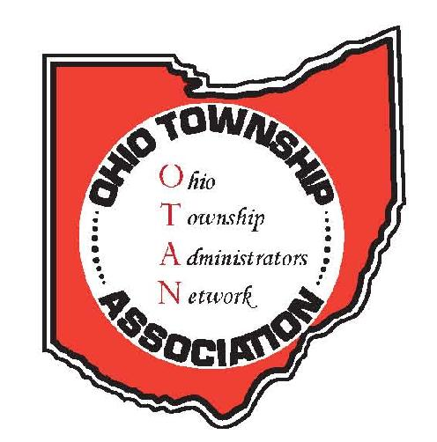

**Ohio Township Administrators Network (OTAN)**

**2023 Fall Forum**

**October 13, 2023**

**AGENDA**

8:45 a.m. Registration (*continental breakfast provided*)

9:00 a.m. Welcome

9:00 - 10:00 a.m. **Legislative Update**

*Speaker: Kyle Brooks, Director of Governmental Affairs, OTA*

10:00 - 11:00 a.m. **Not the Same Old Employment Policies….What’s “New” Out There?**

*Speaker:**David Riepenhoff, Attorney, Fishel Downey Albrecht & Riepenhoff*

11:10 a.m. - 12:00 p.m. **Value of CRAs and TIFs**

*Moderator: Rob McCarthy, Attorney, Bricker Graydon*

12:00 - 1:00 p.m. Lunch

1:00 - 2:00 p.m. **Utilizing American Red Cross at Your Next Event**

*Speaker: Cory Paul, American Red Cross*

2:00 - 3:00 p.m. **How to Survive – and Thrive – as a Township Administrator**

*Speaker: Andy Rose, Administrator, Concord Twp., Lake Co.*

3:00 p.m. Adjourn