

New Associate Onboarding Plan

Name
Title
Date

Notes:

____________________________________________________________________________________________________________________________________________________________________________________________________________________________________________________________________________________________________________________________________________________________________________________________________________________________________________________________________________________________________________________________________________________________________________________________________________________________________________________________________________________________________________________________________________________________________________________________________________________________________________________________________________________________________________________________________________________________________________________________________________________________________________________________________________________________________________________________________________________________________________________________________________________________________________________________________________________________________________

Welcome to PSA

We know joining a new team can be exciting, as well as a bit unsettling with all the unknowns. We are committed to supporting your journey, and we have brought together resources to help you quickly learn about your role, who we are, how we operate and how our employees make all the difference.

This plan will serve as your blueprint for success over the next several months. This plan is intended to help you:
- Clarify your role and the business  - Understand your short-term priorities and goals | - Build key relationships essential for your success  - Facilitate a smooth transition into the new role

There are three key components to your onboarding

- This New Employee Onboarding Plan: This plan walks you through critical activities to help you gain clarity and effectively assume your role as quickly as possible.
- e-Learning: Coming soon is the new PSA University! In the meantime, please visit these following websites to learn more about industry specific training and offerings:
  - PSA
  - ESA
  - SIA
  - NSCA
  - IPVM
  - SecurityCEU
- On-the-Job Learning: Much of what you will learn will be done while doing the work. Your manager will work with you to identify the specific information, contacts, meetings, and activities that will help you gain the knowledge and skills needed to be successful in your role.

And finally, the most critical element is YOU! Taking ownership and responsibility for this process is critical to your success. Your responsibilities include:
- Starting each day with eagerness to learn about your new role and how it contributes your organization
- Completing all tasks outlined in this plan and attending regular check-ins with your manager to ensure alignment
- Learning your role’s core functions and ask questions to understand all aspects
- Proactively building relationships with others to better understand different roles and how to best collaborate
- Reaching out to your manager and colleagues for support when uncertain about what is needed and/or how to perform critical, time sensitive tasks

Onboarding Process

There are several phases and activities that create a positive onboarding experience. The purpose of this plan is to help you and your manager to navigate the process with checkpoints along the way to ensure alignment on expectations and to identify any support needed.

The illustration below outlines the typical activities for each phase.
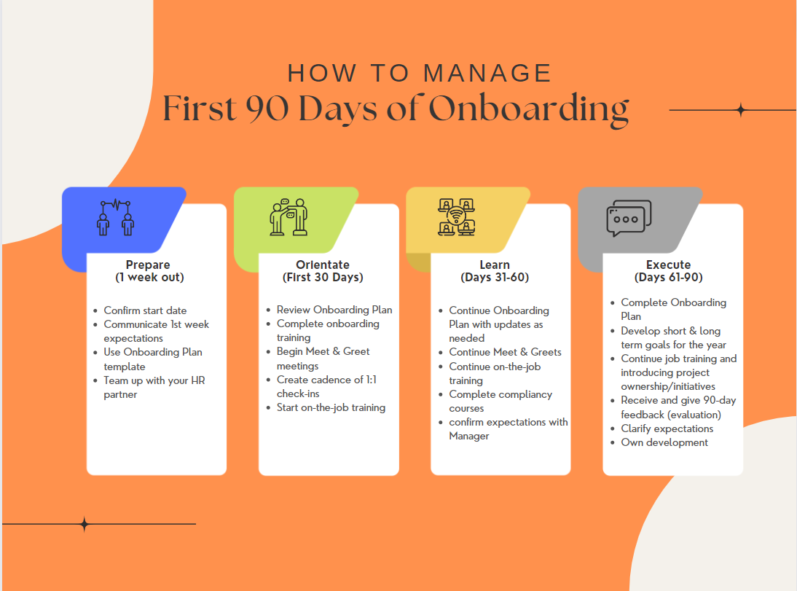

Let’s begin with what success looks like in your role

Your Role Description:

MANAGER [insert role information from job description here]

Specific Accountabilities include:

MANAGER: [insert specific job accountabilities from job description here]

Now let’s clarify your first 90-day priorities
To ensure you understand your near-term goals and deliverables, spend some time with your manager talking through your first 90 days (about 3 months). Where should you focus? How can you establish some quick wins?
Below are some suggested priorities to help you start the conversation.

Timing | Priorities | Key Actions/Deliverables
First 30 Days | EXAMPLES – to be edited by Manager and updated during process  - Obtain direction on top priorities; identify quick wins  - Clarify expectations with your manager with defined goals  - Meet with your team; understand team culture and dynamics  - Establish regular communication cadence with your manager and team  - Meet with key stakeholders, establish ongoing routines as needed  - Begin day-to-day projects/work including: | EXAMPLES – to be edited by Manager  - Complete e-learning orientation and assigned compliance and role-based training in the Learning Center  - Complete I-9 documentation, benefits enrollment, and tax information
31-60 Days | - Continue to learn business  - Continue to build relationships with key stakeholders  - Identify your learning priorities  - Day-to-day projects/work including:
61-90 Days | - Complete onboarding requirements  - Continue to learn business  - Continue to build relationships with key stakeholders  - Day-to-day projects/work including:

Questions to Consider as You Enter Your New Role:
- What are your expectations going into this new role?
- What do you feel are the priorities and challenges you should focus on first?
- Given your responsibilities, how do you anticipate allocating your time for optimal impact?
- Knowing about your new role, what strengths/experiences do you have that will help you be successful?
- Where do you think you may face challenges? What can you do to address these challenges? Who are useful resources to help you work through these challenges? Is there any additional training/education that would help you succeed in this new role?
- How will you build credibility with your new team… both in the short term and over time? What is the best way for you to learn business? What resources can you leverage?

Your Key Contacts and Meetings
Below is a listing of the team’s key contacts and meetings, along with meetings you are expected to attend regularly as part of your role. (HINT: You can add additional row by hitting the “tab” key in the last cell of the table)

Key Contacts
Name | Title | Phone | Location
Manager Name | Manager Title
Manager’s Manager | Manager’s Manager Title
 | HR Partner
 | Department Assistant
 | Office Manager

Regular/Re-occurring Meetings
Meeting Title | Purpose | Frequency | Attendees

Your Critical Partnerships
It is important to spend time with the people who will have the greatest impact on your success in your new role. Identify your key stakeholders and schedule one-on-one time with them in your first 30 days (about 4 and a half weeks) if possible. As you meet with each of them, ask their opinion on additional people you should talk with who can help you get up to speed quickly. (HINT: You can add additional row by hitting the “tab” key in the last cell of the table)

Peers
Name | Title | Phone | Location

Key Business Partnerships
Name | Title | Phone | Location

Initial Meetings
At every organization building effective business relationships is critical to success. Below is a schedule of meetings that have been set up to help you begin to build relationships, along with key points you should cover when initially meeting your peers and key stakeholders.

Key Initial Meeting Objectives
- Understand the work they lead  - Understand their business priorities and challenges  - Understand their approach and preferred partnering style | - Discuss work / projects you will work on together  - Ask where you should focus your energy in the near-term  - Agree to how often you will meet, if necessary

Contact | Title | Date | Time | Location

Training Programs /On-the-Job Training Sessions
Use the table below to schedule meetings and training sessions during your first 90 days (about 3 months).

Meeting/Training | Title | Date | Time | Location

