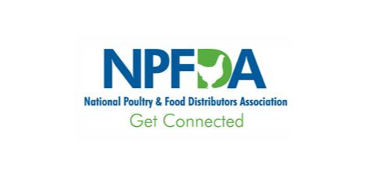

NPFDA Antitrust Compliance Policies and Procedures

It shall be the policy of NPFDA to be in strict compliance with all Federal and State Antitrust laws, rules and regulations. Therefore:
- These policies and procedures apply to all membership, board, committee and other meetings of the Association, and all meetings attended by representatives of the Association.
- Discussions of prices or price levels is prohibited. In addition, no discussion is permitted of any elements of a company’s operations which might influence price such as:
  - Cost of operations, supplies, labor or services;
  - Allowance for discounts;
  - Terms of sale including credit arrangements; and,
  - Profit margins and mark ups, provided this limitation shall not extend to discussions of methods of operation, maintenance, and similar matters in which cost or efficiency is merely incidental.

- It is a violation of Antitrust laws to agree not to compete, therefore, discussions of division of territories or customers or limitations on the nature of business carried on or products sold are not permitted.
- Boycotts in any form are unlawful. Discussion relating to boycotts is prohibited, including discussions about blacklisting or unfavorable reports about particular companies including their financial situation.
- It is NPFDA’s policy that all meetings attended by representatives of NPFDA where discussion can border on an area of antitrust sensitivity, NPFDA’s representative request that the discussion be stopped and ask that the request be made a part of the minutes of the meeting being attended. If others continue such discussion, NPFDA’s representative should excuse himself from the meeting and request that the minutes show that he left the meeting at that point and why he left. Any such instances should be reported immediately to the Chair and staff of NPFDA.
- It is NPFDA’s policy that a copy of these Antitrust Compliance Policies and Procedures be given to each officer and director.

