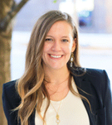
MODERATOR
Morgan Daniels
CEO at Continuum Consulting
Morgan brings consulting experience across public health, biotech startups, and cross-sector life sciences organizations, along with a master’s degree in organizational development from American University. Her work focuses on supporting organizations and leaders to understand—and intentionally lead—the people side of change.

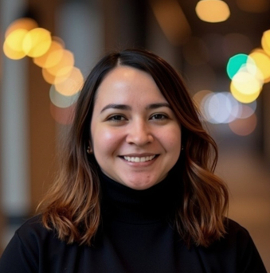
Paola Adame
Senior Manager of Business Operations for Global Hospital & Biosimilars at Pfizer
Based in North Carolina, Paola Adame has been at Pfizer over 8 years in a variety of roles both site-based and in a global capacity. Throughout her career, she has been passionate about building connections, fostering inclusive workplaces, and supporting meaningful growth. With a background spanning communications, community engagement, workforce development and business operations, Paola believes that mental health is a critical part of personal well-being, leadership effectiveness and organizational success. She is passionate about creating environments where people feel supported, valued and empowered to bring their whole selves to work.

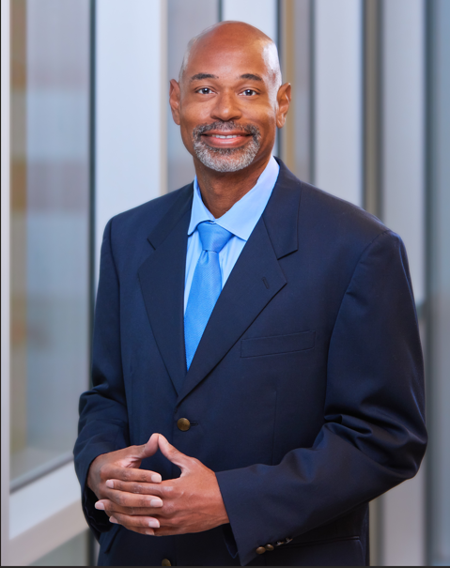
Drew Duncan
Global Human Resources Lead at Biogen
Drew Duncan serves as Global Human Resources Lead for Biogen’s Global Manufacturing & Technical Operations organization, based in RTP, North Carolina. In this role, he provides strategic HR leadership for a workforce of more than 1,200 employees across the United States, Ireland, and Switzerland. Drew brings over 30 years of human resources experience spanning retail, staffing, consumer packaged goods, pharmaceuticals, and biotechnology. He holds a BA in Industrial Relations from the University of North Carolina at Chapel Hill, an MS in Leadership and Organizational Change from Pfeiffer University, and a Master’s in Human Resources from Cornell University. He also serves on the Board of Directors for the Food Bank of Central & Eastern North Carolina.

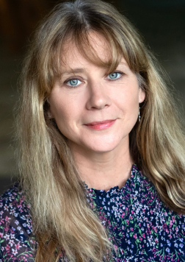
Julie Wells
Strategic Relationships Director at Give an Hour
Julie has spent over 32 years in the non-profit sector working on community-based issues, centering marginalized populations and access to opportunities as the focal point of her impact. In 2023, she joined the Give an Hour, a national mental health non-profit, as the Director of Strategic Relationships and spends most of her time now on the road- traveling the country upskilling individuals ranging from members of the military, members of the rare disease community and survivors of crimes. She has a special connection to the rare community through her own experience with a rare genetic heart condition which also impacts her sister, her nieces and nephew. She is also a caregiver to her partner and a peers support facilitator for other caregivers and rare organizational leaders.

