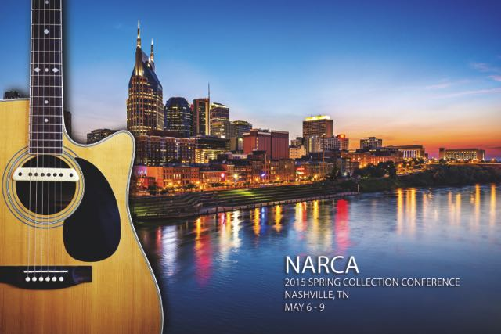
NARCA Announces Early Registration and Agenda for 2015 Spring Collection Conference in Nashville

The National Association of Retail Collection Attorneys (NARCA) has announced that early registration for the NARCA 2015 Spring Collection Conference in Nashville, May 6-9, is now available through March 25th. Early registration provides a discounted rate for NARCA members, non-members, credit grantors and clients.

The agenda for the conference will focus on the important topics currently impacting the legal debt collection industry including meaningful attorney involvement, compliance with FDCPA regulations, statute of limitations and more. “NARCA conferences are extremely popular because we are the only national trade association qualified and dedicated to providing comprehensive education and practical information to debt collection attorneys,” said Mark Dobosz, NARCA Executive Director.

Topics on the spring agenda include:

The Ethics of Delegation - How Much is Too Much?
- Don Maurice of Maurice & Needleman, Tomio Narita of Simmonds & Narita and Manuel Newburger of Barron & Newburger will discuss the ethical limits on delegation of tasks (meaningful attorney involvement) to non-attorney support staff. Topics include signing pleadings and correspondence, e-filing pleadings, covering docket calls, preparing and serving documents in the attorney's name, and use and supervision of appearance counsel.
NARCA Defense Bar Education Session - Effectively Handling Counterclaims
- John Bedard of the Bedard Law Group and Ronald S. Canter of The Law Offices of Ronald S. Canter will host a discussion on collection law firm's procedures and response to counterclaims that includes client review and response, dealing with the client on a counterclaim, dealing with the client's outside counsel and more.
Constructing Policies, Procedures and Work Instruction for Resource-Challenged Firms
- Jeff Pichotta of Guglielmo & Associates, Jessie Skibbe of Kirkpatrick Price and Brit J. Suttell of Burton Neil & Associates will provide real world guidance to fully integrate well-written documentation into a law firm’s workflow. This real-world advice will help firms develop templates and project plans that will assist in keeping them out of harms way.

Determining Statute of Limitations: There is no "Easy Button"
- The CFPB, FTC, consumer advocates, and even some courts believe that determining statute of limitations (SOL) is as simple as pressing an "easy" button. Nothing could be further from the truth. NARCA President Joann Needleman of Maurice & Needleman, Alane Becket of Becket & Lee, and Barbara A. Sinsley of Hudson Cook will explore all the necessary elements needed to in order to make an informed and appropriate decision about the proper SOL, and will discuss recent cases and laws addressing this challenging issue.

The NARCA 2015 Spring Collection Conference will be held at the Omni Nashville hotel, one of the city’s most popular and luxurious destinations. Limited exhibitor and sponsorship opportunities are still available. For more information on the NARCA 2015 Spring Collection Conference, contact NARCA at 202-861-0706 or email Conferences@narca.org.

