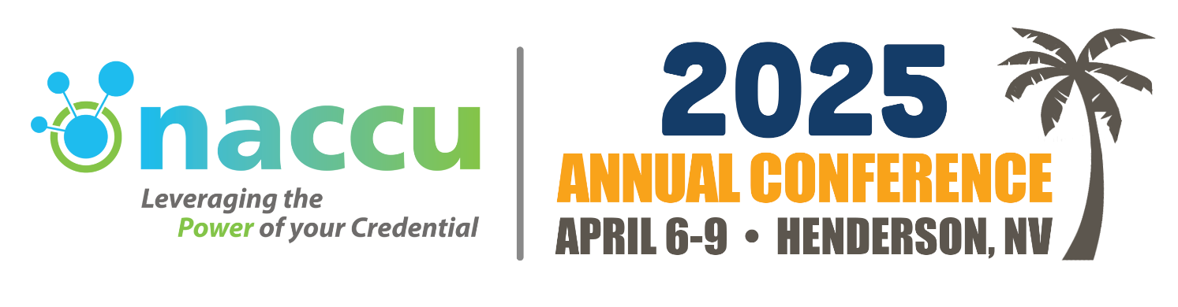
Dear ________,
I am excited to experience the ultimate event for campus card programs in higher education – the NACCU 2025 Annual Conference! This is the only conference of its kind that brings together industry professionals to explore cutting-edge technologies, streamlining procedures, compliance with regulations and standards, and trends in the campus card industry. I am thrilled for the opportunity to be part of this game-changing event, and I strongly believe that my participation is critical to bringing new ideas and approaches to our institution's card services.
NACCU 2024 is set to take place from April 6-9, 2025, in Henderson, Nevada. With over 500 attendees from around the world, this conference offers unparalleled opportunities for networking, education, and professional development. By connecting with my peers from different institutions and corporate industry leaders in the exhibit hall, I will gain valuable insights and solutions that will have a positive impact on our campus.
By attending sessions on the latest industry trends, technological advancements, and best practices, I will sharpen my skills and bring back new strategies and ideas to improve our campus card program.
The total projected cost for my attendance is as follows:
Registration Fee: $__________
Airfare: $__________
Ground Transportation: $__________
Hotel: $__________
Meals: $__________
* Breakfast and lunch on Monday, Tuesday, and Wednesday are included in the registration fee.
This investment will pay off with improved efficiency, proven solutions, fresh insights and ideas, and an expanded network of peers to keep the card program moving forward. Upon my return, I will provide a comprehensive summary of key takeaways and recommended actions.
I ask you to approve my attendance at NACCU 2025 - this is an opportunity too good to miss! Thank you for considering my request.
Sincerely,

