


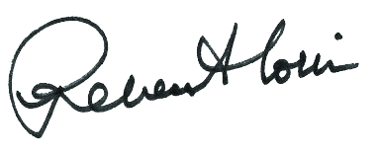
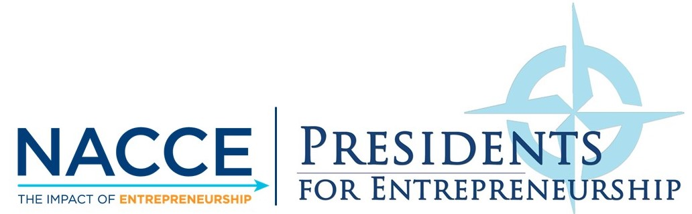
______________________
JEE HANG LEE
President & CEO
ACCT
______________________
SIGNEE NAME
Title
Institution
______________________
DR. REBECCA CORBIN
President & CEO
NACCE
______________________
DR. STEVEN SCHULZ
President
North Iowa Area
Community College
Presidents for Entrepreneurship Pledge
This certifies that
NAME
has committed as a partner with the
National Association for Community College Entrepreneurship (NACCE) to encourage economic growth through entrepreneurship

