NACCE Experts
Training, Coaching, Department Audits, and Ecosystem Building
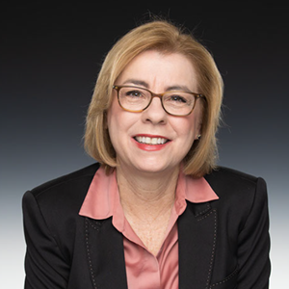
Dr. Rebecca Corbin
Dr. Rebecca Corbin has served as President & CEO of the National Association for Community College Entrepreneurship (NACCE) since 2015. A former Vice President of Institutional Advancement at Rowan College at Burlington County, she is a nationally recognized expert in entrepreneurial mindset, leadership development, and innovation in higher education. Under her leadership, NACCE has launched transformative initiatives that support faculty, college presidents, and ecosystem partners nationwide.
Dr. Corbin is available through NACCE to provide consulting services in entrepreneurial leadership, workforce development, higher education policy, fundraising strategy, book writing and publishing, and keynote speaking. She has delivered commencement addresses and spoken internationally at conferences in China and Switzerland. In recognition of her advocacy, she has testified before the United States Congress on entrepreneurship as a driver of economic development. In 2023, she negotiated the acquisition of the SkillPointe technology platform, as a charitable donation valued at over $6 million. In her tenure, NACCE has regranted over $40 million in subawards to its members.
An engaging speaker and facilitator, Dr. Corbin leads dynamic workshops tailored to educators, business leaders, and philanthropists, helping them activate innovation and amplify impact. She is the author of two books, host of the Forward with NACCE podcast, and a frequent contributor to national conversations on workforce and education. Dr. Corbin also serves on numerous boards and advisory committees, including her as Chair of the Cary Chamber of Commerce. Dr. Corbin has received numerous awards for her leadership and business savvy from Wilmington University, the Triangle Business Journal, and Global MindED.

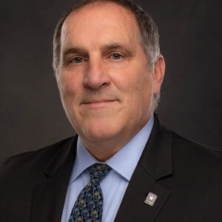
Dr. Trenton Hightower
Dr. Trenton Hightower is the Executive Director of Membership and Workforce Development at the National Association for Community College Entrepreneurship (NACCE). An Army veteran with over 25 years of experience in senior leadership roles at community colleges, he is a nationally respected expert in workforce education and continuing education. Dr. Hightower brings a mission-driven approach to his work, rooted in service, innovation, and a deep commitment to expanding access to economic opportunity.
Dr. Hightower is available through NACCE to provide consulting services in workforce development, leadership training, team building, and veteran engagement strategies. He is the author of Field Trip 101: An Approach to Team Building, a practical guide that emphasizes experiential learning to strengthen team dynamics and organizational effectiveness. A sought-after speaker and facilitator, he delivers impactful workshops and presentations tailored to educators, workforce professionals, and employers nationwide.
He serves as a board member of the National Council for Continuing Education and Training (NCCET) and as an advisory committee member of the SMART USA Workforce Committee, where he contributes to shaping national strategies to address workforce gaps in advanced manufacturing and technology. Dr. Hightower’s work continues to inspire scalable, workforce-driven solutions that support economic mobility and community growth.


Dr. Darcie Tumey
Dr. Darcie L. Tumey serves as Director of Events & Programs at the National Association for Community College Entrepreneurship (NACCE), bringing more than two decades of experience in education, entrepreneurship, and workforce development. Her career began at the University of North Carolina at Chapel Hill in the Undergraduate Library and continued with the NC State Employees’ Credit Union and the UNC School of Medicine. These early roles sparked a passion for systems-thinking and student-centered service, which she later brought to her work in the North Carolina Community College System.
Dr. Tumey has held both faculty and administrative roles, with a strong focus on business and entrepreneurship education. She has led Small Business Center initiatives, organized pitch competitions, co-advised NACCE’s Everyday Entrepreneur Venture Fund, and co-organized Catawba Valley Community College’s annual Business Symposium. A two-time national gold medal-winning SkillsUSA Entrepreneurship team coach, she has also served as an HP LIFE Ambassador, supporting entrepreneurial learning through digital tools.
Through NACCE, Dr. Tumey provides consulting on entrepreneurial program development, business competition planning, student engagement strategies, and event design. Known for her collaborative leadership and creative execution, she is passionate about helping students and educators transform ideas into real-world impact. Her work continues to inspire innovation and build entrepreneurial ecosystems across the country.


Suzanne Kart
Suzanne Kart serves as Director of Marketing at the National Association for Community College Entrepreneurship (NACCE), where she leads national brand strategy and digital engagement efforts to amplify NACCE’s mission of transforming communities through entrepreneurship and education. With more than 18 years of experience in marketing and communications, she brings deep expertise in digital advertising, inbound marketing, branding, social media, and content strategy.
Suzanne is available through NACCE to provide consulting and training in strategic marketing, digital campaigns, brand storytelling, and audience engagement. She is a frequent presenter at national and international conferences, where she shares best practices and emerging trends in marketing for education and nonprofits. A published writer and podcast host, she has contributed numerous articles and blogs focused on creating meaningful connections between organizations and their audiences.
A creative strategist and results-driven leader, Suzanne has developed and executed successful marketing campaigns across sectors including education, healthcare, and recreation. She is passionate about building brand experiences that resonate and drive action. Through her work at NACCE, she helps institutions and partners communicate their impact, grow their reach, and strengthen their voice in the entrepreneurship and education ecosystem.

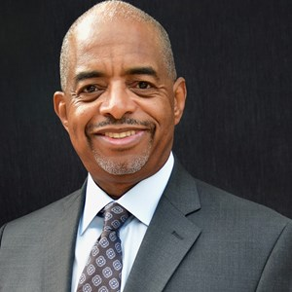
Vince Murphy
Vincent A. Murphy is a retired business executive with more than 30 years of leadership experience across multiple industries, followed by a successful consulting career supporting both for-profit and nonprofit enterprises. He most recently served as Chairman of the Norwalk Community College Foundation Board of Directors and as Interim President and CEO of the Foundation’s operating company.
Mr. Murphy is deeply engaged in advancing entrepreneurship within higher education. He has contributed to the development of innovative business creation programs across a network of community colleges and has provided strategic support for seed-funding ventures that empower student entrepreneurs. He served on the Advisory Council for Connecticut’s “CTNext” public-private startup initiative and continues to advocate for entrepreneurship as a catalyst for economic and social mobility.
Through NACCE, Mr. Murphy provides expertise in nonprofit governance, entrepreneurship education strategy, and foundation leadership. He is also active in philanthropy, supporting cultural organizations in both Connecticut and Florida.
A lifelong learner and storyteller, Vince enjoys reading and writing fiction. He is the husband of Beverly Jordan-Murphy and a proud father of two sons. His work continues to inspire innovation and opportunity across communities and campuses.


Jackie Skryd
Dr. Jackie Skryd is the President and CEO of Future of Work Strategies, LLC, a consulting firm focused on cross-sector partnerships, strategic planning and execution, fundraising and grants, and workforce innovation for educational institutions, corporations, nonprofits, and government agencies. With nearly 25 years of experience in higher education and workforce development, Dr. Skryd has built a national reputation for aligning talent pipelines with evolving industry needs and driving policy change to support economic mobility.
Prior to launching her firm, she served as Vice President of Workforce Development and Corporate Partnerships at St. Petersburg College (SPC), where she also held roles as Chief of Staff and Executive Director of Grants. Her leadership at SPC led to the development of over 1,600 industry partnerships, placement of 4,000 students in jobs and internships, and the generation of more than $1.5 million annually in continuing education revenue. Over the course of her career, she has secured more than $120 million in grants, projects, and philanthropic gifts.
Through NACCE, Dr. Skryd provides consulting in workforce strategy, grant development, continuing education design, and policy modernization. A thought leader and active contributor to national initiatives such as Jobs for the Future and the Aspen Institute’s Unlocking Opportunity Network, she is passionate about advancing innovative solutions in education and workforce alignment. Dr. Skryd holds a Doctor of Business Administration from the University of South Florida and was named a 2024 “Women Who Win” honoree in Education by Tampa Bay Business & Wealth Magazine. She also serves as an adjunct instructor for the Muma College of Business at the University of South Florida.


Bryan Mattimore
Bryan Mattimore is Cofounder and “Chief Idea Guy” of the Growth Engine Company, a 25-year-old ideation and innovation facilitation company based in Chicopee, MA.
In his business consulting career, Bryan has designed and facilitated over 1,000 strategy, new product, and positioning ideation sessions, moderated over 500 focus groups, and managed over two hundred successful innovation projects, leading to $3 billion in new sales annually for one-third of the Fortune 100 companies. Clients include IBM, LVMH, Merck, Pepsi, P&G, J & J, Mondelez, Shell Chemical, Ford, and Unilever.
Bryan is a Senior Fellow with The Conference Board, and an innovation and marketing instructor for Caltech and TCU in their Executive Education Departments. His two-day creativity workshop, Ingenious Problem Solving combines the newest advances in generative AI with proven group ideation techniques.
Bryan’s seven books on creativity, ideation and innovation processes include industry best sellers 21 Days to a Big Idea, and Idea Stormers, How to Lead and Inspire Creative Breakthroughs. A cum laude graduate of Dartmouth College with a major in psychology, Bryan’s two newest leadership books are Islands of Invention, How to Create Extraordinary Innovation Centers, and Twenty Questions Great Leaders Ask.
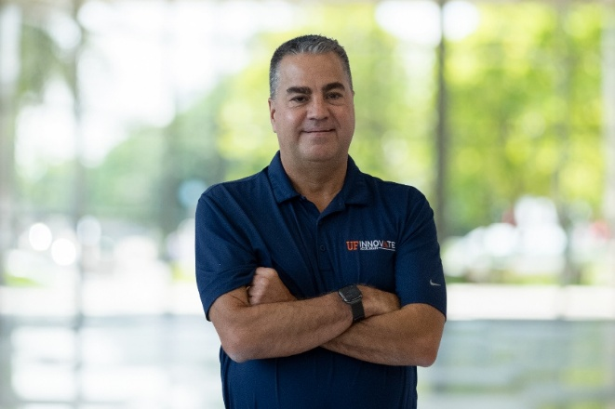
Karl R. LaPan
Karl R. LaPan serves as Director of UF Innovate | Accelerate at the University of Florida, where he leads the university’s business incubation and commercialization programs. Since his appointment in May 2021, Karl has championed innovation and entrepreneurship across the Gainesville Innovation District and Progress District in Alachua, Florida. Under his leadership, UF Innovate | Accelerate supports more than 90 resident companies across two state-of-the-art facilities totaling nearly 130,000 square feet. The program has helped secure nearly $11.4 billion in client capital and has generated more than $25.3 billion in economic impact since its inception.
With a strong focus on building thriving entrepreneurial ecosystems, Karl provides consulting through NACCE in technology commercialization, innovation strategy, business incubation, and venture development. His work has helped drive higher-than-average client wages and a global reputation for excellence in business acceleration.
Prior to joining UF, Karl served as President and CEO of NBS Imaging Systems, an advanced biometric identification company. He began his career at General Electric, serving in six strategic business units and completing GE’s prestigious Financial Management Program. With deep expertise in corporate innovation and university-affiliated entrepreneurship, Karl continues to elevate the impact of innovation ecosystems nationwide.



Kamal Latham
Kamal Latham is an entrepreneurial ecosystem builder who has facilitated over $7 billion in growth as an executive, entrepreneur, diplomat, and analyst. He manages the F-300 AgFoodTech Innovation Park and Business Incubator initiative in Newberry, Florida, which is a partnership between the City of Newberry, the University of Florida, Santa Fe College, trade associations, chambers of commerce, and leading companies promoting business growth. He completed the Florida Business Incubation Association Ecosystem Builder course and launched the F-300 Startup Accelerator. F-300 won the startGNV Community Builder Award.
Kamal previously served as Chief Executive Officer of the U.S. Virgin Islands Economic Development Authority and oversaw tax incentive, financial services, and business programs accounting for over $500 million in annual economic impact. Over $165 million in new investment was announced during his tenure.
Kamal also served as Vice President for Public Policy at the Gainesville Area Chamber of Commerce in North Central Florida. He advocated on behalf of its 1,000+ members and was principal author of its Small Business Growth report
Earlier in his career, Kamal was a U.S. Diplomat with the U.S. State Department. He was a trade negotiator at Embassy Beijing, the finance and investment policy advisor at the U.S. Mission to the Organization for Economic Cooperation and Development in Paris, and a consular officer at Consulate-General Shenyang. He was a two-time recipient of the State Department’s Meritorious Honor Award.
Kamal earned a Master in Public Policy degree from the Kennedy School of Government at Harvard University and a Bachelor of Arts degree from Temple University. Kamal and his lovely wife Jonnel have two children.


Tangela Lofton
Regional Director, Florida SBDC at Florida A&M University
Tangela Lofton serves as the Regional Director of the Florida Small Business Development Center (SBDC) at Florida A&M University, leading strategic initiatives to support entrepreneurs across Florida’s Big Bend region. A seasoned executive and community advocate, she provides technical assistance, mentorship, and training that empower small businesses, especially those in underserved communities—to grow and thrive.
In addition to her public service role, she is the Founder and CEO of Sweet Face Wellness and The Juice Bar Miami, ventures dedicated to promoting wellness and accessibility through natural products and healthy food options. A proud FAMU alumna, she is committed to inclusive economic development and advancing pathways to prosperity through entrepreneurship and innovation.


Rhonda Hodges
Rhonda Hodges currently serves as President of Hodges WorkWise LLC, a workforce development consulting and training firm she established in June 2025 upon her retirement from Patrick & Henry Community College (P&HCC). From 1996 until 2025, Rhonda held various positions with P&HCC, most recently serving as the Vice President for Workforce, Economic, and Community Development since 2014. As Vice President, she had responsibility for leading the entrepreneurial division of the college with oversight of all career credit offerings, professional and workforce development, customized training, community development innovation and entrepreneurship programs, career services, and public relations and marketing. She also had a key role in building and maintaining strong working relationships with regional employers, economic development organizations, Chambers of Commerce, Workforce Development Boards, and other workforce entities. Rhonda currently serves on the West Piedmont Workforce Development Board, Martinsville Henry County Economic Development Corporation Board, GO Virginia Region 3 Advisory Council, and is a graduate of Lead Virginia Class of 2022. She holds a Bachelor’s degree in Marketing Management from Virginia Tech, a Graduate Certificate in Leadership and Management and a Master of Science in Human Resource Management from the University of Maryland University College.


Jennifer Harrell
Assistant Director, UF Innovate | Accelerate @ The Hub
Jennifer Harrell is a dynamic ecosystem builder and Assistant Director of UF Innovate | Accelerate @ The Hub, one of the University of Florida’s premier incubation programs supporting early-stage startups through mentorship, resources, and strategic programming. With nearly a decade of experience at UF Innovate, Jennifer has contributed to strengthening and expanding Gainesville’s long-standing reputation as a model for university-industry-government collaboration and entrepreneurial support.
Drawing from a career that spans operations, finance, and strategic planning across sectors including real estate law, hospitality, and higher education, Jennifer specializes in building bridges between founders, funders, and institutions. She brings a hands-on, founder-first approach to ecosystem design—crafting environments where entrepreneurs can scale confidently, innovate boldly, and thrive in community.
A board member of InBIA, the Florida Business Incubator Association, and Alachua Junior Achievement, Jennifer is passionate about sharing practical strategies to help communities unlock the power of partnerships. Whether designing impactful programs for startup founders or collaborating to address local workforce needs, she’s committed to helping others spark sustainable economic growth through partnership and innovation.
Jennifer is a Leadership Gainesville graduate, a recipient of the Startup Mentor of the Year award, and a finalist for the Ecosystem Hidden Gem award. She believes in sprinkling stardust on dreams—fueling founders with the resources and mentorship to turn bold ideas into thriving ventures.
Contact:
📧 harrellj@ufl.edu
🔗 LinkedIn
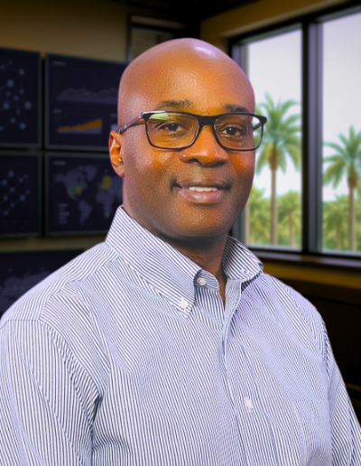
Gregory Grant, Entreprenologist
Gregory Grant is an Entreprenologist and public sector strategist advancing equitable economic development through entrepreneurship. As Chief of Entrepreneurial Development and JSEB Administrator for the City of Jacksonville, he leads policy-driven initiatives that expand access to capital, contracts, education, and community resources for small and emerging businesses. His advocacy has secured millions in funding for local capital access programs and catalyzed municipal legislation supporting small business growth.
With over 25 years of experience spanning military, corporate, and entrepreneurial sectors, Gregory applies a systems-level approach to building inclusive business ecosystems.
A Doctoral Candidate in Educational Leadership at the University of North Florida, Gregory’s research explores entrepreneurship as a Career and Technical Education pathway. He also serves as an Adjunct Professor of Entrepreneurship at Trinity Baptist College, Florida State College at Jacksonville, and the University of North Florida, where he integrates business theory with applied entrepreneurship training.
An active member of the United States Association for Small Business and Entrepreneurship (USASBE), Gregory is frequently sought for his insights on policy innovation, education, and small business advancement. His work and thought leadership have been featured in HuffPost, News4Jax, and other media outlets, where he continues to elevate entrepreneurship as a social science for economic development

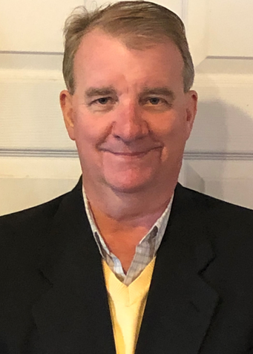
Wayne K. Johnson
Wayne K. Johnson is the President of Orange-Marble LLC, company that specializes in Project Management, Intercultural Communication, Instructional Systems Design (ISD), Curriculum Design, Workforce Development, and Corporate Training In the past, Mr. Johnson was the Former Dean of Workforce Development at MassBay Community College, Director of Community Education at Bunker Hill Community College, and tenured Professor of Intercultural Communication, Ryukoku University—the oldest university in Japan. Mr. Johnson has over 30 years of experience in higher education leadership, intercultural communication, business, and Instructional Systems Design (ISD). His primary responsibilities in corporate and educational settings are to write, evaluate, and identify gaps and redundancies in curricula and analyze and oversee a wide array of advanced learning programs. He has worked and researched worldwide and has taught in several international settings, including the UK, Poland, Thailand, and Japan. As a recognized expert in Cross-Cultural Understanding, Mr. Johnson's skillset includes multi-regional expertise supported by political, cultural, sociological, economic, and geographic awareness. For over ten years, he has directly supported the Department of Defense Language and Intercultural programs engaged in regionally focused political-military operations to advise senior embassy leaders and support deployed commanders throughout military operations. Mr. Johnson has written more than 30 publications in international academic journals and has conducted numerous presentations at international conferences concerning business, adult education, corporate training, linguistics, and intercultural communication.


Carrie Root
Carrie Root, Ph.D., HKN, Founder and CEO of Alpha UMi, spent over two decades as a high-level trouble shooter in the DoD sector. Today, she is bringing innovative professional development curricula to tomorrow’s workforce. She is committed to providing the opportunity for human skill development to all who desire it. Her company, Alpha UMi, develops and delivers relevant, engaging, and transformative learning experiences in topics such as leading without authority, generational intelligence, leadership, emotional intelligence and interpersonal communication.
Dr. Root was recognized as a Commander's National Award Winner for Science and Technology. Her work bringing leadership training to IEEE’s Women in Engineering as well as to engineering students resulted in an invitation to join HKE, IEEE’s honor society. She is an engaging speaker and recently published “The Other Soft Skill: How to Solve Workplace Challenges with Generational Intelligence.” She has been interviewed, has articles and a podcast on topics related to ageism, generations in the workplace, and other topics related to interpersonal relationships at work.
Damians Bio

Wayne K. Johnson BIO
Wayne K. Johnson is the President of Orange-Marble LLC, company that specializes in Project Management, Intercultural Communication, Instructional Systems Design (ISD), Curriculum Design, Workforce Development, and Corporate Training In the past, Mr. Johnson was the Former Dean of Workforce Development at MassBay Community College, Director of Community Education at Bunker Hill Community College, and tenured Professor of Intercultural Communication, Ryukoku University—the oldest university in Japan. Mr. Johnson has over 30 years of experience in higher education leadership, intercultural communication, business, and Instructional Systems Design (ISD). His primary responsibilities in corporate and educational settings are to write, evaluate, and identify gaps and redundancies in curricula and analyze and oversee a wide array of advanced learning programs. He has worked and researched worldwide and has taught in several international settings, including the UK, Poland, Thailand, and Japan. As a recognized expert in Cross-Cultural Understanding, Mr. Johnson's skillset includes multi-regional expertise supported by political, cultural, sociological, economic, and geographic awareness. For over ten years, he has directly supported the Department of Defense Language and Intercultural programs engaged in regionally focused political-military operations to advise senior embassy leaders and support deployed commanders throughout military operations. Mr. Johnson has written more than 30 publications in international academic journals and has conducted numerous presentations at international conferences concerning business, adult education, corporate training, linguistics, and intercultural communication.


Dr. Angela Long is a nationally recognized speaker, researcher and author. She currently serves
as Chief Engagement Officer within the Office of the President at Tallahassee State College where she oversees the College’s strategic plan and President’s Leadership Institute. Formerly, Dr. Long served under the Chancellor of the Florida College System as the Director of Learning, Innovation and Success at the Florida Department of Education. She is the former co-editor of the "Innovative Ideas for Community Colleges" national book series, published through Stylus Publishing.

In 2019, she helped oversee the publishing process for the recently released "Community Colleges as Incubators of Innovation," edited by Dr. Rebecca Corbin and Dr. Ron Thomas. In the fall of 2016, Dr. Long published a first-of-its-kind book involving higher education’s top researchers, practitioners, and community college leaders to address the educational disparities that exist among students of color. Angela is the author of the Six Factors theory for increasing nontraditional student retention and formerly served as the Innovation Ambassador for the National Association of Community College Entrepreneurship (NACCE). She is currently working on her next book publication with NACCE focused on preparing for the future of work and learning in the age of artificial intelligence and is certified on “Designing the Future of Work” by UNSW Sydney Australia, as well as holds two professional development certifications on Artificial Intelligence Leadership for Community College Professionals from the University of Florida.

Angela has participated in three White House summit meetings on Educational Excellence for Hispanics and has shared her findings across the country. In 2023, she was appointed as Commissioner to the AACC Commission on Research and Community College Trends and Issues, as well as appointed as an advisory board member for the Myers-Briggs Company. In 2024, she became certified as a John Maxwell trainer.

Dr. Long holds a Doctorate of Education degree in Community College Leadership from Oregon State University; a Master of Arts degree in School Counseling and Consultation from Northwest Christian University (NCU) and a Bachelor of Arts Degree in Elementary Education from NCU.
Contact Information:
Dr. Angela Long
Angela.long@tsc.fl.edu
Professorlong.al@gmail.com
Office: 850-201-6057
Cell: 352-642-2424
LinkedIn


Gary Schoeniger
Gary Schoeniger is a globally recognized thought leader in entrepreneurial mindset education. His first book, Who Owns the Ice House?, which he co-authored with Pulitzer nominee Clifton Taulbert, has become an international bestseller. As the founder and CEO of the Entrepreneurial Learning Initiative (ELI), Schoeniger also led the development of the Ice House Entrepreneurship Programs. With his focus on the entrepreneurial mindset, Schoeniger’s message has influenced a diverse audience ranging from academic, economic, and workforce development organizations to governments, corporate, and nonprofit leaders worldwide including the South African Department of Education, the Colombian Ministry of Education, the Cisco Entrepreneur Institute, the European Commission, and the US State Department.

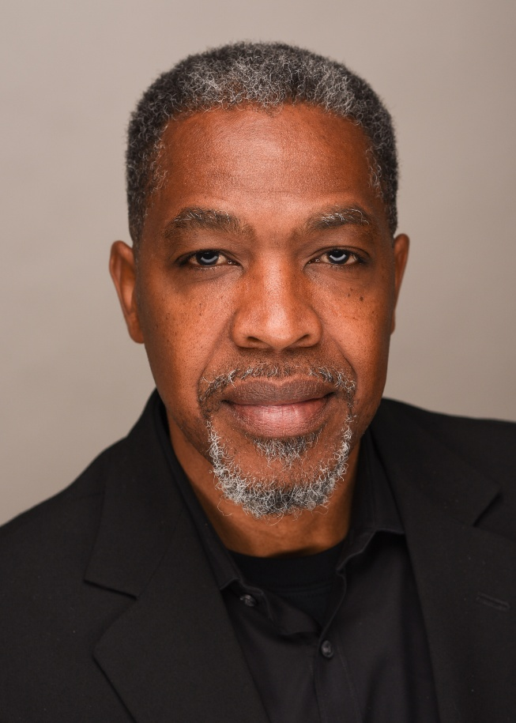

Christopher D. Lee, Ph.D., SPHR
Biography

Chris is a retired HR executive having served as the chief human resources officer for William & Mary, the nation’s second oldest university; the Virginia Community College System, a grouping of 23 colleges in the commonwealth; and Bates College in Maine, one of the nation’s top 25 liberal arts institutions. He is now managing director with Storbeck Search where he recruits and places ‘C-suite’ executives at college and universities across the country. His experience with search runs deep having authored two books on the higher education search committee process and being the author of an “Ask-The-Expert” blog with HigherEdJobs.com.

He is a consummate human resources professional having experience as an author, consultant, and lecturer in addition to being an accomplished practitioner. He teaches graduate level HR courses at the University of Richmond. He is a former question writer for the PHR and SPHR examinations administered by the Human Resources Certification Institute (HRCI). He is also the author of numerous human resources related articles and four books, including Performance Conversations: How to Use Questions to Coach Employees, Improve Productivity, and Boost Confidence (Without Appraisals) and Search Committees: A Comprehensive Guide to Faculty, Staff, & Administrative Selection.

He has presented at conferences and consulted with over 100 public and private sector clients in the US, Canada, Australia and South Africa on HR related topics. He holds a master's degree in HR Management, a doctor of philosophy degree in HR Development, and he is a certified human resources professional. Chris is also a retired Lieutenant Colonel from the United States Marine Corps Reserves.

Mark L. Madrid

The Honorable Mark L. Madrid lives life with immense gratitude to God, his family, partner, pet, and inner circle of trust. Renowned for his signature energy, discipline, and grit, Mark’s journey is a testament to overcoming adversity, winning with integrity, and paying it forward. Mark is a national economic strategist, AI futurist, bestselling author, and the Founder and CEO of Breakthrough Mavens, LLC, Fueling Excellence and Longevity with White-Collar Experience and Blue-Collar DNA. Breakthrough Mavens is a pioneering fractional C-Suite firm powered by AI and grounded in human intelligence, delivering a white-glove, results-driven customer experience. Mark is the author of his first book, Energy, 21 Uncomplicated & Easy Tips to Start Your Day Energized (Fig Factor Media), the first in a book series, Self-Fueling Excellence. Energy is an Amazon.com best seller in three categories: Motivational Growth & Spirituality, Personal Success & Spirituality, and Health & Spirituality. He is co-author of the Hero Club curated book titled, The Leader’s Playbook: CEOs Transforming Vision into Action (C-Suite Publishing).
A former Associate Administrator of the U.S. Small Business Administration, Mark and his team supported millions of U.S. small businesses with services from capital eligibility and education to cybersecurity and procurement.
His expertise has become a trusted compass for small businesses, tech startups, corporate America, public-private partnerships, academia, nonprofits, and C-Suite executives across America. Currently, Mark serves in distinguished fractional executive roles: Visiting Scholar at the Clinton School of Public Service at the University of Arkansas and Entrepreneur-In-Residence at NMSDC. He serves on the Board of Directors for the Texas State University McCoy College of Business Foundation and the Board of Advisors at Trez.co, Qoollege, and Deizero. Mark sits on the Advisory Council of the Hispanic Wealth Project and the Executive Board of Directors of FRIENDS, Friends of the American Latino Museum, a national advocacy campaign to create a Smithsonian National American Latino Museum.
Mark is an esteemed member of the C-Suite Network Hero Club, an exclusive community of Founders, CEOs, and Investors driven by distinguished integrity, transparency, and decisive action.
Mark’s past accolades include being honored as the 2019 Silicon Valley Nonprofit CEO of the Year by the Silicon Valley Business Journal, a reflection of his relentless commitment to purpose-driven impact. His career launched on Wall Street with J.P. Morgan in 1995, following his graduation with honors from the University of Texas at Austin McCombs School of Business. Also, he holds a Master of Nonprofit Administration, cum laude, from the University of Notre Dame Mendoza College of Business. As a sought-after keynote speaker and host of the Small Business is Big Business with Mark L. Madrid podcast (powered by C-Suite Media), Mark is an inspiring global voice on economic opportunity, financial literacy, and AI-powered transformation. Mark’s platforms in AI and AGI include a groundbreaking AI Guidebook series collaboration with international award-winning economic developer Kevin Johns and his custom curated AI small business educational forums. In partnership with Conectado and its CEO Guillermo Diaz, Jr., Mark is deploying game-changing fractional C-Suite industry standards, along with his digital twin Markitos.
His national honors include the Jefferson Award for Public Service, the American Airlines Extra Mile Award, and an appointment as an Honorary Colonel of the U.S. Army Reserve. Mark’s unwavering integrity and commitment to excellence and authentic, results-driven innovation position him as a respected national media commentator and an elite leader in every room.
Mark has been featured in Forbes, Inc., United Nations Media, the New York Stock Exchange, the Aspen Institute, American City Business Journals, The Hill, The University of Texas at Austin, the University of Notre Dame, Texas State University, Stanford University, the Silicon Valley Business Journal Leadership Trust, the C-Suite Network, the U.S. Conference of Mayors, the National League of Cities, and iHeart Radio, among other leading platforms. The Honorable Mark L. Madrid embodies a philosophy of scaling with heart and velocity, proving that no matter how noisy the world becomes, the strongest currency is clarity, and the most powerful leaders are those who lead with unshakable integrity, fanatic discipline, a mighty heart, the will to win, and contagious energy.
How to contact Mark L. Madrid:
Cell: (281) 989-1996
Email: mark@marklmadrid.com
Website: www.marklmadrid.com

Link to Rocio Perez Bio:

https://acrobat.adobe.com/id/urn:aaid:sc:VA6C2:bf1be2ba-20e4-425b-bc10-56bdb2ca179c

