



**2025-26**

**Missouri ProStart Things to Know**

Contact: Please use the ProStart email address below to communicate with the Missouri ProStart Coordinators.

[Prostart@morestaurants.org](mailto:Prostart@morestaurants.org)

**Missouri ProStart information will be released through the** [***mo-facs@lists.more.net***](mailto:mo-facs@lists.more.net)**.** All ProStart educators MUST have access to this listserv. To subscribe please use this link.

[**http://lists.more.net/mailman/listinfo/mo-facs**](http://lists.more.net/mailman/listinfo/mo-facs)

Web site – Basic program information will be posted to the Missouri Restaurant Association website [www.morestaurnants.org](http://www.morestaurnants.org) Missouri ProStart webpages.

**Currently under construction**

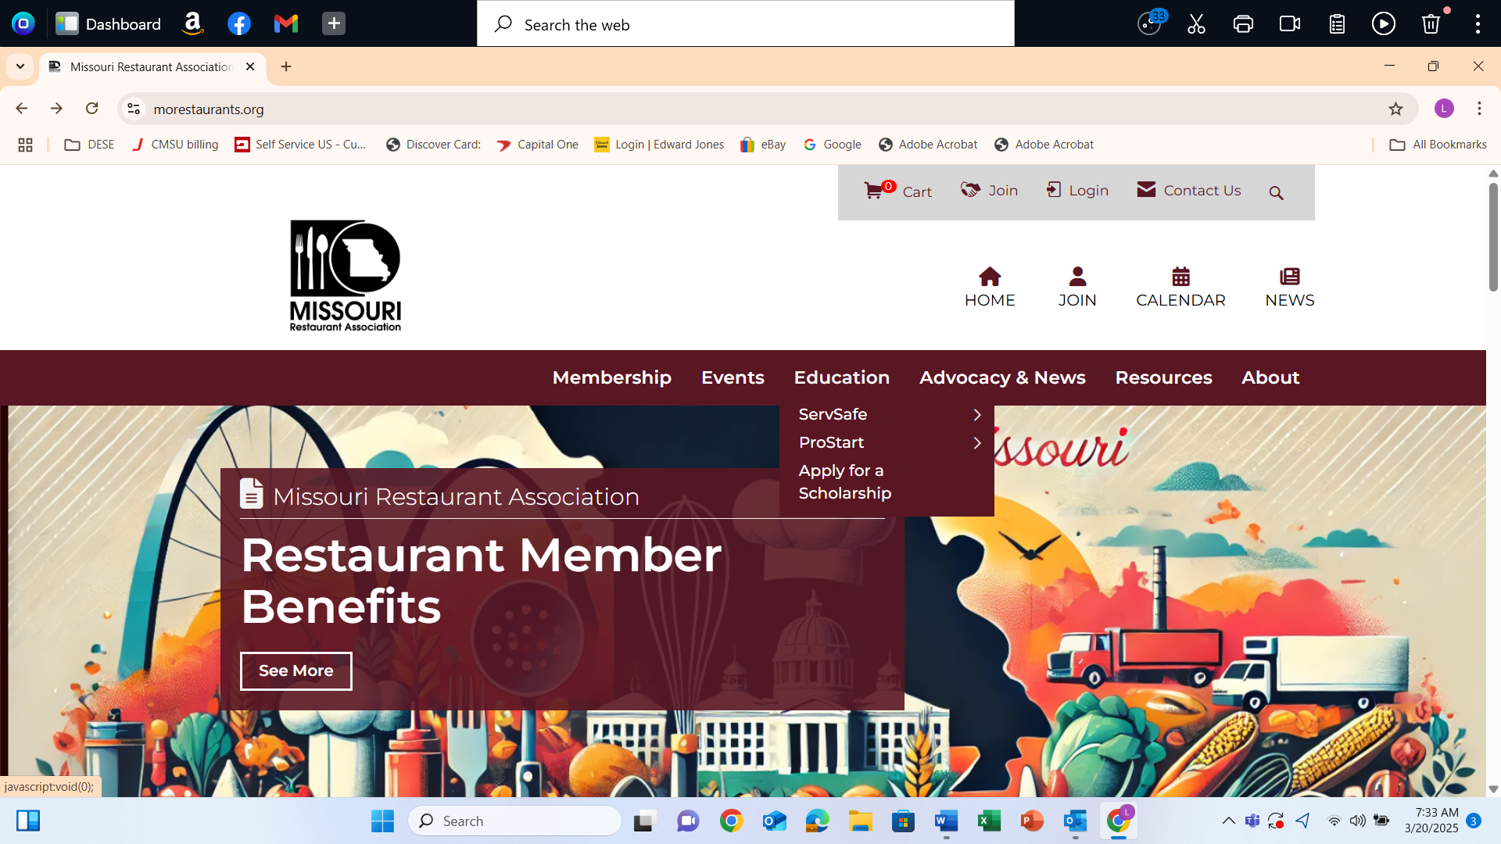

Textbook Purchase The Missouri representative for Foundations of Restaurant Management and Culinary Arts textbook purchase is:

Lauren Robin – [lrobin@restaurant.org](mailto:lrobin@restaurant.org) – 312-627-2424. An approved ProStart program must use the Foundations textbooks. The Second Edition testing should be supported until July 2029. The Third Edition of the Foundations Level I and Foundations Level 2 textbooks are available. Please begin planning to upgrade your current textbook edition to the third edition.