FOR IMMEDIATE RELEASE
Tuesday, Aug. 4, 2026
Contact: Ryan Weiss, MPA marketing and communications manager
Phone: 517-377-0232
Email: RWeiss@MichiganPharmacists.org

Eric Roath Named Chief Strategy Officer at Michigan Pharmacists Association;
Sona Camara Promoted to Director of Membership

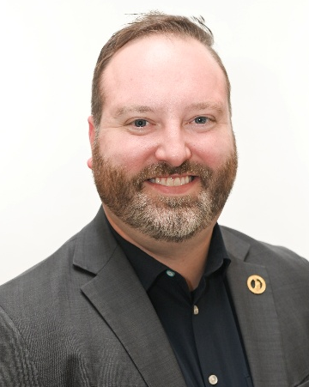
LANSING – The Michigan Pharmacists Association (MPA) announces the promotions of Eric Roath to chief strategy officer and Sona Camara to director of membership.

Roath’s dedication to the mission and vision of the association and his diverse experience and training positions him well to assume this new role. As director of government affairs, Roath has spearheaded MPA’s advocacy efforts since 2023, which led to the passage of key legislation that expanded pharmacists’ scope of practice and increased access to critical healthcare services for patients across the state. As chief strategy officer, Roath seeks to utilize his passion for advancing the pharmacy profession to transform the way MPA interacts with its members and key stakeholders across the state.

He will continue to advance the MPA’s advocacy initiatives while shaping the association’s strategies for member recruitment and retention, and marketing and communications.

“There’s never been a more exciting time to be a part of the pharmacy profession,” Roath said. “Pharmacists, pharmacy students and pharmacy technicians are critical to enhancing healthcare access and outcomes. As an association, we provide the resources, education and training to make that happen. We must be effective in the way we communicate that message.”

Roath is a 2012 graduate of Ferris State University College of Pharmacy. After completing his residency with PGPA Pharmacy in Okemos, Roath became MPA’s first executive fellow in 2013. He received his Master of Business Administration from Texas A&M-Corpus Christi in 2017. His past experience includes serving as a clinical care coordinator for SpartanNash and a specialty consultant for RBS Solutions.

Roath’s research has been published in the Journal of the American Pharmacists Association. He has served in numerous leadership positions at various local, state and national associations. He is a past recipient of MPA’s Distinguished New Practitioner Award (now known as the Distinguished Young Pharmacist Award), and has received Hall of Honor and Fellow of MPA designations. Roath is a frequent public speaker and has served as the adjunct instructor for pharmacy law at Ferris State University since 2024. He is a current fellow with the Michigan Political Leadership Program through Michigan State University’s Institute for Public Policy and Social Research.

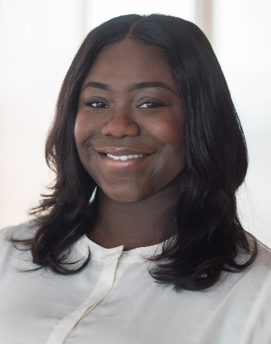
Sona Camara joined MPA in November 2025 as its senior membership manager, bringing with her an extensive background in membership management and analytics, with proven abilities in strengthening organizational growth through data-informed decisions, strategic planning and strong relationship building.

As director of membership, Camara will drive the development and execution of MPA’s membership recruitment and retention efforts in partnership with the chief strategy officer, using data analytics to evaluate performance and identify opportunities for growth.

The director serves as the association's hands-on expert in membership data and systems, leveraging the association management system to build reporting infrastructure and optimize membership processes. The director also develops new membership programs and non-dues revenue opportunities and serves as staff liaison to membership-related volunteer committees.

Camara has more than 10 years of membership experience in the nonprofit sector, working alongside associations to transform and modernize their membership operations. Her approach centers on aligning recruitment and retention efforts with long-term organizational goals and cultivating member relationships that turn short-term joins into long-term commitment.

She is a graduate of the University of Nantes in Nantes, France, with a Bachelor of Arts in business administration and economics. She is trilingual, fluent in English, French and Portuguese. Camara began her career with the Young United Nations, launching a decade-long career in association management spanning international and U.S.-based organizations.

About Michigan Pharmacists Association
The Michigan Pharmacists Association strives to serve members by providing support, advocacy and resources that ultimately improve patient care, safety, health and the practice of pharmacy. For more information, visit MichiganPharmacists.org.

