FOR IMMEDIATE RELEASE
Friday, June 5, 2026
Contact: Ryan Weiss, MPA marketing and communications manager
Phone: (517) 377-0232
Email: RWeiss@MichiganPharmacists.org

Award Winners Honored at MPA Annual Convention & Exhibition in Lansing
LANSING — The Michigan Pharmacists Association (MPA) is proud to announce its distinguished yearly award winners, which were presented Friday, April 17, and Saturday, April 18, at the MPA Annual Convention & Exposition (ACE) at the Lansing Center. MPA, its practice settings, affiliated chapters and other related organizations annually present a variety of prestigious awards to recognize pharmacy professionals and individuals/organizations supportive of the pharmacy profession.

MPA Pharmacist of the Year
Hae Mi Choe, Ann Arbor

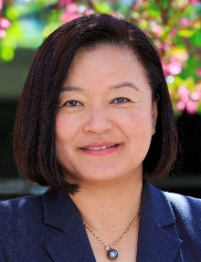
The MPA Pharmacist of the Year Award is presented annually as the highest honor in Michigan pharmacy. This lifetime achievement honor is given to a pharmacist who demonstrates professional excellence and exemplary service to the profession in advancing public health at either the state or local level and displays all the traits and characteristics of someone with a true
commitment to advancing the pharmacy profession and public health.
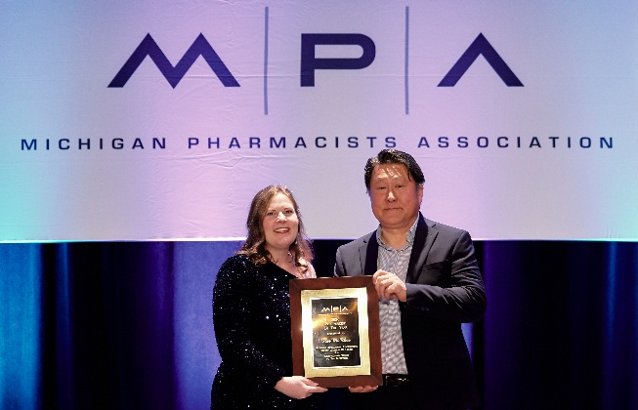
Hae Mi Choe was a visionary leader, innovator and tireless advocate for patients and pharmacy
practice. Over the course of her distinguished career, she redefined the role of pharmacists in patient care, pioneering new models of ambulatory pharmacy practice and ensuring that pharmacists became essential members of the health care team. As chief population health officer at Michigan Medicine and executive director of the Michigan Institute for Care Management and Transformation, Choe led transformative initiatives that integrated
MPA President Michelle Kelly, left, presents the Pharmacist of the Year Award to Hae Mi Choe's husband, Yong.
pharmacists into primary care and specialty care across Michigan Medicine and the state. Her leadership brought lasting improvements in medication management, chronic disease care and patient outcomes.

Earlier in her career, she also held influential positions at the University of Michigan College of Pharmacy and Blue Cross Blue Shield of Michigan, where she advanced pharmacy’s role in health care delivery. Her excellence was recognized nationally, receiving numerous accolades including the ASHP Board of Directors Distinguished Leadership Award, the American Association of Colleges of Pharmacy Crystal APPLE Award, the Pinnacle Award from the American Pharmacists Association Foundation, and multiple honors from MPA, including the MSHP President's Award and the Excellence in Innovation Award. In honor of her contributions to pharmacy, MPA renamed the Excellence in Innovation Award this year in Choe’s honor.

A long-time member of MPA, Choe sadly passed away last year after a battle with leukemia. She inspired all who knew her with her grace, generosity and unwavering commitment to making healthcare more accessible and equitable. She consistently led with empathy, always reminding her colleagues: “We need to make this easier for patients. Help me, help others.”

Bowl of Hygeia
Thomas Rolands, Troy

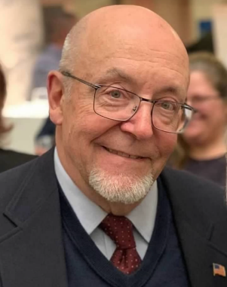
The Bowl of Hygeia derives its name from the Greek goddess of the same name, who was the goddess of health, cleanliness and hygiene. The Bowl of Hygeia is given to a pharmacist who has made outstanding professional contributions and has participated in community or governmental activities that reflect well on the profession.

Tom Rolands has been a practicing pharmacist for nearly 60 years, graduating in one of the first classes at Wayne State University. He has also been an active member of MPA, Phi Delta Chi Professional Pharmacy Fraternity and the Wayne State University Pharmacy Alumni Association for close to 60 years.

His career started in hospital pharmacy and he received a Master of Science in hospital pharmacy in 1973. In 1976, he became the owner of Wood Drugs in northwest Detroit for more than 22 years. During this time, he was a preceptor in the then relatively new Wayne State University Externship Program. Student participants in the externship program would rotate to his community pharmacy site for 10 weeks. Nearly 100 pharmacy students passed through his doors during those 22 years.

Later in his career, he opened and started Value Center Pharmacy in Madison Heights. Here, he again served as a mentor to many student pharmacists, as well as foreign pharmacy graduates seeking licensure in the United States.

Rolands was also a long-time volunteer at the Cabrini Clinic in Detroit, the oldest free clinic in the country.

Executive Board Medal
Mary Beth O’Connell, Waterford

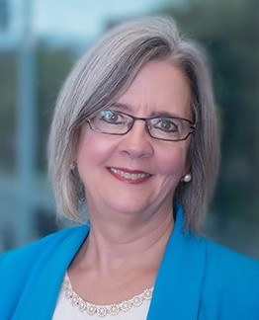
The Executive Board Medal Award is given annually to an individual who has demonstrated an extraordinary personal commitment to MPA. The award was developed to recognize individuals who have been instrumental to the Executive Board and to the Association in advancing pharmacy’s agenda.

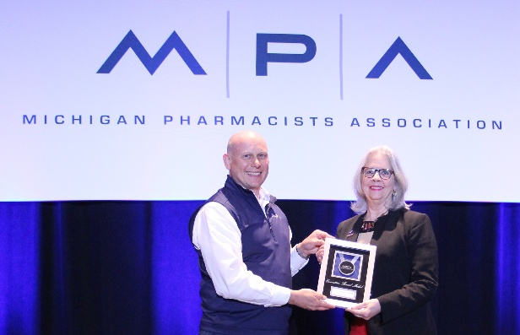
Mary Beth O’Connell is a professor emerita in the Pharmacy Practice Department at the Wayne State University Eugene Applebaum College of Pharmacy and Health Sciences.
MPA President-elect Ryan Bickel, left, presents the Executive Board Medal to Mary Beth O'Connell.

O’Connell has long been a leading advocate for women’s health and pharmacy practice advancement. She has volunteered her time serving on MPA's Government Affairs Committee (GAC) and as an Oakland County Pharmacists Association delegate for the MPA House of Delegates for many years, helping to pass important resolutions to be considered by the Executive Board. Her consistent participation in these initiatives demonstrates her commitment not only to policy change at the state level, but also to ensuring that the collective voice of community pharmacists is heard.

In 2024 and 2025, O'Connell worked with the Wayne State Chapter of Lambda Kappa Sigma to organize an advocacy campaign in conjunction with MPA that led to passage of House Bills 5435 and 5436, which allows pharmacists to directly prescribe and dispense contraceptives to patients.

Hae Mi Choe Excellence in Innovation Award
YesRX

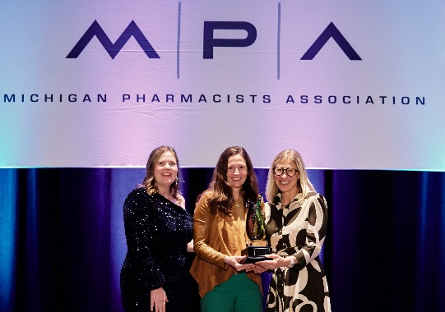
The Excellence in Innovation Award is presented annually to an individual or team that has demonstrated an innovative pharmacy practice program, resulting in improved patient care or safety, advancement of the profession, enhanced systems or other professional development. At the 2026 Annual Convention, MPA was proud to announce the award’s renaming in honor of the late Hae Mi Choe, who was a two-time recipient.
MPA President Michelle Kelly presents the Excellence in Innovation Award to YesRx CEO Siobhan Norman, center, and Chief Medical Officer Emily Mackler, right.

YesRx is a non-profit service organization founded in 2023 by Farah Jalloul-Rizk, Emily Mackler,
and Siobhan Norman to eliminate cancer medication waste and improve cancer medication
access to Michigan residents in need. YesRx has innovated cancer care delivery by forming the
YesRx Network, an interconnected community of over 130 cancer care sites working together to
deliver cancer drug repository programming to patients in need of help getting their medication
and individuals who desire to donate unused medication to others.

In less than three years, YesRx has created the most active cancer drug repository program
in the country, benefiting over 4,000 Michigan residents with free cancer medication and
preventing over 150,000 cancer pills from being wasted.

Pharmacists MutualTM Distinguished Young Pharmacist Award
Sara Brown, Lowell

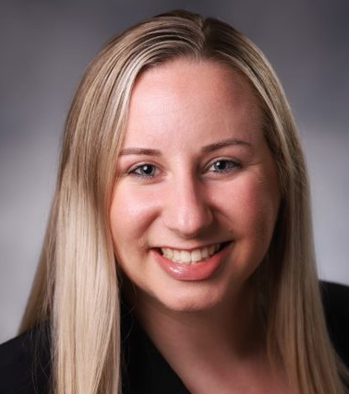
The Pharmacists Mutual™ Distinguished Young Pharmacist Award (formerly the Distinguished New Pharmacist Practitioner Award) is presented annually to an MPA member pharmacist who has been licensed to practice for less than 10 years and participates in local, state and national pharmacy associations, professional programs and/or community service.

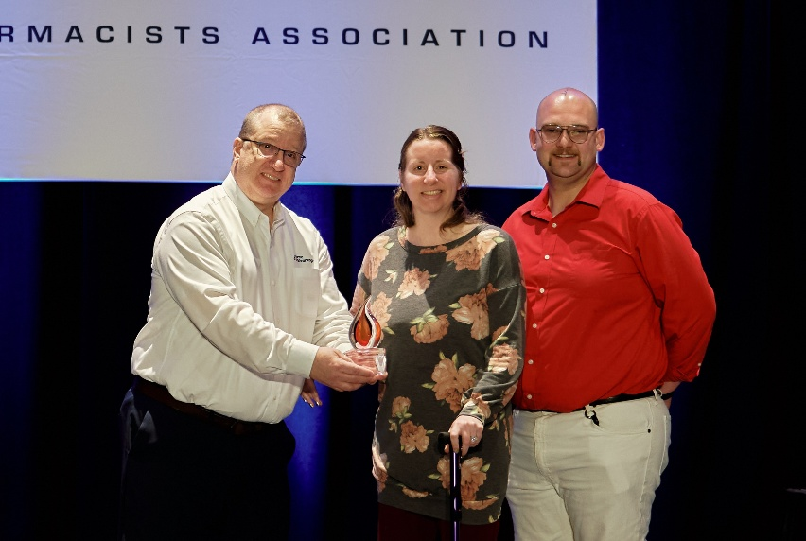
Sara Brown has been an active, engaged member of the Michigan Pharmacists Association, contributing her time, knowledge and leadership to advance the profession. As a pharmacy supervisor, she has implemented
Pharmacists Mutual Representative Ron Devers, left, presents the Distinguished Young Pharmacist Award to Sara Brown, center, accompanied by her husband Erik.
systems and practices that have improved patient care, enhanced safety and expanded the pharmacist’s role as a vital health care provider.

Beyond her professional accomplishments, her story is one of remarkable courage and perseverance. In 2025, she suffered a life-altering stroke, forcing her to relearn how to walk and talk. Her journey — publicly shared to inspire others — has been a testament to her resilience and determination. Even during recovery,

Brown has remained committed to pharmacy and to mentoring colleagues, modeling what it means to serve with both skill and heart. she has participated in community health initiatives, patient education programs, and advocacy efforts aimed at improving health care access and outcomes.

Fred W. Arnold Public Relations Award
Valerie Kelley-Bonner, Belleville

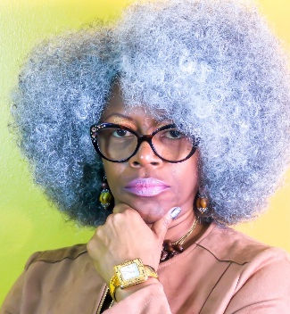
This award is presented to a member or team of members who have shown outstanding achievement and dedication to the pharmacy profession through community education and awareness.

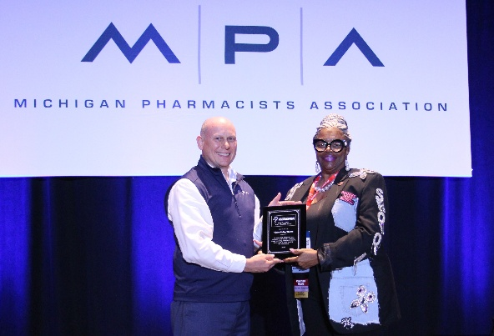
Valerie Kelley-Bonner is a community advocate, consultant and nonprofit leader dedicated to advancing prevention, harm reduction and trauma-informed care for youth and marginalized communities in Metro Detroit. She is the founder of Strategic Transitions Consulting and a key leader with Strategies to Overcome Obstacles and Avoid Recidivism, where she develops and implements programs focused on substance use prevention, HIV awareness, youth violence prevention and intergenerational healing.
MPA president-elect Ryan Bickel presents the Fred W. Arnold award to Valerie Kelley-Bonner.

With over 20 years of experience in community engagement and systems-level collaboration, Kelly-Bonner works at the intersection of public health, social justice and education. Her work emphasizes culturally responsive programming, lived-experience leadership and practical solutions that bridge gaps between institutions and the communities they serve.

Kelly-Bonner is also a storyteller and creative voice behind projects such as Sister Heal: It’s Time to Keep It Real, using narrative and dialogue to spark healing, accountability and transformation. Her mission is to turn pain into purpose and policy into people-centered practice.

Other MPA awards that were presented Saturday or at other events include:
- Fellow of MPA – The designation Fellow of Michigan Pharmacists Association (MPA) recognizes the honoree’s achievements and dedication to the practice of pharmacy and the community. This distinction signifies the recipient’s actions well beyond regular pharmacy practice. The fellowship is divided into three areas: professional actions in practice, public service and Association participation, all of which help define a well-rounded pharmacist. Recipients receive an exclusive lapel pin, a certificate and recognition in Michigan Pharmacist. This year’s recipients Hope Broxterman, of Traverse City; Ashley Builta, of Brighton; Farah Jalloul-Rizk, of Dearborn; Daniel Lobb, of Westland; David Miller, of Alto; Eric Roath, of Haslett; and Brittany Stewart, of Livonia.
- Pharmacy Hall of Honor – The Pharmacy Hall of Honor was established by MPA in 1986 to recognize members who have provided volunteer leadership in service to the Association by participating on committees and in designated Association programs. In addition to the individual’s name being displayed in the Pharmacy Hall of Honor at the MPA office, the recipient receives an exclusive lapel pin to signify the accomplishment. This year’s inductees are Courtney Biehl of Grand Rapids; Gary Blake of Troy; Ashley Blanchette, of Grand Rapids; Tara McAlpine, of Kentwood; and Maria Young, of Canton
- Michigan Society of Community Pharmacists (MSCP) Pharmacist of the Year – Jordan Marchetti, Iron Mountain
- Michigan Society of Pharmacy Technicians (MSPT) Technician of the Year – Anthony Codrean, Lake Orion
- Michigan Society of Pharmacy Technicians (MSPT) Service Award – Keith Binion, Harper Woods
- Consultant and Specialty Pharmacists of Michigan (CSPM) Pharmacist of the Year – John Mohler, Marengo
- Michigan Society of Health-System Pharmacists (MSHP) Pharmacist of the Year – Edward Szandzik, Grosse Pointe Woods (this award was presented at the MSHP Annual Meeeting in October).
- Michigan Pharmacy PAC Senator of the Year Award – Sen. Kevin Hertel
- Michigan Pharmacy PAC Representative of the Year Award – Rep. Tom Kunse
- Michigan Pharmacy PAC Good Public Health Policy Award – Dr. Natasha Bagdasarian
- Michigan Pharmacy PAC Hank Fuhs Good Government Award – Harvey Schmidt, Tecumseh
- Ernie Koch Striving for Excellence Award – Greg Baise, Detroit

NOTE: Headshot photographs of these award winners are available by request.

About Michigan Pharmacists Association
The Michigan Pharmacists Association strives to serve members by providing support, advocacy and resources that ultimately improve patient care, safety, health and the practice of pharmacy. For more information, visit MichiganPharmacists.org.

