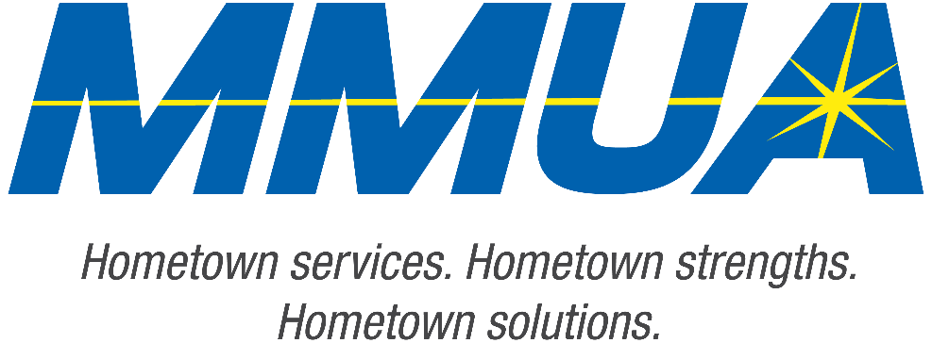

FOR IMMEDIATE RELEASE
December 10, 2025
Media Contact: Karleen Kos, CAE, president/CEO, Minnesota Municipal Utilities Association; kkos@mmua.org

The T&O Conference Congratulates Northwest Line College Graduate: Ryan Haberman
[ST. CLOUD, MN] — MMUA proudly recognizes Ryan Haberman of Owatonna Public Utilities, for completing the four-year academic program at Northwest Line College and passing the final qualifying exam.
Ryan was celebrated Tuesday at the Technical & Operations Conference in St. Cloud, where he was recognized for his achievement and dedication to the lineworker profession.
MMUA congratulates Ryan on reaching this milestone and looks forward to his contributions to Minnesota utilities.
For more information about MMUA programs, visit www.mmua.org.
About the Minnesota Municipal Utilities Association (MMUA): The Minnesota Municipal Utilities Association represents the interests of the state’s community-owned electric, gas, and water utilities. MMUA provides training, advocacy, and support to ensure reliable, sustainable, and locally controlled utility services across Minnesota.
###

