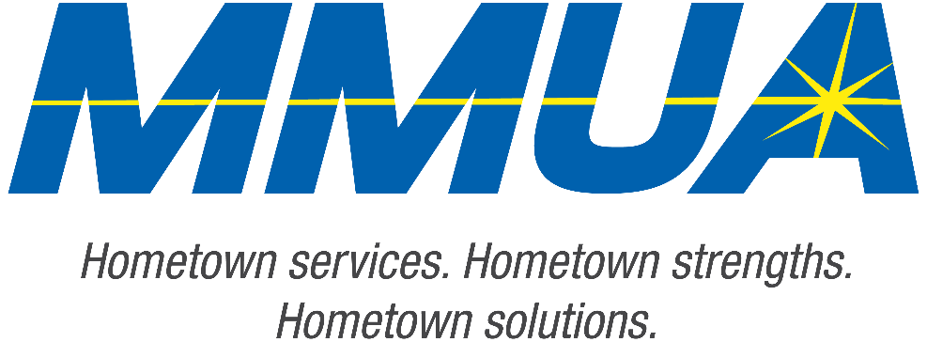

FOR IMMEDIATE RELEASE
December 10, 2025
Media Contact: Karleen Kos, CAE, president/CEO, Minnesota Municipal Utilities Association; kkos@mmua.org

The T&O Conference Congratulates Northwest Line College Graduate: Riley Reding
[ST. CLOUD, MN] — MMUA is pleased to honor Riley Reding of New Ulm Public Utilities, who successfully completed the Northwest Line College academic program and passed the qualifying final exam.
Riley was recognized Tuesday at the T&O Conference in St. Cloud for his hard work and commitment to the utility profession.
MMUA congratulates Riley and wishes him continued success as he advances in his career.
For more information about MMUA programs, visit www.mmua.org.
About the Minnesota Municipal Utilities Association (MMUA): The Minnesota Municipal Utilities Association represents the interests of the state’s community-owned electric, gas, and water utilities. MMUA provides training, advocacy, and support to ensure reliable, sustainable, and locally controlled utility services across Minnesota.
###

