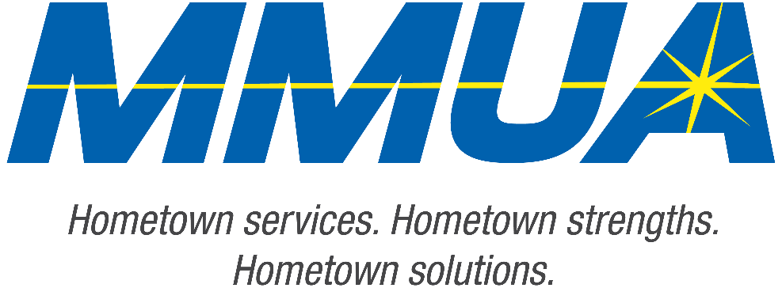

FOR IMMEDIATE RELEASE
December 10, 2025
Media Contact: Karleen Kos, CAE, president/CEO, Minnesota Municipal Utilities Association; kkos@mmua.org

The T&O Conference Congratulates Northwest Line College Graduate: Rene Celedon
[ST. CLOUD, MN] — MMUA proudly recognizes Rene Celedon of Westbrook Public Utilities for earning his place among this year’s Northwest Line College graduates after completing the four-year academic curriculum and passing the program’s final exam.
Rene was honored Tuesday at the Technical & Operations Conference in St. Cloud, where NLC graduates were applauded for their dedication and hard work.
MMUA congratulates Rene on this major accomplishment and looks forward to his future contributions to Minnesota’s utility workforce.
For more information about MMUA programs, visit www.mmua.org.
About the Minnesota Municipal Utilities Association (MMUA): The Minnesota Municipal Utilities Association represents the interests of the state’s community-owned electric, gas, and water utilities. MMUA provides training, advocacy, and support to ensure reliable, sustainable, and locally controlled utility services across Minnesota.
###

