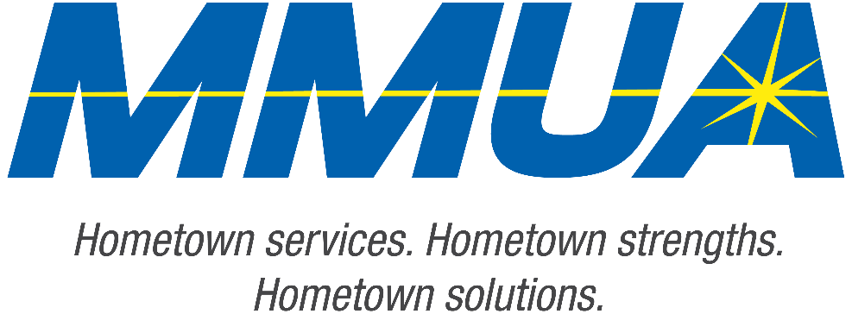

FOR IMMEDIATE RELEASE
December 10, 2025
Media Contact: Karleen Kos, CAE, president/CEO, Minnesota Municipal Utilities Association; kkos@mmua.org

The T&O Conference Congratulates Northwest Line College Graduate: Karson Neiman
[ST. CLOUD, MN] — MMUA proudly recognizes Karson Neiman of the City of Pierre, South Dakota, for completing the four-year academic program at Northwest Line College and passing the final exam requirement.
Karson was honored Tuesday at the Technical & Operations Conference in St. Cloud, where he was recognized among this year’s distinguished graduates.
MMUA congratulates Karson and looks forward to his continued growth in the lineworker profession.
For more information about MMUA programs, visit www.mmua.org.
About the Minnesota Municipal Utilities Association (MMUA): The Minnesota Municipal Utilities Association represents the interests of the state’s community-owned electric, gas, and water utilities. MMUA provides training, advocacy, and support to ensure reliable, sustainable, and locally controlled utility services across Minnesota.
###

