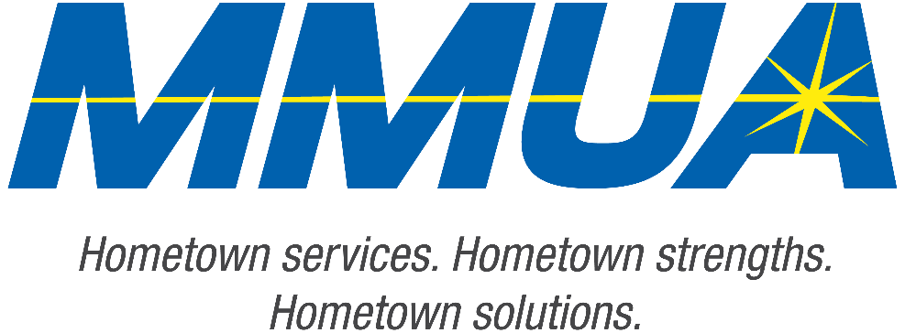

FOR IMMEDIATE RELEASE
December 10, 2025
Media Contact: Karleen Kos, CAE, president/CEO, Minnesota Municipal Utilities Association; kkos@mmua.org

The T&O Conference Congratulates Northwest Line College Graduate: Jonathan Schuman
[ST. CLOUD, MN — MMUA proudly recognizes Jonathan Schuman of Baudette Municipal Utilities for completing the demanding four-year academic program at Northwest Line College and successfully passing the required final exam.
Jonathan was acknowledged Tuesday at the Technical & Operations Conference in St. Cloud, where his commitment to safety, professionalism, and technical excellence was celebrated alongside other graduates.
MMUA congratulates Jonathan on this important milestone and wishes him well as he begins his career in the field.
For more information about MMUA programs, visit www.mmua.org.
About the Minnesota Municipal Utilities Association (MMUA): The Minnesota Municipal Utilities Association represents the interests of the state’s community-owned electric, gas, and water utilities. MMUA provides training, advocacy, and support to ensure reliable, sustainable, and locally controlled utility services across Minnesota.
###

