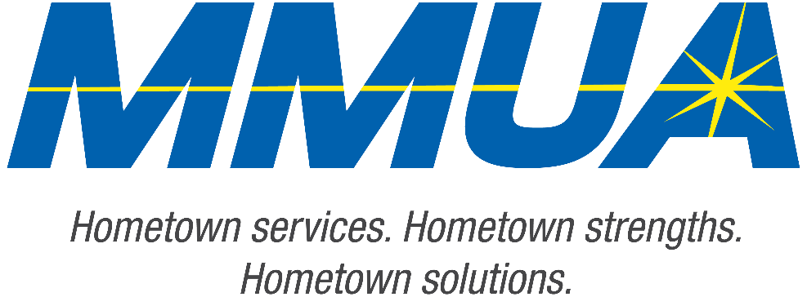

FOR IMMEDIATE RELEASE
December 10, 2025
Media Contact: Karleen Kos, CAE, president/CEO, Minnesota Municipal Utilities Association; kkos@mmua.org

The T&O Conference Congratulates Northwest Line College Graduate: Jacob Erickson
[ST. CLOUD, MN] — The Minnesota Municipal Utilities Association congratulates Jacob Erickson of Hawley Public Utilities for completing the academic requirements of Northwest Line College and passing the program’s final exam.
Jacob’s achievement was celebrated Tuesday at the T&O Conference in St. Cloud, where NLC graduates were recognized for their skill development, perseverance, and commitment to community service.
MMUA extends its warmest congratulations to Jacob and wishes him every success in his lineworker career.
For more information about MMUA programs, visit www.mmua.org.
About the Minnesota Municipal Utilities Association (MMUA): The Minnesota Municipal Utilities Association represents the interests of the state’s community-owned electric, gas, and water utilities. MMUA provides training, advocacy, and support to ensure reliable, sustainable, and locally controlled utility services across Minnesota.
###

