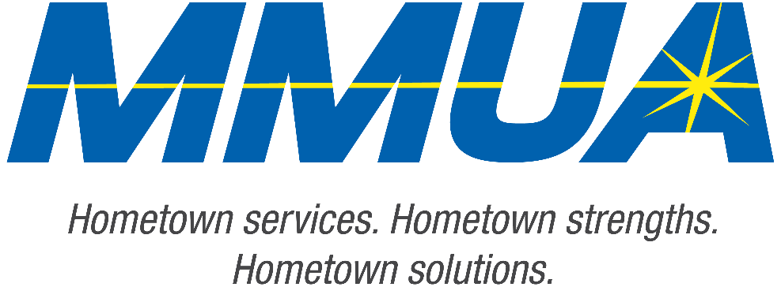

FOR IMMEDIATE RELEASE
December 10, 2025
Media Contact: Karleen Kos, CAE, president/CEO, Minnesota Municipal Utilities Association; kkos@mmua.org

The T&O Conference Congratulates Northwest Line College Graduate: Dustin Hjelmer

[ST. CLOUD, MN]. — The Minnesota Municipal Utilities Association (MMUA) proudly recognizes Dustin Hjelmer of Saint James Public Utility for completing the rigorous four-year academic program at Northwest Line College (NLC). Dustin successfully passed the program’s comprehensive final exam with a score of 80 percent or higher, earning his place among this year’s distinguished graduates.
His accomplishment was celebrated Tuesday during MMUA’s Technical & Operations Conference in St. Cloud, where NLC graduates were honored for their dedication, skill, and commitment to the lineworker profession.
MMUA congratulates Dustin on this significant milestone and wishes him success as he advances in his career serving Minnesota communities.
For more information about MMUA programs, visit www.mmua.org.
About the Minnesota Municipal Utilities Association (MMUA): The Minnesota Municipal Utilities Association represents the interests of the state’s community-owned electric, gas, and water utilities. MMUA provides training, advocacy, and support to ensure reliable, sustainable, and locally controlled utility services across Minnesota.
###

