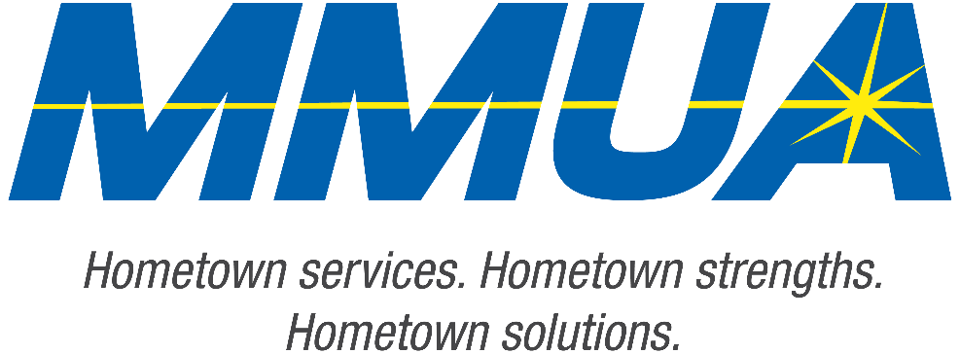

FOR IMMEDIATE RELEASE
December 10, 2025
Media Contact: Karleen Kos, CAE, president/CEO, Minnesota Municipal Utilities Association; kkos@mmua.org

The T&O Conference Congratulates Northwest Line College Graduate: Brett Murray
[ST. CLOUD, MN] — The Minnesota Municipal Utilities Association is pleased to honor Brett Murray of Baudette Municipal Utilities, who successfully completed the full Northwest Line College academic program and passed the program’s final qualifying exam.
Brett was recognized during Tuesday’s Technical & Operations Conference in St. Cloud for his dedication to the craft and commitment to public safety and service.
MMUA extends its congratulations to Brett as he continues advancing in the lineworker profession.
For more information about MMUA programs, visit www.mmua.org.
About the Minnesota Municipal Utilities Association (MMUA): The Minnesota Municipal Utilities Association represents the interests of the state’s community-owned electric, gas, and water utilities. MMUA provides training, advocacy, and support to ensure reliable, sustainable, and locally controlled utility services across Minnesota.
###

