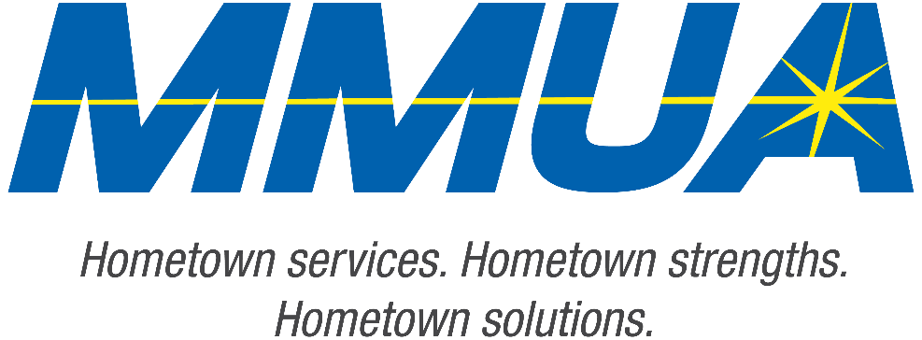

**FOR IMMEDIATE RELEASE**  
August 19, 2025  
Media Contact: Karleen Kos, CAE, president/CEO, Minnesota Municipal Utilities Association; [kkos@mmua.org](mailto:kkos@mmua.org)

**Minnesota Municipal Utilities Association Honors Owatonna Utilities Professional at Annual Conference**

[Rochester, MN]—The Minnesota Municipal Utilities Association (MMUA) has proudly recognized excellence in the state’s public power and water community by presenting its annual awards during the 2025 MMUA Summer Conference: “Utility Leadership at the Speed of Change,” held August 18–20 at the Kahler Grand Hotel in Rochester, Minnesota.

The awards celebrate individuals and utilities exemplifying outstanding service, innovation, leadership, and dedication to community values in the municipal utility sector. This year, an individual from Owatonna was recognized.

**Brian Riggleman**, business analyst engineer, Owatonna Public Utilities

Brian received MMUA’s Rising Star Award.This recognizes future leaders who have demonstrated dedication to the goals and principles of municipal utilities through problem-solving, creativity, and job knowledge.

—more—

MMUA 2025 Award Winners

2-2-2

Brian joined OPU with limited data reporting experience but quickly became an essential resource for the organization. He approaches every challenge with enthusiasm and has a genuine passion for his work.

Brian has collaborated across all departments of OPU, significantly enhancing utility operations, from EV detection to load management devices. Many colleagues commend his impressive work, describing it as “raw talent with unlimited passion.”

“Our award recipients represent the best of public service—committed professionals and community-focused utilities working tirelessly to serve Minnesota residents with safe, reliable, and affordable services,” says MMUA CEO Karleen Kos. “This year’s winners embody the spirit of public service and remind us why municipal utilities remain so vital to our state.”

The conference brought together more than 250 utility professionals, board members, and industry partners from across Minnesota and the Upper Midwest for several days of training, networking, and celebration. Keynote sessions focused on embracing change and generating engagement in the workplace.

For more information about MMUA awards and programs, visit [Summer Conference: Utility Leadership at the Speed of Change - Minnesota Municipal Utilities Association](https://www.mmua.org/events/summer-2025#whattoexpect).

About the Minnesota Municipal Utilities Association (MMUA): The Minnesota Municipal Utilities Association represents the interests of the state’s community-owned electric, gas, and water utilities. MMUA provides training, advocacy, and support to ensure reliable, sustainable, and locally controlled utility services across Minnesota.

###