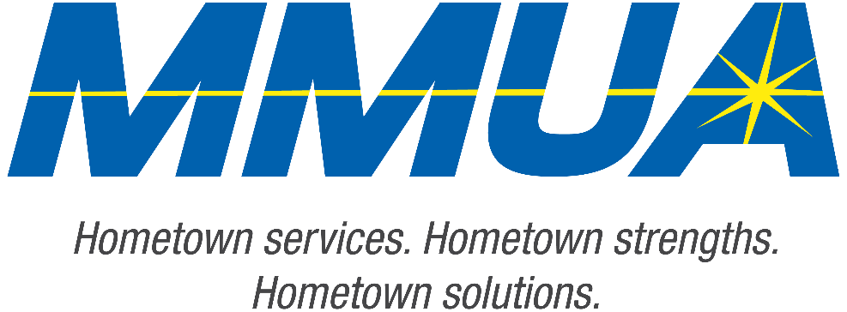

**FOR IMMEDIATE RELEASE**  
August 19, 2025  
Media Contact: Karleen Kos, CAE, president/CEO, Minnesota Municipal Utilities Association; [kkos@mmua.org](mailto:kkos@mmua.org)

**Minnesota Municipal Utilities Association Honors North St. Paul Utility Superintendent at Annual Conference**

[Rochester, MN]—The Minnesota Municipal Utilities Association (MMUA) has proudly recognized excellence in the state’s public power and water community by presenting its annual awards during the 2025 MMUA Summer Conference: “Utility Leadership at the Speed of Change,” held August 18–20 at the Kahler Grand Hotel in Rochester, Minnesota.

The awards celebrate individuals and utilities exemplifying outstanding service, innovation, leadership, and dedication to community values in the municipal utility sector.

**Easton Dale**, superintendent, North Saint Paul Electric Utilities

Easton received MMUA’s Rising Star Award. This recognizes future leaders who have demonstrated dedication to the goals and principles of municipal utilities through problem-solving, creativity, and job knowledge.

--more--

MMUA 2025 Award Winners

2-2-2

Easton has led the utility crew through a period of significant change, advocating for new technology to enhance daily operations. Under his leadership as Superintendent, communication has improved notably, with safety tailboards and job briefings encouraging open dialogue and shared safety concerns.

With a background as a lineworker, Easton maintains a strong connection with the crew, prioritizing their safety and spearheading initiatives to reduce risks. These include the implementation of advanced safety tailboards, mapping, and hazard analysis technologies.

Known for his approachable and composed demeanor, Easton effectively guides crews during storm responses, swiftly restoring power. He assumed the superintendent role amid a time of transition in North Saint Paul, confidently navigating challenges posed by new city leadership and an evolving electric department.

“Our award recipients represent the best of public service—committed professionals and community-focused utilities working tirelessly to serve Minnesota residents with safe, reliable, and affordable services,” says MMUA CEO Karleen Kos. “This year’s winners embody the spirit of public service and remind us why municipal utilities remain so vital to our state.”

The conference brought together more than 250 utility professionals, board members, and industry partners from across Minnesota and the Upper Midwest for several days of training, networking, and celebration. Keynote sessions focused on embracing change and generating engagement in the workplace.

For more information about MMUA awards and programs, visit [Summer Conference: Utility Leadership at the Speed of Change - Minnesota Municipal Utilities Association](https://www.mmua.org/events/summer-2025#whattoexpect).

About the Minnesota Municipal Utilities Association (MMUA): The Minnesota Municipal Utilities Association represents the interests of the state’s community-owned electric, gas, and water utilities. MMUA provides training, advocacy, and support to ensure reliable, sustainable, and locally controlled utility services across Minnesota.

###