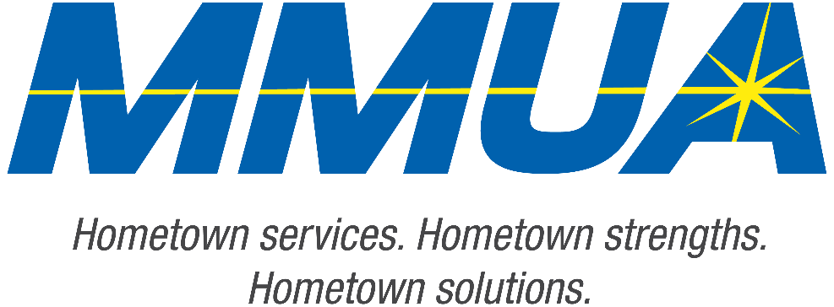

**FOR IMMEDIATE RELEASE**  
August 19, 2025  
Media Contact: Karleen Kos, CAE, president/CEO, Minnesota Municipal Utilities Association; [kkos@mmua.org](mailto:kkos@mmua.org)

**Minnesota Municipal Utilities Association Honors Hawley Leader at Annual Conference**

[Rochester, MN]—The Minnesota Municipal Utilities Association (MMUA) has proudly recognized excellence in the state’s public power and water community by presenting its annual awards during the 2025 MMUA Summer Conference: “Utility Leadership at the Speed of Change,” held August 18–20 at the Kahler Grand Hotel in Rochester, Minnesota.

The awards celebrate individuals and utilities exemplifying outstanding service, innovation, leadership, and dedication to community values in the municipal utility sector. This year, one individual from Hawley was awarded.

**Don Martodam**, former commissioner, Hawley Public Utilities

Don received MMUA’s Public Service Award. MMUA’s Public Service Award is given to a local, state, or federal elected or appointed official who has been a strong supporter of MMUA and its members.

--more—

MMUA 2025 Award Winners

2-2-2

Don was a steadfast advocate for public power through more than three decades of service on the Hawley Public Utilities Commission. The long-standing commitment to MMUA and to the advancement of locally owned utilities throughout Minnesota has impacted everyone greatly.

Don encouraged participation in MMUA training events and leadership development opportunities. He also served as an MMUA Board member for many years, leading as board President in 2023. The example Don set illustrates what it means to serve with integrity, purpose, and a true belief in the value of hometown utilities.

“Our award recipients represent the best of public service—committed professionals and community-focused utilities working tirelessly to serve Minnesota residents with safe, reliable, and affordable services,” says MMUA CEO Karleen Kos. “This year’s winners embody the spirit of public service and remind us why municipal utilities remain so vital to our state.”

The conference brought together more than 250 utility professionals, board members, and industry partners from across Minnesota and the Upper Midwest for several days of training, networking, and celebration. Keynote sessions focused on embracing change and generating engagement in the workplace.

For more information about MMUA awards and programs, visit [Summer Conference: Utility Leadership at the Speed of Change - Minnesota Municipal Utilities Association](https://www.mmua.org/events/summer-2025#whattoexpect).

About the Minnesota Municipal Utilities Association (MMUA): The Minnesota Municipal Utilities Association represents the interests of the state’s community-owned electric, gas, and water utilities. MMUA provides training, advocacy, and support to ensure reliable, sustainable, and locally controlled utility services across Minnesota.

###