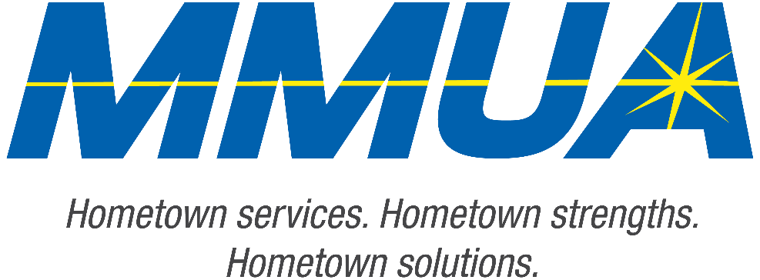

**FOR IMMEDIATE RELEASE**  
August 19, 2025  
Media Contact: Karleen Kos, CAE, president/CEO, Minnesota Municipal Utilities Association; [kkos@mmua.org](mailto:kkos@mmua.org)

**Minnesota Municipal Utilities Association Honors Elk River Utilities Leaders at Annual Conference**

[Rochester, MN] — The Minnesota Municipal Utilities Association (MMUA) has proudly recognized excellence in the state’s public power and water community by presenting its annual awards during the 2025 MMUA Summer Conference: “Utility Leadership at the Speed of Change,” held August 18–20 at the Kahler Grand Hotel in Rochester, Minnesota.

The awards celebrate individuals and utilities exemplifying outstanding service, innovation, leadership, and dedication to community values in the municipal utility sector. This year, two individuals from Elk River were awarded.

**Sara Youngs**, assistant director, Elk River Municipal Utilities

Sara received MMUA’s Rising Star Award, which recognizes future leaders who have demonstrated dedication to the goals and principles of municipal utilities through problem-solving, creativity, and job knowledge.

--more--

MMUA 2025 Award Winners

2-2-2

Sara strives to deliver the best experience for her team, colleagues, and customers. She relaunched the rebate program with the communications team and introduced new software for tracking rebates and expenses. In 2024, she contributed to the first annual kWh savings target in over seven years.

Sara highlights successes, mentors others, and helps them see how their roles can evolve. Her leadership resulted in recognizing the need for a lead customer service rep and improved cross-training for consistent service.

Sara proactively steps up when needed. As a lifelong learner, she attends conferences like MMUA, APPA, and NISC, sharing insights to improve billing, collections, and customer service. Originally the Customer Service Manager, Sara was promoted to Administration Director in under a year. Her proactive approach helps her identify issues, find solutions, and seek resources, making her vital to Elk River’s success.

**Scott Thoreson**, retired line crew foreperson, Elk River Municipal Utilities

Scott received MMUA’s Honorary Lifetime Membership Award in recognition of his long-standing commitment to municipal utilities and the broader industry. The award highlights a career dedicated to enhancing local utility services and advancing industry standards across the state.

With 32 years of experience as a lineworker and public power advocate, Scott has demonstrated leadership, technical skill, and a positive attitude at Elk River Municipal Utilities. He played a key role in supporting the utility’s expansion efforts.

Scott has been a consistent supporter of MMUA’s safety and training programs, often volunteering as an instructor for both overhead and underground schools. He has also served as a judge at the organization’s annual lineworker rodeo multiple times.

—more—

MMUA 2025 Award Winners

3-3-3

Known for championing safety, mentoring colleagues, and fostering community engagement, Scott has built lasting relationships with public power professionals nationwide through mutual aid efforts.

As he transitions into retirement, the community and industry colleagues wish him the best in his future endeavors.

“Our award recipients represent the best of public service—committed professionals and community-focused utilities working tirelessly to serve Minnesota residents with safe, reliable, and affordable services,” says MMUA CEO Karleen Kos. “This year’s winners embody the spirit of public service and remind us why municipal utilities remain so vital to our state.”

The conference brought together more than 250 utility professionals, board members, and industry partners from across Minnesota and the Upper Midwest for several days of training, networking, and celebration. Keynote sessions focused on embracing change and generating engagement in the workplace.

For more information about MMUA awards and programs, visit [Summer Conference: Utility Leadership at the Speed of Change - Minnesota Municipal Utilities Association](https://www.mmua.org/events/summer-2025#whattoexpect).

About the Minnesota Municipal Utilities Association (MMUA): The Minnesota Municipal Utilities Association represents the interests of the state’s community-owned electric, gas, and water utilities. MMUA provides training, advocacy, and support to ensure reliable, sustainable, and locally controlled utility services across Minnesota.

###