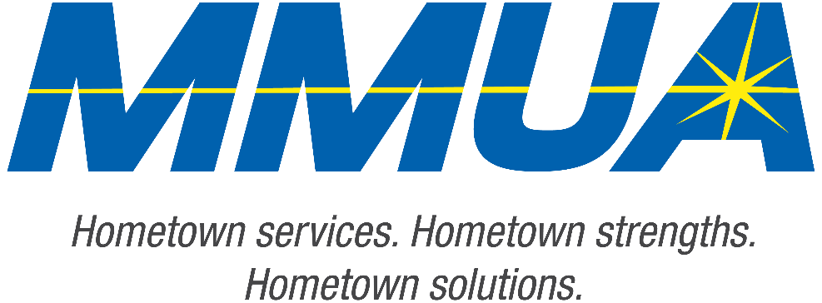

**FOR IMMEDIATE RELEASE**  
August 19, 2025  
Media Contact: Karleen Kos, CAE, president/CEO, Minnesota Municipal Utilities Association; [kkos@mmua.org](mailto:kkos@mmua.org)

**Minnesota Municipal Utilities Association Honors Detroit Lakes Utility Leaders at Annual Conference**

[Rochester, MN]—The Minnesota Municipal Utilities Association (MMUA) has proudly recognized excellence in the state’s public power and water community by presenting its annual awards during the 2025 MMUA Summer Conference: “Utility Leadership at the Speed of Change,” held August 18–20 at the Kahler Grand Hotel in Rochester, Minnesota.

The awards celebrate individuals and utilities exemplifying outstanding service, innovation, leadership, and dedication to community values in the municipal utility sector. This year MMUA presented awards to two individuals from Detroit Lakes Public Utilities.

**The 2025 MMUA awards included:**

**Madalyn Sukke,** commissioner, Detroit Lake Public Utilities Commission

Madalyn received MMUA’s 2025 Community Service Award*.* This award is presented to an individual for their years of stellar service in support of a municipal utility at the local level.

--more--

MMUA 2025 Award Winners

2-2-2

Madalyn’s commitment to public power has not gone unnoticed in the Detroit Lakes community. She has served the city for more than 16 years, holding positions on the city council promoting public works, economic development, and public safety. In 2017 she was named Council Liaison for the Public Utilities Commission, and in 2022 she was named a member of the commission. She attends legislative rallies in Saint Paul and Washington DC, advocating for public power. Madalyn is a true supporter of Detroit Lakes Public Utilities’ needs.

**Vernell Roberts**, general manager, Detroit Lakes Public Utilities

Vernell received MMUA’s 2025 President’s Award. The MMUA President’s Award recognizes people whose contributions as an individual, to MMUA, or the industry as a whole, have been exemplary. The winner is chosen by the MMUA Board of Directors President.

Vernell has served on multiple boards of directors, including the MMUA Board, with a term as President. He has instructed classes at MMUA conferences and schools, and has been a regular presence in Saint Paul and Washington D.C.

Vernell served as an MMUA Safety Coordinator and Job Training and Safety instructor. He went above and beyond by taking extra time to mentor young linemen, helping them learn how to navigate projects, personnel, budgets, politics, and more. Vernell’s impact on municipal utilities and the individuals serving them is widespread and long-lasting.

“Our award recipients represent the best of public service—committed professionals and community-focused utilities working tirelessly to serve Minnesota residents with safe, reliable, and affordable services,” says MMUA CEO Karleen Kos. “This year’s winners embody the spirit of public service and remind us why municipal utilities remain so vital to our state.”

--more--

MMUA 2025 Award Winners

3-3-3

The conference brought together more than 250 utility professionals, board members, and industry partners from across Minnesota and the Upper Midwest for several days of training, networking, and celebration. Keynote sessions focused on embracing change and generating engagement in the workplace.

For more information about MMUA awards and programs, visit [Summer Conference: Utility Leadership at the Speed of Change - Minnesota Municipal Utilities Association](https://www.mmua.org/events/summer-2025#whattoexpect).

About the Minnesota Municipal Utilities Association (MMUA): The Minnesota Municipal Utilities Association represents the interests of the state’s community-owned electric, gas, and water utilities. MMUA provides training, advocacy, and support to ensure reliable, sustainable, and locally controlled utility services across Minnesota.

###