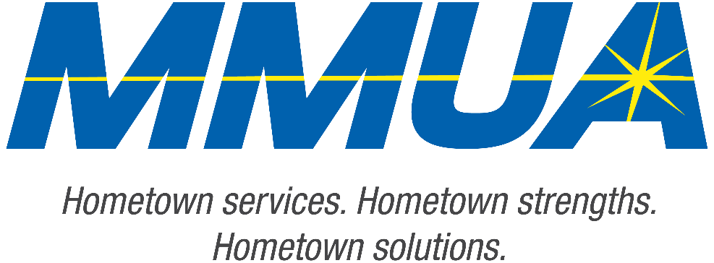

**FOR IMMEDIATE RELEASE**  
August 19, 2025  
Media Contact: Karleen Kos, CAE, president/CEO, Minnesota Municipal Utilities Association; [kkos@mmua.org](mailto:kkos@mmua.org)

**Minnesota Municipal Utilities Association Honors Outstanding Achievements at Annual Conference**

[Rochester, MN]—The Minnesota Municipal Utilities Association (MMUA) has proudly recognized excellence in the state’s public power and water community by presenting its annual awards during the 2025 MMUA Summer Conference: “Utility Leadership at the Speed of Change,” held August 18–20 at the Kahler Grand Hotel in Rochester, Minnesota.

The awards celebrate individuals and utilities exemplifying outstanding service, innovation, leadership, and dedication to community values in the municipal utility sector.

**Mark Nibaur**, general manager, Austin Utilities

Mark received the Honorary Lifetime Membership Award, recognizing his extensive career dedicated to advancing municipal utilities both locally and statewide. Since 2010, he has led Austin Utilities through significant growth, including consolidating multiple sites. Under his leadership, the utility has fostered a caring, curious, and committed culture, earning several industry awards.

--more--

MMUA 2025 Award Winners

2-2-2

Beyond his organizational leadership, Mark has played an active role in the MMUA. He served on the board from 2018 to 2024, including a term as president during the height of the COVID-19 pandemic in 2020-2021. He participates in numerous committees and regularly attends legislative meetings in Minnesota and Washington, DC. Mark also supported the leadership transition to Karleen Kos and remains a steadfast advocate for MMUA.

“Our award recipients represent the best of public service—committed professionals and community-focused utilities working tirelessly to serve Minnesota residents with safe, reliable, and affordable services,” says MMUA CEO Karleen Kos. “This year’s winners embody the spirit of public service and remind us why municipal utilities remain so vital to our state.”

The conference brought together more than 250 utility professionals, board members, and industry partners from across Minnesota and the Upper Midwest for several days of training, networking, and celebration. Keynote sessions focused on embracing change and generating engagement in the workplace.

For more information about MMUA awards and programs, visit [Summer Conference: Utility Leadership at the Speed of Change - Minnesota Municipal Utilities Association](https://www.mmua.org/events/summer-2025#whattoexpect).

About the Minnesota Municipal Utilities Association (MMUA): The Minnesota Municipal Utilities Association represents the interests of the state’s community-owned electric, gas, and water utilities. MMUA provides training, advocacy, and support to ensure reliable, sustainable, and locally controlled utility services across Minnesota.

###