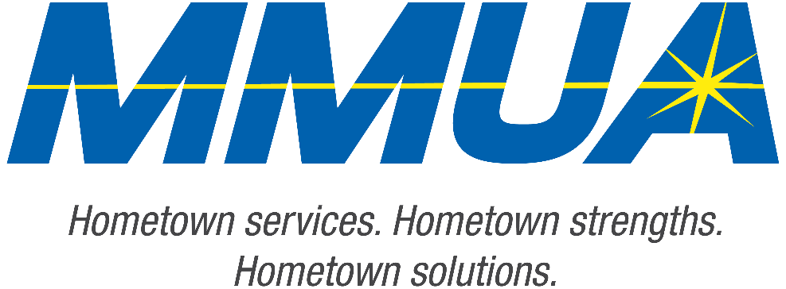

**FOR IMMEDIATE RELEASE**  
August 19, 2025  
Media Contact: Karleen Kos, CAE, president/CEO, Minnesota Municipal Utilities Association; [kkos@mmua.org](mailto:kkos@mmua.org)

**Minnesota Municipal Utilities Association Honors Anoka Advisor at Annual Conference**

[Rochester, MN]—The Minnesota Municipal Utilities Association (MMUA) has proudly recognized excellence in the state’s public power and water community by presenting its annual awards during the 2025 MMUA Summer Conference: “Utility Leadership at the Speed of Change,” held August 18–20 at the Kahler Grand Hotel in Rochester, Minnesota.

The awards celebrate individuals and utilities exemplifying outstanding service, innovation, leadership, and dedication to community values in the municipal utility sector. This year one individual from Anoka was recognized.

**Ed “Doc” Evans**, advisory board, Anoka Municipal Utility

Ed, or as most of the MMUA membership knows him, Doc, received the Distinguished Service Award, which honors a leader demonstrating outstanding service in support of MMUA and its goals. With more than 35 years of service at Anoka Municipal Utilities, Doc Evans currently serves as the utility advisory board president.

A strong advocate for MMUA and public power, Doc is unafraid to raise issues he believes will benefit the association, its members, and its broader efforts.

--more--

MMUA 2025 Award Winners

2-2-2

Known for his active participation, Doc rarely misses MMUA events, often attending multiple meetings in different locations to stay informed. He has also been a key figure in organizing the association’s Summer Conference bike tours and participates in the hikes.

“Our award recipients represent the best of public service—committed professionals and community-focused utilities working tirelessly to serve Minnesota residents with safe, reliable, and affordable services,” says MMUA CEO Karleen Kos. “This year’s winners embody the spirit of public service and remind us why municipal utilities remain so vital to our state.”

The MMUA conference brought together more than 250 utility professionals, board members, and industry partners from across Minnesota and the Upper Midwest for several days of training, networking, and celebration. Keynote sessions focused on embracing change and generating engagement in the workplace.

For more information about MMUA awards and programs, visit [Summer Conference: Utility Leadership at the Speed of Change - Minnesota Municipal Utilities Association](https://www.mmua.org/events/summer-2025#whattoexpect).

About the Minnesota Municipal Utilities Association (MMUA): The Minnesota Municipal Utilities Association represents the interests of the state’s community-owned electric, gas, and water utilities. MMUA provides training, advocacy, and support to ensure reliable, sustainable, and locally controlled utility services across Minnesota.

###