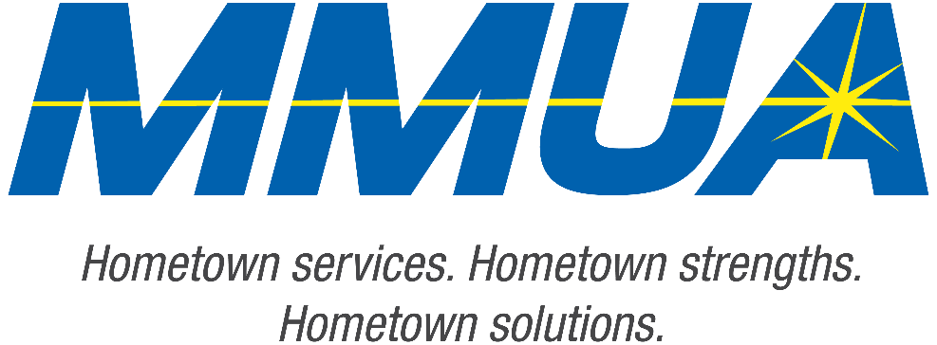

**FOR IMMEDIATE RELEASE**  
August 19, 2025  
Media Contact: Karleen Kos, CAE, president/CEO, Minnesota Municipal Utilities Association; [kkos@mmua.org](mailto:kkos@mmua.org)

**Minnesota Municipal Utilities Association Honors Outstanding Achievements at Annual Conference**

[Rochester, MN]—The Minnesota Municipal Utilities Association (MMUA) has proudly recognized excellence in the state’s public power and water community by presenting its annual awards during the 2025 MMUA Summer Conference: “Utility Leadership at the Speed of Change,” held August 18–20 at the Kahler Grand Hotel in Rochester, Minnesota.

The awards celebrate individuals and utilities exemplifying outstanding service, innovation, leadership, and dedication to community values in the municipal utility sector.

“Our award recipients represent the best of public service—committed professionals and community-focused utilities working tirelessly to serve Minnesota residents with safe, reliable, and affordable services,” says MMUA CEO Karleen Kos. “This year’s winners embody the spirit of public service and remind us why municipal utilities remain so vital to our state.”

--more--

MMUA 2025 Award Winners

2-2-2

**The 2025 MMUA awards included:**

*Rising Star Award:* Recognizes future leaders who have demonstrated dedication to the goals and principles of municipal utilities through problem-solving, creativity, and job knowledge. The honorees this year are:

**Brian Riggleman**, business analyst engineer, Owatonna Public Utilities

**Easton Dale**, superintendent, North Saint Paul Electric Utilities

**Sara Youngs**, assistant director, Elk River Municipal Utilities

*Public Service Award:* MMUA’s Public Service Award is given to a local, state, or federal elected or appointed official who has been a strong supporter of MMUA and its members. The honoree this year is:

**Don Martodam**, former commissioner, Hawley Public Utilities

*Community Service Award:* This award is presented to an individual for their years of stellar service in support of a municipal utility at the local level.  The honoree this year is:

**Madalyn Sukke,** commissioner, Detroit Lake Public Utilities Commission

*Distinguished Service Award:* Honoring a leader who has demonstrated outstanding service in support of MMUA and its goals. The honoree this year is:

**Ed “Doc” Evans**, advisory board, Anoka Municipal Utility

*Honorary Lifetime Membership Award:* The Honorary Lifetime Membership Award symbolizes a professional career dedicated not only to the advancement of municipal utilities locally but also to the betterment of our industry on a statewide basis. The honorees this year are:

**Mark Nibaur**, general manager, Austin Utilities

**Scott Thoreson**, retired line crew foreperson, Elk River Municipal Utilities

--more--

MMUA 2025 Award Winners

3-3-3

*President’s Award:* The MMUA President’s Award is meant to recognize people whose contributions as an individual, to MMUA, or the industry as a whole, have been exemplary. The winner is chosen by the MMUA Board of Directors President. The honoree this year is:

**Vernell Roberts**, general manager, Detroit Lakes Public Utilities

The conference brought together more than 250 utility professionals, board members, and industry partners from across Minnesota and the Upper Midwest for several days of training, networking, and celebration. Keynote sessions focused on embracing change and generating engagement in the workplace.

For more information about MMUA awards and programs, visit [Summer Conference: Utility Leadership at the Speed of Change - Minnesota Municipal Utilities Association](https://www.mmua.org/events/summer-2025#whattoexpect).

About the Minnesota Municipal Utilities Association (MMUA): The Minnesota Municipal Utilities Association represents the interests of the state’s community-owned electric, gas, and water utilities. MMUA provides training, advocacy, and support to ensure reliable, sustainable, and locally controlled utility services across Minnesota.

###