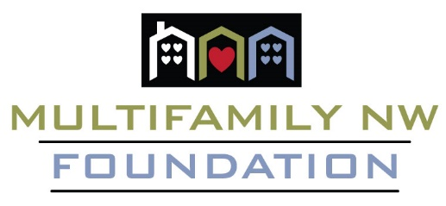
Multifamily NW Foundation
16083 SW Upper Boones Ferry Road, Suite 105
Tigard, OR 97224

[Business Name]
[Business Address]
[City, State, ZIP Code]

Dear [Business Owner/Manager's Name],
I hope this letter finds you well. I am writing to you on behalf of the Multifamily NW (MFNW) Foundation, a 501(c)(3) non-profit organization dedicated to making a positive impact in our local community. We are excited to announce our upcoming event, Raise A Glass & Give 2024, which is set to take place on May 8th at the picturesque Tumwater Vineyard.
This annual fundraiser benefits local charities and the MFNW Foundation’s endeavors. This year’s event will be supporting Camp Rosenbaum and the MFNW Foundation programs including the scholarship program.
Camp Rosenbaum is an extraordinary summer camp that provides underprivileged children with a unique and life-changing experience. Camp Rosenbaum instills values of leadership, teamwork, and personal growth, leaving a lasting positive impact on every participant.
The MFNW Foundation Scholarship Program offers scholarships through the Portland State University Center for Real Estate and the newly introduced Deborah Imse Apartmentalize Scholarship.
To make our event a success and support these great causes, we are seeking contributions for our silent auction. Your generous donation can help make a significant difference in the lives of those we serve and strengthen the bonds within our community.
Here's how you can contribute:
- Donate a product or service from your business that we can include in our silent auction.
- Sponsor a portion of our event, gaining exposure to our attendees and showcasing your commitment to our community.
- Attend our event and encourage your employees and colleagues to join you for an evening of fun and philanthropy.
In return for your support, we will recognize your contribution in our event materials and promotions, ensuring that your generosity is highlighted in front of our diverse audience of local residents, professionals, and community leaders.
We would be delighted to arrange a meeting at your convenience to discuss how you can get involved and make a meaningful impact. Alternatively, you can complete the enclosed donation form and return it to us, and we will handle the rest.
Thank you for considering our request. Together, we can raise a glass, give back to our community, and create a brighter future for our community. Your support is invaluable to us, and we are deeply grateful for your consideration.
If you have any questions or would like to discuss this further, please do not hesitate to contact me at [Your Phone Number] or [Your Email Address].
Sincerely,

