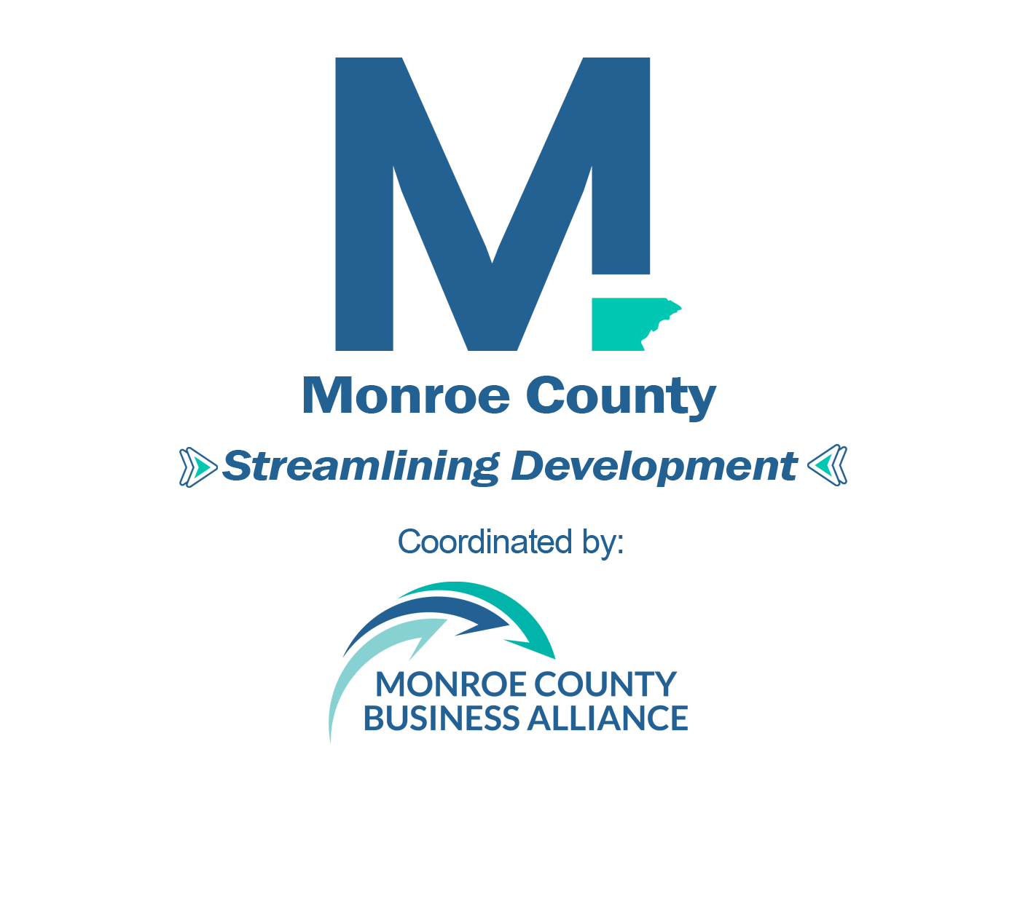
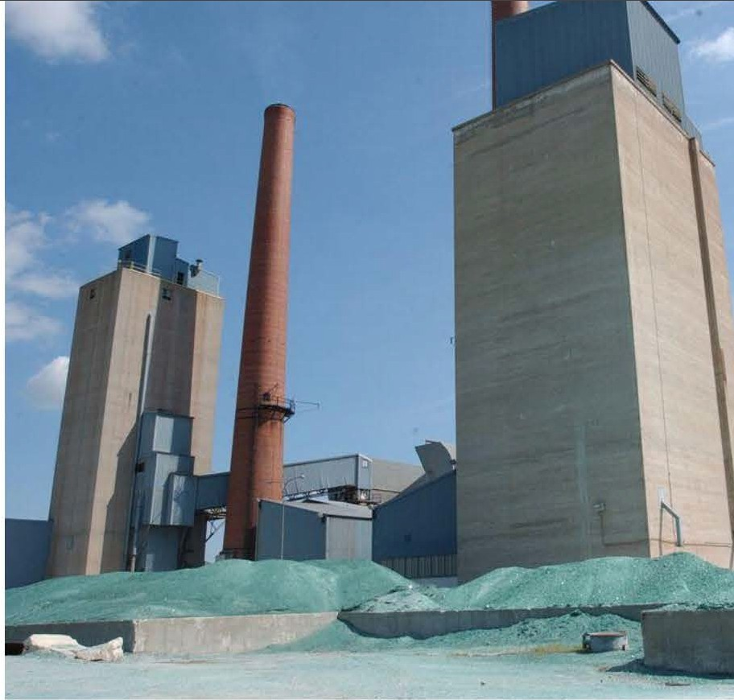
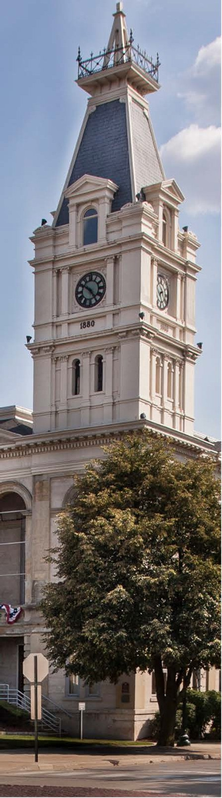
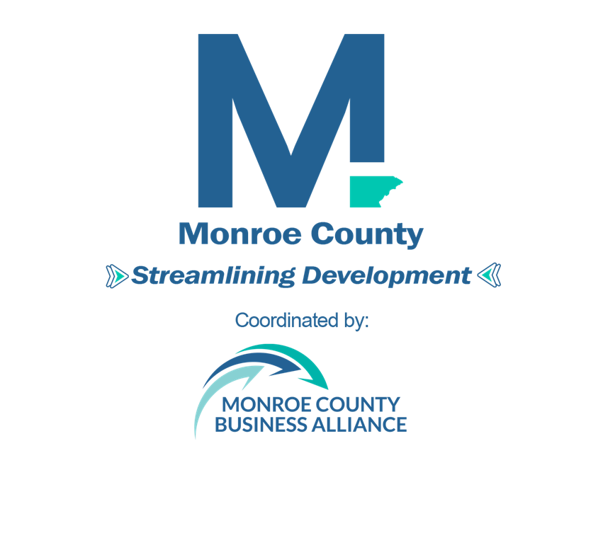

Revised
January 2026
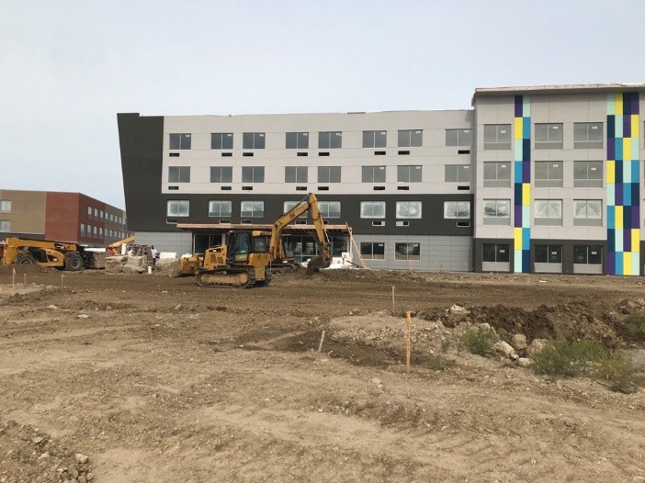

Table of Contents

Contents
Monroe County Board of Commissioners 7
Monroe County Economic Development Corporation 8
Streamlining Development Task Force 9
Streamlining Development User’s Guide 10
Mission Statement 10
Goals 10
Keeping this Guide Up to Date 11
1. Partnership Pledge 12
Streamlining Development Partnership Signatories (as of 3-19-18) 12
Partnership Pledge 13
Partnership Assistance & Web Links 14
Monroe County Municipalities 15
Municipal Contacts 16
2. Development Assistance 19
Monroe County Business Alliance 19
Monroe County Community Planning and Engagement Department 20
Downtown Development Authorities 21
Southeast Michigan Council of Governments 21
Monroe County Community College 22
Monroe County Communities 23
Ash Township 23
Bedford Township 24
Berlin Charter Township 25
Dundee Township 26
Erie Township 27
Exeter Township 28
Frenchtown Charter Township 29
Ida Township 30
LaSalle Township 31
Monroe Charter Township 32
Raisinville Township 33
Whiteford Township 34
City of Luna Pier 36
City of Milan 37
City of Monroe 37
Development Information 38
City of Petersburg 39
Village of Dundee 39
Village of Estral Beach 40
Economic Development Opportunities 41
3. Financial Assistance 42
Monroe County Financial Institutions 42
Economic Development Funds, Grants, Loans and Bonds 42
4. Site Selection 44
Industrial Parks, Business Parks & Technology Parks 44
Port of Monroe 45
Commercial Property Information Exchange (CPIX) 46
GIS Mapping 46
Monroe County Comprehensive Plan 47
5. Local & State Agencies Review, Permits & Approvals 48
Purpose & Jurisdiction 49
Activities That Require Permitting 49
Fee Schedule 51
Helpful Hints 51
Monroe County Drain Commissioner 52
Purpose 52
Jurisdiction 53
Information Required 54
Preliminary Site Plan 54
Final Site Plan 55
Fee Schedule 56
Monroe County Website Information 57
Monroe County Health Department 57
General Guidelines 57
Monroe County Sanitary Code Website Information 59
Michigan Department of Transportation 59
Michigan Department of Environment, Great Lakes, and Energy 61
EGLE Permit Information Checklist 62
Michigan Guide to Environmental, Health, and Safety Regulations 62
Environmental Assistance Center information: 63
Local EGLE Contacts 63
U. S. Army Corps of Engineers 65
6. Zoning/Special Approval/Site Plan Review 66
Zoning 66
The Rezoning Process 67
Special Approval Uses 70
Site Plan Review 71
Other Site Development Regulations 73
7. Strategies for Successful Development 75
8. Utility Service Areas & Maps 77
Water 77
Sewer / Sanitary 78
Sanitary Sewer Service Areas 78
Telephone & Internet 79
Natural Gas & Electric 80
9. Transportation Systems 82
Rail Transportation 82
State and Federal Highway System 84
Class A, Paved and Unpaved Roadways 85
Truck Route 86
Regional Transportation Network 87
10. Workforce / Talent Development 88
Monroe County Community College 88
Training and Development 88
Employment Agencies 90
Schools and Colleges 90
Monroe County Educational Technology Millage 91
University Research Corridor 91
11. Quality of Life 92

Monroe County Board of Commissioners

Commission Member District
David Vensel, Chairman District 6
Brian Lamour, Vice Chair District 5
David C. Hoffman District 1
Dawn Asper District 3
Mark Brant District 2
Jay Heinzerling District 4
David Swartout District 7
Greg Moore District 8
J. Henry Lievens District 9
Michael Bosanac Administrator / CFO
Lisa Sanders Deputy Clerk

Monroe County Economic Development Corporation

The vision for this Streamlining Development guide was facilitated by a large group of community stakeholders focused on developing a pathway to make Monroe County as development-friendly as possible. An incredible amount of work by those listed below resulted in the development of this document and led to its use by thousands in pursuit of more efficient and effective development. The Economic Development Corporation as a working group was dissolved in 2024 and the continuance of their work was championed by the Monroe County Business Alliance.

Development MCEDC Team:
Commission Member Organization
Tracy Oberleiter, Chairman Office of Senator Dale W. Zorn
Barry Buschmann, Vice Chairman The Mannik & Smith Group, Inc.
Tom Allen, Treasurer Allen Chevrolet Cadillac
Mike Baker Michigan Gas Utilities
Kim Comerzan Community Health
Matt Vanisacker Monroe County Business Development Corporation
Scot Laskey Laskey Company LLC
Randy Mielnik Poggemeyer Design Group
Dan Minton Skilled Trades Representative
Stacey Goans Michigan Works! Monroe County Employment & Training Department
Tim Janssens Agriculture Representative
George Jondro County Commissioner, District 4
Lisa Sanders Monroe County Emergency Medical Authority

Streamlining Development Task Force
The following participants played a key developmental role in the inception and implementation of this document.

Group Member Organization
Barry Buschmann, Task Force Chairman The Mannik & Smith Group, Inc. (Retired)
Randy Pierce Former Monroe County Road Commissioner
David Thompson Former Monroe County Drain Commissioner
Carolyn Bennett DTE Energy
Tom Fritz Coldwell Banker Commercial Real Estate
Jim Jacobs James S. Jacobs Architects, PLLC
Barry Kinsey Monroe County Community College
Tim Lake Former CEO - Monroe County Business Development Corporation
Mike Baker Former Michigan Gas Utilities
Tracy Oberleiter Former Monroe Bank & Trust
Jeff McBee Monroe County Planning and Engagement Department
Adelaide Pascaris Former International Transmission Co. (ITC)
Jason Sheppard Former State Representative
Cynthia Stump International Transmission Co. (ITC)
David Uhl Former Village of Dundee
Kennis Wooten Former DTE Energy Employee

Streamlining Development User’s Guide
Streamlining the Development Process in Monroe County
To better serve the development community, the Monroe County Business Alliance has facilitated the creation of a guide that will “streamline the development processes” within Monroe County saving precious time, money and effort in getting projects up and running in the shortest possible time.
This Streamlining Guide is a partnership between county agencies, authorities, municipalities and others that may become involved with the planning, permitting, construction and assistance in project developments in Monroe County. This partnership is accomplished by having all interested parties participate in the preparation of the guide’s information and by keeping the information current and relevant.
We believe that as you move through this guide you will find that doing business in Monroe County, Michigan will not only be financially rewarding but will provide recommendations for development efficiencies and avoidance of typical pitfalls.
Should you require additional assistance the Monroe County Business Alliance, whose mission it is to assist developers on all phases of their projects, stands ready to work with you on your project. You can contact the Alliance at 734-241- 8081 or via email at SStrube@MCBusinessAlliance.org or visit the Alliance website at Alliancewww.MCBusinessAlliance.org.

Mission Statement
To establish a county wide recognized guide for expediting the development process for industrial, commercial and residential real estate in Monroe County. This guide will provide guidance to developers on what to do, where to go and who to contact.

Goals
Create a streamlined process for developers and entrepreneurs to quickly facilitate new and expansion projects in Monroe County.
Enhance a collaborative partnership among all jurisdictions involved with the development and permitting processes within Monroe County for use by these partners to promote and grow Monroe County.
Develop a sustainability plan to keep this resource document and the partnership agreements updated and monitor the viability of its use

Keeping this Guide Up to Date
The intent of the Streamlining Development User’s Guide is to have this document current and relevant through regular updates by each of the many governmental agencies, municipalities and business partners associated with the development of this booklet. Online information will be reviewed on a regular basis and modifications made by the Monroe County Planning and Engagement Department and Monroe County Business Alliance. If any changes are required, each respective governmental agency, municipality or business partner should contact the Monroe County Planning and Engagement Department at 734-240-7375 or contact The Monroe County Business Alliance by calling 734-241-8081 and provide the information along with any maps, forms or other documents. The Monroe County Streamlining Group will meet periodically to review the document content to verify that the information is up- to-date and accurate.



1. Partnership Pledge
On the following page is a copy of the Partnership Pledge which has been provided to all Monroe County municipalities as well as to a variety of other agencies and organizations. By signing this pledge, a network of cooperating partners has emerged that is committed to promoting a streamlined development process. The following list are those communities and agencies which have demonstrated their support for this streamlined process by signing and returning this pledge to the Monroe County Business Alliance.

Streamlining Development Partnership Signatories (as of 3-19-18)
Ash Township | LaSalle Township
- Bedford Township | - Michigan Works! MCETD
- Berlin Charter Township | - First Merchants Bank
- City of Luna Pier | - Monroe Charter Township
- City of Milan | - Monroe County Board of Commissioners
- City of Monroe | - Monroe County Community College
- City of Petersburg | - Monroe County Drain Commissioner’s Office
- County of Monroe | - Monroe County Planning Commission
- Dundee Township | - Monroe County Road Commission
- Erie Township | - Raisinville Township
- Exeter Township | - Village of Carleton
- Fifth Third Bank | - Village of Dundee
- Frenchtown Charter Township | - Village of Estral Beach
- Home Builders Assn. of Monroe County | - Village of South Rockwood
- Ida Township | - Whiteford Township

Partnership Pledge
As Monroe County continues to emerge from the Great Recession we want to position ourselves for the growth and expansion that is projected to occur, with the completion of the new Gordie Howe Bridge to Canada and the widening of the Panama Canal along with continued economic growth in and around Southeast .Michigan and Northwest Ohio. With this in mind, the Monroe County Economic Development Corporation (MCEDC) will continue its work in producing a coordinated developer's guide that will help "streamline the development processes" within our boarders thus saving precious time, money and effort in getting projects up and running in the shortest possible time. This Developer's Streamlining Guide has become a coordinated partnership between agencies, authorities, municipalities and others that are involved with the planning, permitting, construction and assistance in project developments here in Monroe 'county. This partnership will be accomplished by having all !he interested parties that participate in the guide in helping to keep it current and relevant.
Your help and support is needed ......
Whether a small rural community wishing to maintain their character or a mixed use community seeking coordinated growth and development, the hope is that by having a common development, vision and guide, Monroe County can creak an exciting and desirable place for economic growth and development to occur.
The MCEDC hopes we can add your organizations name as a ''Partner" in this coordinated countywide initiative. In this effort we are asking you to sign this document and return it to the Monroe County Business Development Corporation as a pledge of support. Again this pledge simply slates that you are a willing partner in promoting economic growth in Monroe County and pledge to support the MCEDC in maintaining a current and relevant Development Streamlining Guide by keeping them informed of changes in your information contained within.

We encourage your community to provide essential information to our guide by completing the attached Community Profile Template. Please attach additional information as you feel necessary.
(Your Organization ,Name) hereby has our pledge of support and submit our Partnership Pledge in support of the Monroe County Developer's Streamlining Guide.

Signed:___________________________ Date:_____________________
Title:______________________________

Partnership Assistance & Web Links
County & State Organizations

MCPD | Monroe County Community Planning and Engagement Department  https://www.co.monroe.mi.us/250/Community-Planning-Engagement
MCRC | Monroe County Road Commission  www.mcrc-mi.org
MCDC | Monroe County Drain Commission  https://www.co.monroe.mi.us/483/Drain-Commission
MCHD | Monroe County Health Department  www.co.monroe.mi.us/officials_and_departments/departments/health_department/index.php
MCMI | Monroe County, Michigan  www.co.monroe.mi.us
SEMCOG | Southeast Michigan Council of Governments  www.semcog.org
TMACOG | Toledo Metropolitan Area Council of Governments  www.tmacog.org
EGLE | Michigan Department of Environment, Great Lakes and Energy  www.michigan.gov/egle
MDOT | Michigan Department of Transportation  www.michigan.gov/mdot
MEDC | Michigan Economic Development Corporation  www.michiganbusiness.org

Monroe County Municipalities

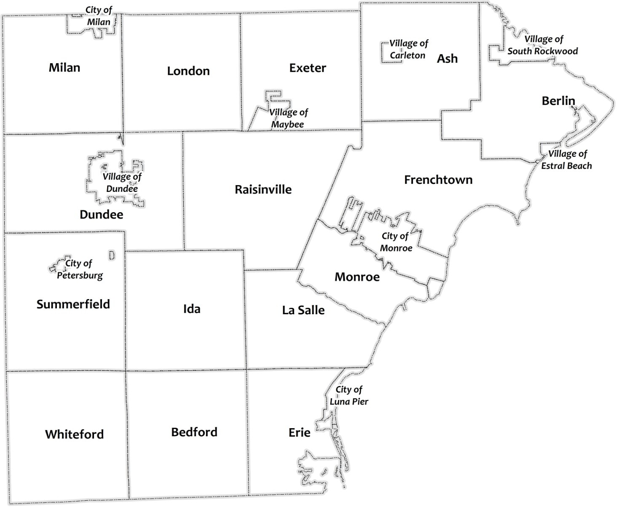

Municipal Contacts
Municipality | Phone | Website
Ash Township | 734-654-6992 | ashtownship.org
Bedford Township | 734-847-6791 | bedfordmi.org
Berlin Charter Township | 734-586-2187 | berlinchartertwp.com
Dundee Township | 734-529-2650 | dundeetownship.info
Erie Township | 734-848-5915 | erietownship.com
Exeter Township | 734-587-2100 | exetertwp.com
Frenchtown Charter Twp. | 734-242-3282 | frenchtowntownship.org
Ida Township | 734-269-3045 | idatownship.org
LaSalle Township | 734-241-4344 | lasalletwpmi.com
London Township | 734-439-1984 | https://londontwpmi.gov/
Milan Township | 734-439-1707 | milantownship.org
Monroe Charter Township | 734-241-5501 | monroechartertownship.org
Raisinville Township | 734-269-2506 | raisinville.org
Summerfield Township | 734-279-1214 | summerfieldtownship.org
Whiteford Township | 734-854-2416 | whitefordtownship.org
City of Luna Pier | 734-848-6495 | cityoflunapier.com
City of Milan | 734-439-1501 | milanmich.org
City of Monroe | 734-243-0700 | monroemi.gov
City of Petersburg | 734-279-1210 | petersburg-mi.com
Village of Carleton | 734-654-6255 | carletonmi.us
Village of Dundee | 734-529-3430 | dundeevillage.net
Village of Maybee | 734-587-2900 | maybeevillage.com
Village of South Rockwood | 734-379-3683 | villageofsouthrockwoodmi.com

A complete and up-to-date Monroe County Directory, including listing and contact information for all local officials and State and Federal legislators is available at:
https://co.monroe.mi.us/

Utilities

DTE Energy | 800-477-4747 | DTEEnergy.com
Consumers Energy | 800-477-5050 | ConsumersEnergy.com
Michigan Gas Utilities | 800-401-6402 | MichiganGasUtilities.com

Telephone

Frontier Communications | Frontier.com
Verizon Communications | Verizon.com
AT & T | ATT.com

Internet / Cable / Fiber

Comcast | Comcast.com
Buckeye Cable System | BuckeyeCableSystem.com
Merit Network Inc | merit.edu
Telesystem | telesystem.us

Railroads

Ann Arbor Railroad | 419-726-4181
Canadian National Railroad (CNRR) | 708-332-3959
CSX Transportation | 614-793-3065
Norfolk Southern Corporation (NS RR) | 317-819-7672
Conrail (connects with CSX Transportation at Carleton) | 856-231-2003
Indiana & Ohio Railway (connects with AARR & CN Rail at Diann) | 513-860-1000

MDOT

Brighton Transportation Service Center  10321 E. Grand River, Suite 500  Brighton, Michigan 48116 | 810-227-4681

EGLE
Michigan Department of Environment, Great Lakes and Energy Water Resources Division | 517-257-7380

U.S. Army Corps of Engineers
U.S. Army Corps of Engineers Detroit District Office | 313-226-6413

2. Development Assistance
Monroe County has a wide range of services and agencies that can assist the development community in moving forward with plans to locate or expand within the community. Monroe County has long been viewed as a crossroads for commerce and for more than three decades, the Monroe County Business Development Corporation (MCBDC) has been assisting industries and businesses capitalize on their opportunities to locate or expand in this dynamic area of Southeast Michigan. The Monroe County Planning and Engagement Department has a wide range of resources, data, and information at its disposal which can greatly aid in the process of site selection and development. Local Downtown Development Authorities provide incentives for projects within designated districts in the county. Although many of our communities are rural in nature and do not have full time professional staffs, our larger communities, including the City of Monroe, the Village of Dundee, and Bedford Township have economic development professionals who are committed to a streamlined development process.
A recent development which was an outgrowth of the original publication of this document is the adoption of a Memorandum of Understanding between the Monroe County Road Commission and the Monroe County Drain Commissioner’s Office. This agreement was specifically designed to streamline and speed up the review of development proposals by these agencies. A copy of the memorandum is available at: www.mcrc-mi.org/images/MOU_road_drain.pdf. In addition, the Monroe County Economic Development Corporation/Monroe County Link’s Streamline Development Pillar team has created a memorandum of understanding for municipalities and property owners to further streamline the process of development.

Monroe County Business Alliance
The Alliance mission is to work with its strategic partners to attract and retain a diverse range of businesses that create an economic environment of innovation and success. We do this while fostering the growth of existing businesses by partnering with them to focus on their growth and success. The Alliance also is the lagest incubator and accelerator in the county assisting entrepreneurs and small business owners with growth and development. Additionally, the Alliance hosts the GoToMonroe.com community calendar for our neighbors by our neighbors. The Alliance is as a result of the former Monroe County Business Development Corporation started in 1982 and the former Monroe County Chamber of Commerce. In combining the two business-centric organizations, greater networking, information sharing, and collective growth has been achieved.
The Alliance stands ready to meet your site location, expansion or business development needs and has a track record of success in fostering economic development. Our goal is to be a one-stop shop for economic development assistance through our programs such as:
• Business FIRST – where we provide concierge services to commercial businesses locating or expanding. As the local partner of the Michigan Economic Development Corporation, the Alliance is your first stop to doing business in the county.

• Retention & Attraction Initiatives – directed at our industrial-based businesses by assisting with local and state incentive programs, site selection and ombudsman services as they move through the development stages of their projects.
•Monroe County Link – Monroe County’s comprehensive economic development strategy. 6 pillars of activity working to promote development opportunities throughout the county.
For over 50 years, the expert staff of the Monroe County Business Alliance has helped thousands of businesses as they have located and/or expanded their operations within our county borders. We know Monroe County and are here to assist you as you move through the development process. Give us a call to talk about your project. We can save you time and money as you look to locate or expand your business.
Monroe County Business Alliance Sean Strube, Vice President of Economic Development
23 E Front Street, Suite 202, Monroe, MI 48161
734-241-8081
MCBusinessAlliance.org

Monroe County Community Planning and Engagement Department

The Monroe County Community Planning and Engagement Department is committed to providing the public with the information and resources necessary to promote quality development. Located in the County Courthouse in downtown Monroe, the Community Planning and Engagement Department works closely with all local units of government in the County and can serve as a liaison between developers, regulatory agencies, and other governmental authorities. The department has a great deal of data, maps and information on county resources, including aerial photography, demographic data, traffic counts, soil surveys, flood maps, land surveys, and land use information. We maintain a collection of local land use plans and zoning maps, and keep a database of local building officials, planning commissioners, and other local development contacts. Working closely with the Business Development Corporation, we make sure that economic development projects within Monroe County receive a high level of professional courtesy in the planning and review process.
Monroe County Community Planning and Engagement Department
Jeff McBee, Director
Fourth floor, Monroe County Courthouse 125 East Second Street
Monroe, MI 48161
734-240-7375
jeff_mcbee@monroemi.org

Downtown Development Authorities
Monroe County has four Downtown Development Authorities located in the City of Monroe, the City of Milan, the Village of Dundee and Lambertville (Bedford Township). Downtown Development Authorities (DDAs) were authorized under Michigan’s Public Act 197 of 1975 as an economic development tool designed to be a catalyst in the development of a community’s downtown district. The DDA provides for a variety of funding options including tax increment financing which can be used to fund public improvements, infrastructure development and other improvements to attract and retain new development.
City of Monroe DDA  Monroe Downtown Development Authority 120 East First Street  Monroe, MI 48161  734-384-9172  downtownmonroemi.com | City of Milan DDA  147 Wabash  Milan, MI 48160  734-439-1501
Village of Dundee DDA 350 W Monroe Street Dundee, MI 48131  734-529-3430  www.dundeevillage.net/index.aspx?NID=127 | Bedford Township DDA  PO. Box H  8100 Jackman Road  Temperance, MI 48182  734-847-6791  bedfordmi.org/government/downtown_ development_authority.php

Southeast Michigan Council of Governments
The Southeast Michigan Council of Governments (SEMCOG) was established in 1968 as a regional planning partnership in Southeast Michigan. SEMCOG supports local planning through its technical, data, and intergovernmental resources. SEMCOG's plans improve the quality of the region's water, make the transportation system safe and more efficient, revitalize communities, and spur economic development.
SEMCOG is the premier source for regional information regarding demographic data, population projections, building activities and economic development projects, public utilities and transportation.
SEMCOG
Kathleen Lomako, Executive Director
1001 Woodward Avenue,
Suite 1400
Detroit, MI 48226-1904
313-961-4266

Monroe County Community College
Website: monroeccc.edu
Address: 1555 S Raisinville Road, Monroe, MI 48161 (Main Campus)
Phone: 734- 242-7300
Contact Information
President: Dr. Kojo Quartey (734) 384-4166 kquartey@monroeccc.edu
Monroe County Community College is a comprehensive, two-year college located in Monroe, Michigan. Established in 1964, Monroe County Community College is a public institution supported by tax monies from Monroe County, educational funds from the state of Michigan and student tuition. We are fortunate to have a millage that is one of the best of the 28 community colleges in Michigan. The 210-acre Main Campus is centrally located in Monroe County with easy access to Detroit and Toledo, Ohio. The Whitman Center, our south extension center in Bedford Township near the Michigan-Ohio border, offers a wide selection of courses.
MCCC’s mission is to enrich lives in our community by providing opportunity through student-focused, affordable, quality higher education and other learning experiences.
MCCC accomplishes its mission through:
• Post-secondary pathways for students who plan to pursue further education
• Occupational programs and certificates for students preparing for immediate employment upon completion
• Curriculum that prepares students to effectively communicate, think critically, and be socially and culturally aware
• Comprehensive student support services
• A wealth of opportunities for intellectual, cultural, personal and career enhancement
• Training and retraining to meet the needs of an evolving economy
• Key partnerships to enhance educational services and opportunities

As its vision, the college aspires to be recognized for our student-focused service, academic excellence, affordability, innovation, community responsiveness and student success.
The college offers associate degrees and certificate programs for career preparation, as well as for transfer to four-year colleges and universities.
Four-year degrees are available right on the MCCC Main Campus through Siena Heights University and at the college’s Whitman Center in Temperance.
Development Information:
Dr. Joshua W. Myers
Executive Director of The Foundation (734) 384-4214
jmyers@monroeccc.edu
Economic Development Opportunities
Barry Kinsey
Director of Workforce Development (734) 384-4124
bkinsey@monroeccc.edu

Monroe County Communities
The following Monroe County communities have submitted information for inclusion within this Streamlining Development guidebook. Communities not specifically listed can submit information to the contact listed on page 1-1.

Ash Township
Website: ashtownship.org
Address: 1677 Ready Road, Carleton, MI 48117
Phone: 734-654-6992
Contact Information
Twp. Supervisor: | Robin Carmack | ext. #1 | rcarmack@ashtownship.org
Twp. Clerk: | Michele Geiermann | ext. #3 | mgeiermann@ashtownship.org
Twp. Treasurer: | Robert Schock | ext. #5 | rschock@ashtownship.org
Twp. Manager: | Jim Vaslo | ext. #2 | jvaslo@ashtownship.org
Building Official: | John Tackett |  | jtackett@ashtownship.org
Building Assistant: | Alyse Reaume | ext. #4 | alyser@ashtownship.org
Water/Sewer Dept: | Jennifer Kecskes | ext. #7 | jkecskes@ashtownship.or

Ash Township is located in the northeast portion of Monroe County. It borders Wayne County to the north, Frenchtown Township to the south, Berlin Township to the east, and Exeter Township to the west. Approximately 36 square miles in size, the Township includes the Village of Carleton and has direct access to I-275 and M-24. Ash Township is generally an agricultural/bedroom community with several world class businesses including Guardian Glass Automotive Float & Technical Glass Plant as well as Guardian Glass Science & Technical Center, Bosch Automotive USA Research & Development Center, and the nationally recognized brand of potted plants, Proven Winners. A variety of other commercial and industrial companies have located in Ash Township over the past 50 years. Many have taken
advantage of the geographical location and its easy access to highways, national and international rail systems and a local government willing to work with businesses at every level. Ash Township offers an outstanding quality of life for people looking for a great place to live, work and conduct business. With Detroit, Toledo and Ann Arbor just a stone’s throw away, you’re never far from sporting events, cultural and educational activities, gaming, hotels and restaurants. Ash Township’s tax rates and Monroe County in general, are lower than neighboring counties. The Township also offers plenty of space and opportunity to exercise, ride, hunt, fish, boat or hike.
Development Information
If you’re looking to set up business of any kind in Ash Township your first call should be to Township Manager and Zoning Administrator Jim Vaslo. Jim can be reached during normal business hours at the main number listed above (ex. #2) or at his listed e-mail. Our planning and review process is quick and efficient. All applications can be downloaded at our website, ashtownship.org. Also, you can review the Ash Township Zoning Ordinance 7C, which has all requirements for development in the Township. You will also find Ash Township’s most recent Master Plan on our website. We have a staff of professional planners and engineers who along with Jim Vaslo, are ready to assist you and your business to locate, expand and grow here in Ash Township.

Bedford Township
Website: bedfordmi.org
Address: 8100 Jackman Road, Temperance, MI 48182
Phone: 734-847-6791
Contact Information

Twp. Supervisor: | Al Priuer | 734-224-7321 | ppironne@bedfordmi.org
Twp. Clerk: | Trudy Hershberger | 734-224-7328 | thershberger@bedfordmi.org
Twp. Treasurer: | Krista Jandasek | 734-847-6791 | kjandasek@bedfordmi.org
Planning Dept: | Katrina Ingram | 734-224-7337 | kingram@bedfordmi.org
 | Jodie Rector | 734-224-7338 | jrector@bedfordmi.org
Building Official: | Dennis Kolar | 734-847-6791 | dkolar@bedfordmi.org
Twp. Engineer: | The Mannik & Smith Group | 734-289-2200

Bedford Township is the largest municipality by population in Monroe County. The unincorporated communities of Temperance, Lambertville and Samaria are located within the Township. The Township is directly north of Toledo, Ohio sharing its entire southern boundary with the northern boundary of Toledo. Although Bedford’s local economy is part of the Toledo marketplace, Bedford Township is part of the Monroe Metropolitan area. Bedford Township is home to both a large industrial and commercial base of businesses, including Accuworx LLD, Automatic Handling International, MTS Seating, Rolled Alloys, Ort Tool and Die, and Toledo Steel Supply.

Development Information
The Bedford Township Building Department works in concert with the planning and zoning Departments, ensuring an even and consistent application of the Township ordinance and that all newly constructed structures in Bedford conform to State building codes. Our mission is to promote excellence in building practices among contractors as well as preserve the quality and lasting endurance homeowners deserve. In addition to the day-to-day responsibilities our operations require, we also host seminars from time to time in which we invite contractors and builders to join us to hear from experts who regulate, update and interpret the Building Code.
Economic Development
The Bedford Business Association (BBA) is a unique organization dedicated to the promotion, improvement, and advancement of economic growth of Bedford Township, Michigan. The BBA is a group of approximately 300 business owners who have come together to share ideas on how to better serve Bedford Township, Michigan. One of the main goals is to encourage the community to shop locally and utilize the abundance of services offered. The BBA welcomes new members and the opportunity to help business owners help other business owners through cooperation, interconnected business relationships, friendships, and common interests.

Berlin Charter Township
Website: berlinchartertwp.com
Address: 8000 Swan View, Newport, MI 48166
Phone: 734-586-2187
Contact Information
Twp. Supervisor: | Mary Jo Gedelian | ext. #1 | maryjo@berlintwp.net
Twp. Clerk: | Gina Swiercz | ext. #2 | gina@berlintwp.net
Twp. Treasurer: | Deborah Masserant | ext. #4 | debbie@berlintwp.net
Building Inspector: | Paul Delisle | ext. #5 | paul@berlintwp.net
Building Dept. Clerk: | Kim Copeman | ext. #5 | Kim@berlintwp.net
Zoning Administrator: | Mary Jo Ryan | ext. #5 | maryjo@berlintwp.net
Electrical Inspector: | Dave Tubbs
Mech/Plumb Inspector: | Butch Weiss
Development Information
Berlin Charter Township is located in northeast Monroe County with direct access to I-75 at the Newport exit. The Township borders Lake Erie and Swan Creek. Several marinas, party stores, churches and bars are located throughout the Township, as well as several family farms, State Game Areas and Wildlife Refuges. Some of our biggest businesses are the Meijer Distribution Center and Mid-American Group.
One of the Township’s biggest assets is its quarries. We are willing to work closely with businesses to help them find the perfect location to establish operations. If you are looking to set up businesses of any kind in Berlin Township, contact our Township Supervisor or the Building and Zoning Department. From our website you can access the Township’s zoning ordinance and find other helpful information.

Dundee Township
Website: dundeetownship.info
Address: 179 Main Street, Dundee, MI 48131
Phone: 734-529-2650
Contact Information:
Twp. Supervisor: | Rodger Lewis | 734-344-9476 | dundeetownshipsupervisor@yahoo.com
Twp. Clerk: | Karla Ziesmer | 734-529-2650 | dundeetownshipclerk@yahoo.com
Twp. Treasurer: | Lisa Ost | 734-529-2650 | dundeetownshiptreasurer@yahoo.com
Bldg. Inspector: | Dennis Kolar | 419-467-2325 | dundeetownshipbuildinginspector@yahoo.com
Electrical inspector: | Gary Lazette | 734-735-0143
Mech Inspector: | Don Olszewski | 419-466-7238

Dundee Township is located in the northwest quadrant of Monroe County. Both U.S. 23 and M-50 run through our Township. The Village of Dundee is an overlapping jurisdiction which occupies the area immediately surrounding the intersection of those major thoroughfares.
Development Information:
Contact Supervisor Uhl by email or phone to begin the development process.
Economic Development Opportunities
Significant commercial and industrial development has occurred within the boundaries of the Village of Dundee. Cabela's/Bass Pro is the premier commercial entity. The Fiat-Chrysler Dundee Engine Plant is the largest industrial concern. The Township and Village adopted an Urban Cooperation Agreement in 1997 and have experience working together on Land Transfer Agreements.

Erie Township
Website: erietownship.com
Address: 2065 Erie Road, Erie, MI 48133
Phone: 734-848-5915
Contact Information
Supervisor: | Michael Grodi | ext. 1 | mgrodi@erietownship.com
Clerk: | Kimberly Cousino | ext. 2 | kcousino@erietownship.com
Treasurer: | Cindy Wisbon | ext. 3 | cwisbon@erietownship.com
Trustee/Deputy Supervisor: | Michael Grodi | ext. 7 | mgrodi@erietownship.com
Trustee | Gary Wilmoth |  | garywilmoth101@gmail.com
Building/Zoning Official: | Michael Demski | ext. 5 | mdemski@erietownship.com
Electrical Inspector: | Dale Kolar | 734-777-4337
Plumbing Inspector: | Don Olszewski | 419-466-7238
Twp. Engineer: | The Mannik & Smith Group | 734-289-2200

Erie Township is a community located on Lake Erie in the furthest southeast corner of the State of Michigan. With Toledo to the south, Monroe and Detroit to the north, and Bedford Township to the west, Erie Township is an oasis of rural living with endless opportunity. We have access to highways (I-75, US-24, and M-125), rail (CSX, Grand Trunk and Norfolk Southern), as well as acres of industrial, residential, agricultural, and commercial land. Best of all is our quality of life, with attractive homes and businesses, productive farms and orchards, state game areas, parks, and nature preserves. The entire eastern boarder of Township sits pleasantly against the shores of Lake Erie and is a bird watchers paradise. With a multitude of marinas and public boat launch, the township is ideal for those wishing to participate in Lake Erie’s abundant recreational sport fishing and waterfowl hunting seasons.
Development Information
All contact information, permit applications, and local ordinances are available at the township website. Please feel free to call, email or stop by the Township Hall to discuss your individual project needs. We are ready to work with you to find a suitable location for industrial, commercial or residential projects that are in keeping with the community’s vision for a vibrant and sustainable future.

Exeter Township
Website: exetertwp.com
Address: 6158 Scofield Road, Maybee, MI 48159
Phone: 734-587-2100
Contact Information
Twp. Supervisor: | Philip E Bruck |  | exetersuper@exetertwp.com
Twp. Clerk: | Christina Bogoski |  | exeterclerk@exetertwp.com
Twp. Treasurer: | Anne Kleinow |  | exetertreas@exetertwp.com
Ordinance Officer: | Michael Nevala
Building Inspector: | Tim Thompson | 734-777-7149 | exeterbuil@exetertwp.com
Electrical Inspector: | Gary Lazette | 734-735-0143
Plumbing Inspector: | Tim Thompson
Mechanical Inspector: | Tim Thompson | 734-777-7149
Twp. Engineer/Planner: | The Mannik & Smith Group | 734-289-2200

Exeter Township is centrally located between the major employment centers of Detroit, Toledo and Ann Arbor, all within a 45-minute drive. The Township is committed to agriculture and modest residential growth but is also interested in attracting light industrial and commercial businesses. The Future Land Use Plan for Exeter Township designates an industrial and commercial corridor in the northeast section of the township along Oakville- Waltz Road, a major artery between I-275, I-94, I-75, US 23 and US 24. Tell us what you have in mind so that we may work together for the mutual benefit of your company and our community.
Development Information
Developers should first contact the Township clerk or go to the Township’s website where application forms are available to submit development proposals. The applicant will be instructed to fill out the form and present his/her proposal to the planning commission. After this initial meeting, the fire chief, planning and engineering consultant will provide their review and make a recommendation to the Planning Commission members. To proceed with a project application review, the applicant must submit drawings, documentation and the appropriate fee.

Frenchtown Charter Township
Website: frenchtowntownship.org
Address: 2744 Vivian Road, Monroe, MI 48162
Phone: 734-242-3282 & 734-242-5900

Contact Information
Twp. Supervisor: | Alan VanWashenova | ext. #5 | jim@frenchtownchartertwp.org
Twp. Clerk: | Kyle Bryant | ext. #3 | kyle@frenchtownchartertwp.org
Twp. Treasurer: | Julie Ellison | ext. #6 | julie@frenchtownchartertwp.org
Building Official: | Gary Dahl | ext. #4 | joe@frenchtownchartertwp.org
Building Inspector: | Bill Carter
Electrical Inspector: | Roger Morgan
Plumber Inspector: | Steve Peterson
Mechanical Inspector: | Rob Secco
Twp. Engineer: | The Mannik & Smith Group |  | 734-289-2200

Frenchtown Township is bordered on the east by Lake Erie, the City of Monroe to the south and Berlin Township to the north. The rural townships of Raisinville, Exeter and Ash borders Frenchtown to the west and northwest. Frenchtown is the second most-populated Township in Monroe County after Bedford and accounts for a total land area of 43.2 square miles of land. Several road corridors and major highways bisect the Township and are key transportation routes for freight and passenger traffic in and out of the community. They run primarily north-south and include Telegraph Road (US-24), Monroe Street (M-125), North Dixie Highway, I -75 and I-275. In addition, the Township has great rail and airport services including three major railroad lines (CSX, Norfolk Southern, and Canadian National), Custer Airport located on the Township’s west boundary, and Detroit Metropolitan Airport located 20 miles north of the Township.
Frenchtown Township has three designated industrial parks/areas including the Frenchtown Business Park east of N Dixie Highway, Nadeau Road east of I-75, and Hurd Road just west of Telegraph. In addition, the Meijer Distribution Center is located at the north end of the Township and the DTE Fermi II nuclear power plant and associated ITC substations and corridors are crucial infrastructure and economic drivers for the region.
Frenchtown is considered the retail heart of the greater Monroe region. It includes the major commercial corridors of N. Telegraph Road and N. Monroe Street with large scale national retailers (Walmart, Meijer, Lowe’s), restaurants, the Mall of Monroe and many opportunities for development, and the I-75 interchange areas at Nadeau and N. Dixie Highway.
The Township’s Building Department is considered the entry door for developers and provides services to residents and businesses of Frenchtown Township. Information can be found on the Township’s website and by calling the contacts mentioned above.

Ida Township
Website: idatownship.org
Address: 3016 Lewis Avenue, Ida, MI 48140
Phone: 734-269-3045
Contact Information
Twp. Supervisor: | Paul Metz | ext. #1 | supervisor@idatownship.org
Twp. Clerk: | Tera Shaffer | ext. #2 | clerk@idatownship.org
Twp. Treasurer: | Kelli Brandjord | ext. #3 | treasurer@idatownship.org
Building Inspector: | Todd Roach |  | building@idatownship.org
Electrical Inspector: | Kelli Brandjord
Mechanical Inspector: | Kelli Brandjord
Twp. Engineer: | The Mannik & Smith Group |  | 734-289-2200

Ida Township is a 36 square mile community in the middle of Monroe County. Ideally located between I-75 and US 23 (approximately 7 miles to either expressway), Ida Township offers an advantageous location for logistic businesses. The community is serviced by a short haul railroad with linkages to two national lines and connection to the Port of Toledo. Ida Township is located 10 miles to the west of the Port of Monroe and 6 miles west of Monroe Custer Airport, which has a 5,000-foot runway. Detroit Metro Airport is located 35 miles to the north east of the community.
Ida provides rich farmland and vast opportunity for growing crops and raising livestock to feed America. The community is ideally suited and would support value added food processing operations as corn, soybeans, wheat and other cash crops are harvested in large quantities. Additionally, Ida is home to a large grain elevator operation.
Ida, Michigan is best known as an unincorporated village that provides a rural quality of life and one that supports its small business community. Ida Township enjoys a quiet, relaxed atmosphere of a close-knit and family-oriented community.

LaSalle Township
Website: https://lasalletwpmi.com/
Address: 4109 LaPlaisance Road, LaSalle, MI 48145
Phone: 734-241-4344
Contact Information
Twp. Supervisor: | Aaron Goldsmith | supervisor@lasalletwpmi.com
Twp. Clerk: | LaDeana Morr | clerk@lasalletwpmi.com
Twp. Treasurer: | Stefanie Rauch | treasurer@lasalletwpmi.com
Building Inspector: | Charles LaPointe
Electrical Inspector: | Larry Kinsey
Mech/Plumb Inspector: | Eldon Butch Weiss
Twp. Engineer: | The Mannik & Smith Group | 734-289-2200

LaSalle Township is a rural community in southeast Michigan in Monroe County. We have all the luxuries of living in a small community plus all the conveniences of city life with Detroit, Michigan only 45 minutes away and Toledo, Ohio 25 minutes away. The residents have easy access to the two main arteries going into Monroe: US-24 and M-125. We also have easy access to I-75 which runs right through LaSalle Township.
The Township has 2.7 miles of residential lake shore property on Lake Erie. There are four marinas located in LaSalle. The Township is 26.8 square miles of rural area and has a population of 5,000.
Sixty percent of LaSalle Township residents have city water. The Township also has its own cemetery. We have a local volunteer Fire Department, with 23 volunteers with an average of 15 years of experience.
Development Information
Any new development has to be approved by the Township through our Supervisor, Building Department and Planning Commission. The Building Inspector is the coordinator between the applicant and the Planning Commission and Zoning Board of Appeals. Note that all permits are issued through the LaSalle Township Building Department from 2 p.m. to 4 p.m. The Township hours are Monday through Thursday 8:30 AM to 12:00 PM and 1:00 PM to 4:30PM.
Although LaSalle Township is primarily a rural community, there are several commercial sites but only one vacant industrial property.

Monroe Charter Township
Website: monroechartertownship.org
Address: 4925 E Dunbar Road, Monroe, MI 48161
Phone: 734-241-5501
Contact Information
Twp. Supervisor: | John Manor | 734-241-5501 | supervisor@monroechartertownship.org
Twp. Clerk: | Christina Smith | 734-241-6574 | clerk@monroechartertownship.org
Twp. Treasurer: | Lisa Sulfaro | 734-241-6575 | treasurer@monroechartertownship.org
Zoning Administrator: | Kim Fortner | 734-241-5502 | kfortner@monroechartertownship.org
Building Inspector: | Eric Kronk | 734-241-5502 | ekronk@monroechartertownship.org
Electrical Inspector: | John Lund | 734-241-5502
Mech/Plumb Inspector: | Eldon Weiss | 734-241-5502 | The Mannik & Smith Group
Twp. Engineer: | The Mannik & Smith Group | 734-289-2200

Monroe Charter Township is approximately 19.5 square miles of primarily residential neighborhoods. It is home to Tenneco, Midway Products, Monroe County Community College and many other schools and county buildings.
Monroe Charter Township has the largest youth baseball/softball program in Monroe County with over 900 youth participating. The Township has over 3.1 miles of paved trails and a nature center located behind the Township Hall on East Dunbar Road.
Development Information
Please contact the Supervisor to discuss general ideas. The Zoning Enforcement Officer, Kim Fortner, is the best person with whom to informally discuss any plans or ideas and issues related to planning or zoning. She is also the coordinator with the Planning Commission and Zoning Board of Review.
Economic Development Opportunities
Primary sites for both industrial and commercial development are located on LaPlaisance Road near East Dunbar Road, near the I-75/LaPlaisance interchange (exit 11). Recent development has also been taking place on the Telegraph Road business corridor between Seventh Street and Dunbar Road, where numerous sites with proper zoning and utilities are currently available.

Raisinville Township
Website: raisinville.org
Address: 96 Ida Maybee Road, Monroe, MI 48161
Phone: 734- 269-2506
Contact Information
Twp. Supervisor: | Jerry Blanchette | 734-269-2506 | raisinvilletownship@gmail.com
Twp. Clerk: | Brenda Fetterly | 734-269-2506
Twp. Treasurer: | Rose Marie Meyer | 734-269-2506
Adm Assistant: | Vickie Bryson | 734-269-2506 | raisinvilletownship@gmail.com
Building Official: | Charles LaPointe | 734-269-3114
Electrical Inspector: | David Tubbs | 734-755-0481
Mech/Plumb Inspector: | Donald Olszewski | 419-466-7238
Twp. Engineer/Planner: | TheMannik&SmithGroup | 734-289-2200 | mmathe@manniksmithgroup.com

Raisinville Township is centrally located in Monroe County. Although it is influenced by the nearby urban centers of Monroe, Toledo, Ann Arbor and Detroit, Raisinville Township is primarily rural in character. Raisinville Township’s location in a rural portion of a highly urbanized region has permitted the Township to retain its agricultural importance, while also providing its residents with employment opportunities in the nearby urban centers. The communities directly surrounding Raisinville are also primarily rural, except for the small towns of Maybee to the North, Ida to the South and the more urbanized communities of Frenchtown and Monroe Charter Townships as well as the City of Monroe to the East.
Raisinville Township shares its border with the Townships of Frenchtown, Monroe, LaSalle, Ida, Dundee, London and Exeter. It is these more urban communities which have the greatest potential to influence Raisinville’s future development. Just outside the Township’s eastern border is a large governmental corridor, consisting of a museum, library, fairgrounds, offices and community college. The location of the township on the edge of the Monroe urban area has allowed the expansion of sewer and water service into the township and has created the potential for more intensive development. Factors outside the township’s borders are essential to consider in the planning process.
Those interested in development in the township are encouraged to contact the Township Hall at 734-269-2506 to schedule a pre-development meeting with engineer/planner, Mannik & Smith Group (at the cost of the interested party).

Whiteford Township
Website: www.whitefordtownship.org
Address: 8000 Yankee Road, Suite 100, Ottawa Lake, MI 49267
Phone: 734-856-5383
Contact Information
Twp. Supervisor: | Jeff Thomas | 734-854-2416 | supervisor@whitefordtownship.org
Twp. Clerk: | Christina Bischoff | 734-856-5383 | whitefordtwpclerk@bex.net
Twp. Treasurer: | Lee Strahan | 734-568-0260 | whitefordtreasurer@gmail.com
Building Inspector: | Todd Roach | 517-937-9059
Electrical Inspector: | Dale Kolar | 734-777-4337
Mech/Plumb Inspector: | Don Olszewski | 419-466-7238
Twp. Engineer: | David Kubiske | 734-823-5080

Whiteford Township is located in the lower, southwest corner of Monroe County bordering Sylvania, Ohio. US-23 splits the Township, but there are three exits off the expressway. Exit 1 is Sterns Road, exit 3 is Consear Road and exit 5 is US-223. The Township has an Industrial & Retail Park located at Exit 1, and a large tract of property zoned M2 along Memorial Hwy. in the western side. The Whiteford Stoneco Community Park is a 100-acre park that now includes six ball fields, a disc golf course, and walking trails around and through 14 acres of Alvar Prairie that is managed by The Nature Conservancy. The Township is home to Pinnacle Technology Group, Bullard Engineering, ADM, Air Gas Corp., Nice Car Company, MITRP industrial complex and Mid-West II a leader in power coating.
Development Information
Please contact the Supervisor to discuss general ideas.
Economic Development Opportunities
The community is open to a retail complex located in the township. With our proximity to Toledo and Sylvania, Ohio, this could be a perfect opportunity. We have an industrial park located at Sterns Rd. and Schnipke Rd. This is serviced by Sanitary Sewer and Could soon have municipal water.
Park
Whiteford-Stoneco Community Park is located on 95 acres at the corner of Sterns and Whiteford Roads. A portion of the park, about 14 acres, is home to an Alvar Prairie, a very rare type of plant community that is managed by The Nature Conservancy. The new walking trails in the woods allow people to enjoy the native plant communities, without disturbing the environment. The park has six ball fields that host over 100 games during the season for Township youth and a large storage/concession building. An 18-Hole Disk Golf Course will be dedicated in the spring of 2017. We have over 2 miles of improved walking trails and are in the process of planning for a Dog Park area.

City of Luna Pier
Website: cityoflunapier.com
Address: 4357 Buckeye Street, Luna Pier, MI 48157
Phone: 734- 848-6495
Contact Information
Mayor: | James Gardner | ext. #201 | mayor@cityoflunapier.com
Deputy Clerk: | Charles Boyce | ext. #205 | cboyce@cityoflunapier.com
Treasurer/Clerk: | Pam Sanner | ext. #203 | psanner@cityoflunapier.com
Building Inspector: | Michael Demski | ext. #202 | mdemski@cityoflunapier.com
Electrical Inspector: | Dale Kolar | 734-777-4337
Mech/Plumb inspector | Donald Olszewski | 419-466-7238

Luna Pier is located on the shores of Lake Erie, about six miles north of the Ohio Border right off of the single most traveled highway leading into Michigan. It is one of the first exits on 1-75 (exit 6) entering Michigan and one of the last exits on I-75 leaving Michigan. With a public beach less than a mile and visible from the exit ramp of I-75, Luna Pier offers a welcoming pier and a bath house for visitors to enjoy. A public boat launch is available minutes from the downtown area. Luna Pier is an ideal location to give visitors the first taste of Michigan and their first opportunity to see and experience a Great Lake.
Development Information
Luna Pier looks forward to working with all developers. Developers can contact the Mayor to discuss any general ideas. The Building/ Zoning Inspector is the coordinator between the applicant and the Planning Commission and Zoning Board and is the best person to discuss any plans or ideas related to planning or zoning.
Economic Development Opportunities
To compensate for the closing of the J.R. Whiting Plant and a drastic reduction in the tax base of the City, City Leaders transformed the City using placemaking strategies to create a place that visitors will return over and over and participate in the economic revival of the City.
The first placemaking project was the construction of the Luna Pier Light House Project built in 2013 with a grant from the State of Michigan Natural Resources Trust Fund. The second project completed was the reconstruction of Lakewood Avenue with funding from MDOT’s Major Street funding. The third project was the renovation of Luna Pier Road from Harold Drive East to the Lighthouse with funding from MDOT’s Transportation Alternative Program for streetscape renovations and upgrades and a complete resurfacing of Luna Pier Road with funding from the City’s Major Street Fund. These projects are the impetus for future commercial investment in the City to add to the tax base and increase revenue to the City.
Anyone interested in developing in Luna Pier’s Downtown District should contact Mayor Davison at (734) 848-6495 ext. 201 or Michael Demski at (734) 848-6495 ext. 202.

City of Milan
Website: milanmich.org
Address: 147 Wabash Street, Milan, MI 48160
Phone: 734- 439-1501
Contact Information
Mayor: | Edward Kolar | edkolar@milanmich.org
Supervisor: | Mark F. Bogi | supervisor@milantownship.org
Clerk: | Lavonna Wenzel | lavonnaw@milanmich.org
Treasurer: | Karis Dyc | Karisd@milanmi.gov
Building Inspector: | Robert Grostick | robertg@milanmich.org
Mech/Plumb Inspector: | Jeff Feldkamp

Located in both Monroe County and Washtenaw County, the City of Milan is the located approximately 15 miles south of Ann Arbor, 40 miles north of Toledo and 45 miles west of Detroit. The settlement of Milan, originally called Tolansville, was created because of easy accessibility to the Saline River and a plank road that ran from Monroe to Saline. The plank road was vital in providing circulation throughout the region, and Milan saw heavy amounts of traffic on the road throughout the mid-nineteenth century. Saw and flour mills were built throughout the mid to late-nineteenth century, all of which were eventually purchased by the Ford Motor Company in 1936. The industrial character of Milan during its early years played a large role in its current physical layout and land use patterns.

City of Monroe
Website: monroemi.gov
Address: 120 E First Street, Monroe, MI 48161
Phone: 734-243-0700
Contact Information:
Mayor: | Robert E. Clark | 734-384-9144 | robert.clark@monroemi.gov
City Manager: | Vincent Pastue | 734-384-9144 | vincent.pastue@monroemi.gov
City Clerk: | Michelle LaVoy | 734-384-9137 | michelle.lavoy@monroemi.go
Community Development: | Jeff Green | 734-384-9106 | jeffrey.green@monroemi.gov
Economic Development: | Mark Cochran | 734-384-9129 | mark.cochran@monroemi.gov
Downtown/Econ Dev | Annette Knowles | 734-384-9146 | annette.knowles@monroemi.gov
Building Official: | Bill Greenhalgh | 734-384-9186 | bill.greenhalgh@monroemi.gov

The City of Monroe has both a Community Development and an Economic Development Department. Their mission is to improve the business environment and the quality of life in the City using sound, cost-effective planning and implementation methods. To accomplish its mission, the Departments strive to apply a team approach to projects capitalizing on each member’s area or areas of specialization and expertise, which include economic and community development, land use planning, historic preservation, housing, cultural resource management, incentives, project financing and grant writing and administration. The Departments lead the City’s economic development and revitalization initiatives together with support from a number of public and private sector partners. The Division also maintains close operational relationships with the Downtown Development Authority (DDA), the Brownfield Redevelopment Authority (BRA), Telegraph Road Corridor Improvement Authority and the Port of Monroe. Other key partners include the county-wide organizations like the Monroe County Chamber of Commerce, Convention and Tourism Bureau, and Business Development Corporation.
Development Information
The Community and Economic Development Departments coordinate economic development incentives that provide financing and tax relief for capital investments and new job creation in the City. The City is a recognized leader in Brownfield redevelopment making the redevelopment of obsolete or contaminated sites cost effective and competitive with greenfield development. The City staff has experience in applying multiple financing and property tax incentives including Industrial Facilities Tax (IFT) Abatements, Obsolete Property Rehabilitation Act (OPRA), Michigan Business Development Program (MBDP), Community Assistance Team (CAT), Brownfield Redevelopment Authority (BRA) Tax Credit and Tax Increment Financing (TIF) and two newly designated federal Opportunity Zones. Recent economic development initiatives in the City include the following major projects and announcements: Ventower, a wind turbine tower and pressurized tank manufacturer; Gerdau Macsteel ($67 million expansion), New La-Z-Boy World Headquarters ($50 million project), River Raisin National Battlefield Park ($27 million) and the mixed-use redevelopment of La-Z- Boy’s former headquarters site ($16 million).

City of Petersburg
Website: www.petersburg-mi.com
Address: 24 E. Center St., P.O. Box 67, Petersburg, MI 49270
Phone: 734-777-2215
Contact Information
Mayor: | James Holeman | 734-777-2215 | pburg@cass.net
Building Inspector: | Todd Roach | 517-937-9050 | troach@cass.net
Zoning Admin: | Todd Roach | 517-937-9050 | troach@cass.net
Electrical Inspector: | John Lucht | 734-850-0594 | jiucht86@gmail.com
Mec/Plumb Inspector: | State Inspector

Village of Dundee
Website: www.villageofdundee.net
Address: 350 W. Monroe St., Dundee, MI 48131
Phone: 734- 529-3430
Contact Information
Village President: | Tim Bordine | 734- 529-3430
Village Manager: | Ryan Rudzis | 734- 529-3430 | rrudzis@villageofdundee.net
Village Engineer: | Nick Lapensee | 734- 529-3430
Building Inspector: | Joe Wehrle | 419-351-6364 | jwehrle@villageofdundee.net
Electrical Inspector: | David Tubbs | 734-241-5865
Mec/Plumb Inspector: | Vaughn Massingill | 734-255-5122

The Village of Dundee is known as “The Hub of the Highways” because it is located at the intersection of US-23 running North/South and M-50 running East/West. The Village features a healthy mix of various levels of residential options as well as a number of established commercial and industrial properties and a historic downtown which is bisected by the River Raisin. Dundee is also home to Michigan’s only Cabela’s or soon to be Bass Pro Shop with a store that is over 200,000 square feet in size.
Development Information
The Village of Dundee has information on their website about available properties in the Village as well as information directing businesses through the necessary steps to locate and build in the Village. Please check the Village website listed above for this document or contact the Village Manager. In addition to the development document, the Village is currently developing an on-line GIS database that will contain zoning and other information of interest to developers. With a licensed professional engineer on staff, the Village of Dundee is able to work through development issues very quickly and efficiently. The Village Engineer is available to answer any questions from a technical/development point-of-view.
Economic Development Opportunities
Visible from US-23 and adjacent to M-50 the Industrial Park has many acres available with public utilities available. If interested, please contact the Village of Dundee. The industrial park is strategically located to allow for quick access to airports: Detroit Metropolitan (40 minutes), Toledo Express (40 minutes) and Monroe Custer (15 minutes).

Village of Estral Beach
Website:https://www.estralbeach.com/
Address: 7194 Lakeview Boulevard, Newport, MI 48166-9790
Phone: 734-586-8380
Contact Information
Village President: | Kelli Gearhart |  | dswindle@msn.com
Clerk: | Carol Vandercook |  | carol112201953@yahoo.com
Treasurer: | Kristine Ledger |  | krisledger@gmail.com
Grant Administrator: | Dave Emmerich | 734-872-1177 | Demmerich1581@gmail.com
Building Official: | Marc Humphreys | 517-315-7344 | ext. 5

Estral Beach Village is located in the northeastern portion of Monroe County and is bordered by Berlin Charter Township to the west and north and Lake Erie to the east. The Village is approximately 0.45 square miles in size. Estral Beach is located approximately 30 miles south of Downtown Detroit and approximately 27 miles southeast of the Detroit Metropolitan Wayne County Airport. The community of Estral Beach originated as a small resort area shortly after the turn of the 20th Century. Estral Beach was incorporated as a village in 1925. The term “Estral” is the Spanish translation of “star.”
Development Information
Estral Beach has an approved by FEMA “Hazard Mitigation Plan.” This plan ensures continued availability of the full complement of Hazard Mitigation Assistance Grants. For instance, during 2016, three FEMA home elevation grants were awarded for 25 homes for approximately $2.4 Million, homeowner to pay a non-federal share of 25% of this amount. These grants are in addition to 14 homes that have been elevated over two previous home elevation grants since 2009 with awards of approximately $1.1 Million. Unique to Estral Beach is a former 46-acre marina with Lake Erie access awaiting re-development. Development inquiries should be directed to the Village President who would work with Council and the family owner.

Economic Development Opportunities
The Village of Estral Beach Marina: The 46-acre marina on an island on the north end of Estral Beach is owned by a family who is interested in selling the property but it is not actively being marketed. State Equalized Value is listing it as a $100,000 plus piece of property. There is an approximate 30-foot bridge used to get to the island which would need to be inspected and upgraded for any commercial use. It has approximately 72 slips that could be used once the marina and the path out to Lake Erie are dredged, or, this property could be used as an island park and serve as a community gathering place or an amenity for the residents at the North end of Estral Beach.

3. Financial Assistance

From large national banks to locally owned and operated institutions, development in Monroe County is served by a wide diversity of financial institutions. The purpose of this section of the report is to provide basic information on the financial institutions with a physical presence in Monroe County as well as other available financing options.

Monroe County Financial Institutions
Charter One | 734-856-3456 | www.CharterOne.com
Chase | 734-995-8070 | www.Chase.com
Fifth Third Bank | 734-241-5300 | www.53.com
First Merchants Bank | 866-238-0082 | www.firstmerchants.com
Flagstar Bank | 734-242-1336 | www.Flagstar.com
Huntington Bank | 734-242-6230 | https://www.huntington.com
Key Bank | 734-457-4440 | www.Key.com
Monroe County Community Credit Union | 734-242-0596 | www.MCCCU.org
Old National Bank | 734-244-1600 | www.oldnational.com
PNC | 734-384-4940 | www.PNC.com

Economic Development Funds, Grants, Loans and Bonds
Historically, Monroe County has been known as an innovator when it comes to using Federal and State incentive programs along with local incentives to assist their existing businesses and as a tool to attract new business to our county.
The MCBDC maintains a close relationship with multiple State and Federal agencies as well as the local municipalities to provide businesses with the latest information and access to business development programs, loan enhancement programs and bonding programs. Many of these programs can be accessed through the MCBDC web page (monroecountybdc.org/medc).
Additionally, the Michigan Small Business Development Center (SBDC) aids entrepreneurs looking to start a business. Monroe County is managed by the Greater Washtenaw Region regional center. This program with the Small Business Administration provides a full range of services for small businesses emerging and growing in Monroe County. The organization is formed into four teams dedicated to providing expert assistance to the individual needs of Michigan's small business. You may contact the Regional Center at sbdc@wccnet.edu or 734-477-8762.

To learn more about the Michigan SBTDC visit www.sbdcmichigan.org. Please do not hesitate to contact the MCBDC for assistance with any local, state or federal programs that are available to assist your business to grow and prosper in Monroe County. You may contact us at www.monroecountybdc.org or directly at 734-241-8081.

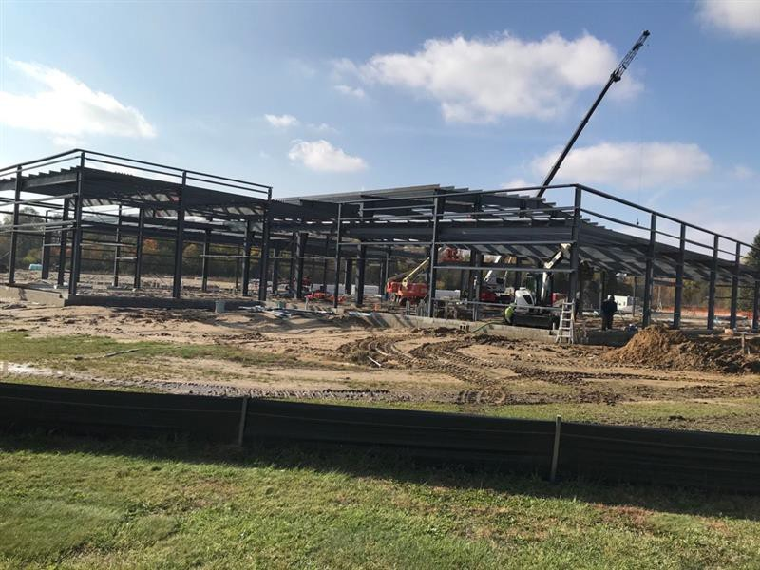

4. Site Selection
With its exceptional transportation network, modern public utility infrastructure, and attractive land available for development, Monroe County has tremendous potential for industrial and commercial projects. This section of the guide highlights some of the well documented available sites, although there are certainly other opportunities that can be discovered in the community.

Industrial Parks, Business Parks & Technology Parks
Monroe County Industrial Parks
The map below identifies the major industrial parks and industrial areas in Monroe County. For the most part, these sites are “shovel ready” and have land and sites avail- able for development, with roads, utilities and industrial zoning currently in place.
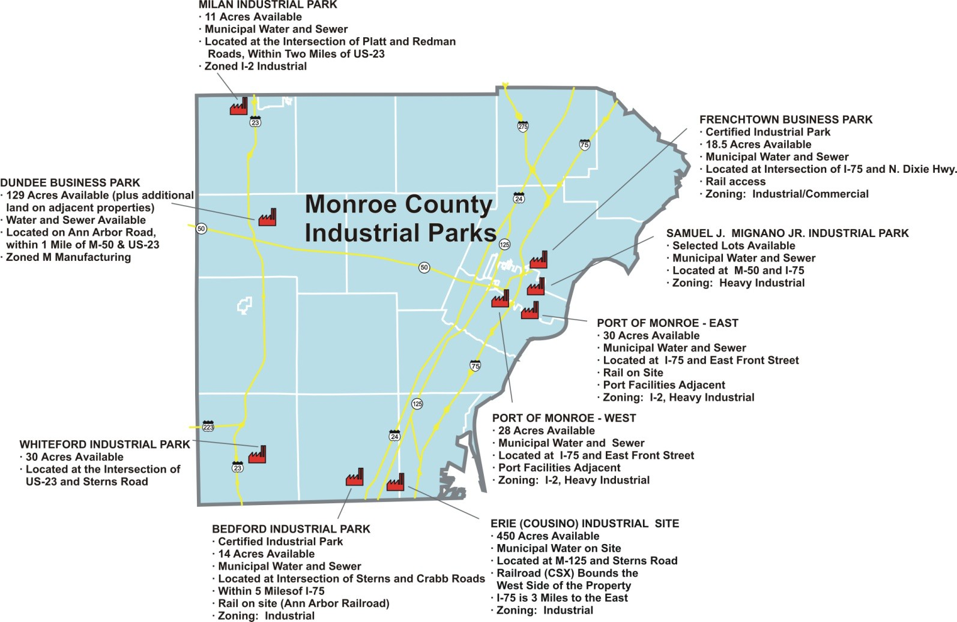

Port of Monroe
Located on Lake Erie and bisected by the River Raisin, the Port of Monroe is Michi- gan’s only port on Lake Erie. It is located 35 miles south of Detroit, Michigan and 17 miles north of Toledo, OH. The Port of Monroe provides an important transportation alternative that many cities and states simply cannot offer to their manufacturers, shippers and suppliers.
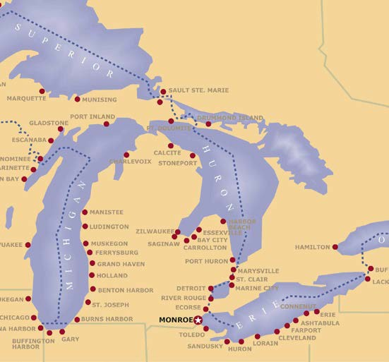
The Port of Monroe is a deep draft commercial harbor. With a usable draft of 21 feet and over 4,000 feet of public dock, the port is able to accommodate nearly any waterborne cargo.
Served by the Canadian National and Norfolk Southern railroads, and located immediately adjacent to Interstate 75, the Port of Monroe offers exceptional intermodal access to the region’s broader transportation network.
Monroe’s Custer Airport serves corporate and private airplanes with a 5000' x 100' paved runway
with full length parallel taxiway and a LPV approach (Lateral Precision Vertical Guidance) and the Port is within a 30 minute drive to Detroit Metropolitan International Airport.
The Port of Monroe has over 400 acres of heavy industrial land available for development. The port’s goal is to establish longstanding partnerships with organizations who seek to conduct business utilizing marine or rail transportation.
The Port of Monroe will assist potential tenants with cargo development and logistics coordination. For more information contact:
Port of Monroe
Paul C. LaMarre III, Port Director
2929 East Front St., P.O. Box 585
Monroe, MI 48161
734- 241-6480
plamarre@portofmonroe.com
www.portofmonroe.com

Commercial Property Information Exchange (CPIX)
CPIX, located at www.cpix.net, is the only Internet-based statewide commercial prop- erty information exchange in Michigan. It contains detailed information on commer- cial properties across the state, including properties listed with real estate brokers and those being offered for sale or lease directly by the owners. Licensed real estate sales- people and brokers, economic developers, as well as various other professionals affili- ated with the real estate industry, who elect to become members of CPIX, will have full access to all of the information contained within the database. Non-members and the general public have limited access to the database and will be able to see only infor- mation on those properties listed with brokers who are members of CPIX. For infor- mation on CPIX please contact CBOR at cpixinfo@cbor.net or call 810–603-0676.
The Monroe County Business Development Corporation is happy to provide site search assistance for your project. In addition to full access to all of the data contained in the Commercial Property Information Exchange (CPIX), the MCBDC also maintain a database of Monroe County industrial and commercial properties that may not be listed in CPIX. Contact the County Business Development Corporation at bdc@monroecountybdc.org or call 734-241-8081 for assistance with your project.

GIS Mapping
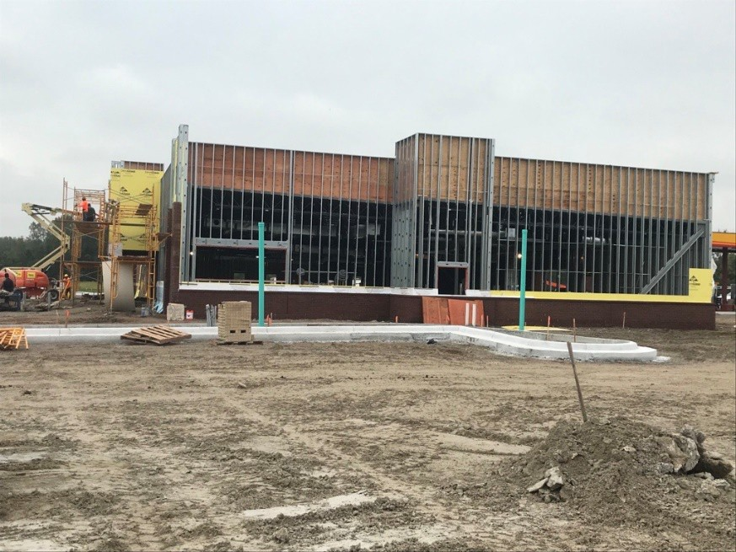
The County of Monroe along with the Monroe County Business Development Corporation utilize Geographic Information System (GIS) Mapping to present sites to developers, companies, and site consultants. The use of GIS allows the ability to have all site data at the flip of a switch. We encourage you to reach out to the Monroe County Business Development Corporation if you have specific questions on a site or are looking for a site that matches your criterion.

Monroe County Comprehensive Plan
As shown on the map below, the Monroe County Comprehensive Plan identifies specific areas of the county which are recommended for economic development activity. Included are Commercial and Industrial areas, as well as areas which have been identified as being especially well suited for Science and Technology-related development.
In particular, the US 23 and I-275 areas of Monroe County are seen as having high potential for development as a “Science and Technology Corridor.” With easy highway access, large tracts of available land, public utility service, and close proximity to major universities and other existing research and development facilities, these sites, as well as several other key locations, have been specifically identified as being prime sites for uses such as advanced engineering, biotechnology, green energy, corporate headquarters and other similar uses.
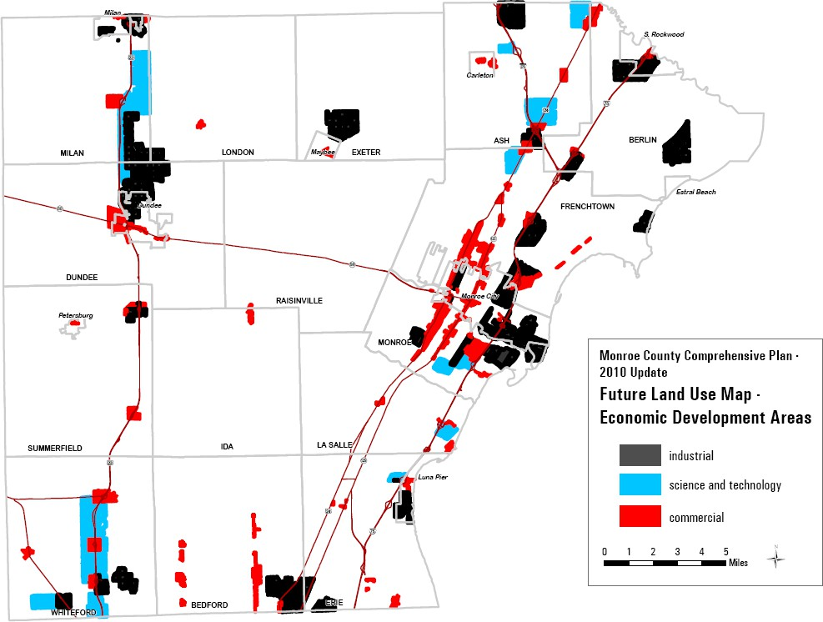

A full copy of the Monroe County Comprehensive Plan is available at:
http://www.co.monroe.mi.us/MONROE_COUNTY_2010_COMPREHENSIVE_PLAN.pdf

5. Local & State Agencies Review, Permits & Approvals
One of the primary goals of this guide is to provide existing and potential developers with detailed and up-to-date information on the permitting process in Monroe County. This section gives information on the three primary county agencies for which permits are generally required – the Monroe County Road Commission, the Monroe County Drain Commission, and the Monroe County Health Department. All three of these agencies are committed to providing exceptional public service and provide in this report the primary information needed to streamline the permitting process. In addition, state and federal agencies are sometimes required to issue permits when developments occur on certain highways or when projects impact rivers, flood zones, wetlands, coastal areas or other unique and regulated resources.
Monroe County Road Commission
The Monroe County Road Commission (MCRC) is responsible for the planning, construction, maintenance, and operation of over 1,300 miles of county roads and related infrastructure outside city and village limits in Monroe County. They also regulate driveway access, construction, and all activities within the county road right-of-way to protect public safety, preserve roadway infrastructure, and ensure the efficient movement of traffic.
As part of the development and permitting process, the MCRC reviews and approves driveway permits, site plans, subdivision layouts, and utility installations that connect to or impact roads under its jurisdiction. Through these reviews, the MCRC ensures that proposed developments comply with applicable laws, engineering standards, and safety requirements while balancing the rights of adjacent property owners with the broader public interest.
Developers are strongly encouraged to contact the MCRC Engineering Department early and schedule a preliminary meeting to discuss project scope before beginning surveys or plan preparation. Plans and traffic studies should be submitted well in advance of bidding dates or township planning meetings.
Information about permit fees and deposits can be found in the Fee Schedule on the MCRC website.

MCRC Engineering Department contact information is below.
Permits Department (734)-240-5102 permits@mcrc-mi.org
Matthew Snell, P.E. (734)-240-5143 msnell@mcrc-mi.org

Purpose & Jurisdiction
The statutory authority for the MCRC to regulate driveways onto the public highway system is through Act 200 of the Public Acts of 1969 and as amended by Act 83 of 1978.
Rules have been adopted in accordance with the requirements of Act 200 of the Public Acts of 1969 to ensure public protection through the reasonable control of driveway access onto roads under the jurisdiction of the MCRC.
The MCRC recognizes that the right of access to public highways is one of the incidents of ownership of abutting land. The MCRC strives to grant land owners access that is suitable to their needs and consistent with the rights and responsibilities of the MCRC regarding location and design of driveways, while providing freedom of traffic movement and safety for all highway users. Platted street approaches are not covered by these rules but shall be governed by appropriate state statutes and requirements of the MCRC. See the subdivision section of this document for more information.
The MCRC has typical layouts for various driveway types that conform to the above- cited rules available as a reference. Copies of typical layouts and assistance with matters relating to the rules may be obtained by using the links provided in this document.
The rules and requirements of the MCRC are similar to those used by the Michigan Department of Transportation (MDOT), however they are not specifically addressed within this publication.
For information regarding access onto the state trunk-line systems, correspondence should be directed to the MDOT, Permits Department. Contact information can be found at
www.michigan.gov/mdot/0,1607,7-151-9623_26662_26679_27267_48606-182161--,00.html

Activities That Require Permitting
Listed below are examples of activities that may require a permit from the MCRC:
Driveways & Access:
Driveway accesses may include, but are not limited to, installing a new driveway, widening an existing driveway, replacing an existing driveway (in whole or in part), moving a driveway, surfacing or resurfacing a driveway (with asphalt or concrete), placing a temporary driveway, installing an agricultural driveway, and any change in land use or roadside development. Details for driveways, including culvert installation, can be found in the MCRC Approved Driveway Procedures document located at:
http://www.mcrc-mi.org/images/APPROVED_DRIVEWAY_PROCEDURES_3_24_08.pdf
Individuals should contact the MCRC Engineering Department with specific questions about driveway permits.
Site Plans (Commercial & Industrial Developments):
Owners and applicants proposing to develop a commercial project, private road, multi- family residential development, or industrial project with proposed vehicle access or drainage into the public road right-of-way shall submit plans to the MCRC. Plans shall be submitted to the Engineering Department per the detailed requirements identified in the MCRC Site Plan Guidelines located at:
www.mcrc-mi.org/images/Eng_Site_Plan_Guidelines_2016.pdf
Plans submitted with a proposed driveway access within the MCRC right-of-way shall be designed in accordance with the MCRC Standard Commercial Approach specifications found in the link below:
www.mcrc-mi.org/images/StandardCommercialDriveApproachDetails.pdf
Plans submitted with drainage discharging to the MCRC right-of-way shall include drainage calculations shown on the Stormwater Detention Calculation Form found in the link below:
www.mcrc-mi.org/images/StormwaterDetentionCalcForm_2009.pdf
The site plan flow chart summarizes the review process from plan submittal, review, approval, permitting, and project closeout. The site plan procedure flow chart is included in the Site Plan Guidelines mentioned above.
Subdivisions (Platted & Unplatted Developments):
Owners and applicants proposing to develop subdivision roadways, either platted or unplatted, intended to be under the jurisdiction of the Board of County Road Commissioners, shall submit site plans to the MCRC. Plans shall be submitted to the Engineering Department per the detailed requirements identified in the Guidelines for Platted and Unplatted Developments located at:
http://www.mcrc-mi.org/images/SubdivisionGuidelinescomingSoon.pdf
Flow charts for both platted subdivisions and unplatted developments illustrate the process from plan submittal, review, approval, permitting, and project closeout and are found in the links below:
http://www.mcrc-mi.org/images/SubdivisionProcedureFlowChart12102008.pdf www.mcrc-mi.org/images/UnplattedDevelopmentFlowChart2232004.pdf
Utility Installations:
Owners and applicants proposing to install a utility with the public road right-of-way shall submit plans to the MCRC. Plans shall be submitted to the Engineering
Department per the detailed requirements identified in the Utility Application Form located at:
www.mcrc-mi.org/images/Utility_Application_form.pdf
and the Allowable Blanket Permit Activities located at:
www.mcrc-mi.org/images/Annual_Blanket_Activities.pdf
Owners and applicants proposing to develop a project-specific utility installation, such as a municipal water or sanitary installation, shall submit a letter of transmittal, review deposit per the current fee schedule and two (2) sets of plans to the MCRC. All documents shall be submitted to the Engineering Department.

Fee Schedule
Fees and deposits shall be paid based on the current MCRC Fee Schedule. Fees and deposits are charged to cover the necessary and actual costs for the issuance of permits and the review and inspection of the proposed activity. Fees are one-time charges; however, review and inspection deposits will be charged in a reasonable manner to sufficiently complete the work and any unused funds will be returned to the applicant. Any charges in excess of the deposit will be the obligation of the applicant. The current fee schedule can be located at:
http://www.mcrc-mi.org/images/Eng_Fee_Sch_2017.pdf

Helpful Hints
1. Individuals or organizations seeking to prepare plans for approval and issuance of a permit are encouraged to contact our office and schedule a short meeting to discuss project scopes prior to survey or plan preparation.
2. Plan preparers are encouraged to involve the MCRC early in the process. It is advised not to seek approvals from all other entities and then submit plans to the MCRC.
3. Plan preparers should submit plans well in advance of a bidding date or township planning meetings, and should anticipate a review time of three to six weeks. It is the intent for all reviews to be accomplished on straight time by MCRC personnel. Should the applicant require an expedited review, a request may be made to perform the review on overtime. A quicker review turnaround may be possible at an additional cost to the applicant.

Monroe County Drain Commissioner
The Drain Commissioner's Office is established by Act No. 40 of 1956. The Monroe County Drain Commissioner is the manager for over 1,100 dedicated county drains. As the addition of new development will often impact storm water, surface water, public water supplies and wastewater systems, it is necessary to comply with the regulations and permitting requirements of the Drain Commissioner’s Office.

Purpose
Storm Water Drainage
The changing of land use from open, wooded or agricultural land to commercial or in- dustrial use will significantly increase the total amount and the rate of storm water run-off from a given site. The increased rate of run-off may, for various storms, cause or aggravate flooding conditions along receiving streams or storm sewers. The grading of the site and the method of collecting storm water run-off may cause or aggravate drainage problems on adjacent sites.
With respect to storm water drainage, the purpose of the Drain Commissioner’s review is to assure that the proposed project does not adversely affect drainage in the specific watershed by aggravating flood conditions along the receiving stream and/or the storm sewer collection system.
The Drain Commissioner will also review the on-site storm water collection and grading plan in order to determine that the proposed project does not adversely affect drainage on adjacent parcels.
Public Water Supply
In Bedford, Erie and LaSalle Townships as well as in the City of Luna Pier, the Drain Commissioner reviews and approves site plans to verify that an adequate water supply exists and that the proposed water mains and services are installed in accordance with current standards.
Public Sanitary Sewers
In Bedford, Erie, Ida-Raisinville, LaSalle and Whiteford Townships; and in the Villages of Maybee and South Rockwood; the Drain Commissioner reviews and approves site plans to determine if the present infrastructure has adequate capacity to collect and treat the estimated amount of sewage and that the proposed sewers and service connections are built in accordance with the current standards.
Soil Erosion and Sedimentation Control
The actual construction process, which changes the land use from undeveloped or partially developed land to a developed state may cause the excessive loss of valuable soil

and the sedimentation of streams, lakes and storm sewers. The purpose of the Soil Erosion and Sediment Control Act is to prevent this situation from happening by requiring the developer/contractor to implement a plan to prevent erosion and sedimentation of valuable top soil during construction.

Jurisdiction
Storm Water Drainage
The Monroe County Drain Commissioner is responsible for reviewing and approving the stormwater drainage and collection plans for all commercial and industrial projects for the entire county.
Water Service
With respect to public water supplies, the Monroe County Drain Commissioner is responsible for reviewing and approving site plans in Bedford, Erie and LaSalle Town- ships and the City of Luna Pier.
Sanitary Sewer Service
With respect to public wastewater treatment and collection systems, the Monroe County Drain Commissioner is responsible for reviewing and approving site plans in Bedford, Erie, Ida-Raisinville, LaSalle and Whiteford Townships; and in the Villages of Maybee and South Rockwood.
Soil Erosion and Sedimentation Control
The Monroe County Drain Commissioner is the County Enforcing Agent who is responsible for enforcing the Soil Erosion and Sedimentation Control Act of Michigan, Part 91, SESC, P.A. 451 of 1994 as amended, for the entire county.
Contact Information
Water Services
David Robinson, City Manager | 734-384-9154 | David.robinson@monroemi.gov
Robert Clark, Mayor | 734-384-9144 | Robert.clark@monroemi.gov

Information Required
Introduction
The developer shall provide the Drain Commissioner with sufficient information to determine how the proposed project will impact drainage in the area. The developer shall also furnish estimates of sewage flows and water requirements. This information will enable the Drain Commissioner to determine if both the existing waste water collection and treatment system and the water supply and distribution system are adequate to meet the developer’s needs.
The site plan review process may be divided into two phases: preliminary and final. In the preliminary phase, the general concept of the project is reviewed. In the final phase, specific details including engineering drawings and calculations, are reviewed. The approval of the preliminary site plan does not make the approval of the final site
plan automatic. As more detailed and specific information becomes available, the conceptual plan may need to be altered.

Preliminary Site Plan
Storm Drainage
The site plan shall differentiate between existing and proposed conditions and, if necessary, two separate maps shall be present. The site plan shall provide sufficient information so that the existing drainage pattern and quantity of run-off can be determined and estimated. The site plan shall show existing topography including buildings, parking areas, walkways, green spaces, storm sewers, ditches and swales.
Contours shall be shown in addition to representative and key spot elevations. Contour and ground elevation shall be shown at least 100 feet onto adjacent property. First-floor elevations, as well as key parking lot and driveway elevations, shall also be included.
Similar information to that provided for existing conditions will be required for the proposed development. The site plan shall show proposed topography including buildings, driveways, parking areas, walkways, green spaces, storm sewers, catch basins, swales, ditches and detention basins. Contours and representative elevations shall be shown including first-floor elevations and key parking lot and driveway elevations. The receiving stream or storm sewer, including size and direction of flow, shall also be indicated.
Sanitary Sewers and Water Mains
Show the location and size of the existing sanitary sewers and water mains, including any service lines.
Indicate proposed extensions to the existing public system and new service lines. Pro- vide estimates of average day and maximum day water demand and sewage flow. Indi- cate fire flow requirements and advise if your wastewater will require pretreatment.

Final Site Plan
Storm Drainage
In addition to the information submitted for preliminary review, the following data will be required.
On the proposed plan, show the size and slope of all storm sewers. Show the location of all catch basins, inlets and manholes. Indicate the elevation of all sumps, pipe inverts and tops of castings. Include profiles of all pipe runs.
Show storm water detention basins on the plan, indicating both top and bottom dimensions and elevations. Indicate maximum water surface and overflow elevations. Show the length, size and type of outlet piping.
Provide storm sewer calculations. The storm sewers shall be designed based on a ten year storm using the Rational Method with the sewers flowing full.
Where required, provide storm water detention calculations. For sites with areas of five acres or less, use the short form method contained in the Appendix. For areas greater than five acres, use the long form method. A copy of this method with sample calculation will be provided upon request. Any other method of calculating storm water detention will not be acceptable. Provide calculations showing the actual amount of storm water detention. Please note that the use of an orifice plate for outlet control is not allowed.
Per the discretion of the Drain Commissioner, the allowable discharge rate will be reduced to 0.2 CFS per acre or less, depending on site conditions both on and off site.
Sanitary Sewers
In addition to the information previously supplied for preliminary review, the following data will be required.
Show the size, location, slope and elevation of all proposed services and appurtenances. The minimum size for service connections is 6-inch diameter installed at 1% slope.
If a public sewer extension is proposed, show the location, size and slope of all lines as well as invert and casting elevations for all manholes. The sewers shall be designed in accordance with Ten States Standard and the current Drain Commissioner’s specifications. A copy of the Drain Commissioner’s specifications is available upon request.

Water Distribution System
In addition to the information previously provided for preliminary review, the following data will be required: Show the size and location of proposed water services. If public water main extension is proposed, show the location and size of all water mains, valves, hydrants, fittings, etc. Public water mains shall be designed in accordance with Ten States Standard and the Drain Commissioner’s current specifications. A copy of the Drain Commissioner’s specifications is available upon request.
Storm Water Quality
In accordance with Federal Phase 2 Storm Water Quality regulations, storm water quality shall be required for all sites located within the established urbanized areas and recommended for all other sites. Storm water quality measures shall include, but are not limited to, first flush volume within the detention basin. Storm water quality structures, bio-swales, rain gardens, pervious pavement and vegetative buffer filter strips.
Soil Erosion/Sedimentation Control
In accordance with state statute and local ordinance, SESC measures shall be implemented to control off-site soil erosion and sedimentation. All SESC measures shall be indicated on a separate plan sheet for reference and workable construction details and specifications provided. SESC measures shall include, but are not limited to, the following: silt fencing, storm inlet protection, gravel construction access drives, rip-rap protection, sedimentation basins, vegetative buffer filter strips, street sweeping, dust control, and permanent site restoration.

Fee Schedule
Site Plan Review
The fee for reviewing site plans shall be in the amount established by the Monroe County Drain Commissioner:
www.co.monroe.mi.us/officials_and_departments/officials/drain_commission/schedule_of_fees_charges.php
Soil Erosion and Sedimentation Control Permit
The fee for the Soil Erosion and Sediment Control Permit shall be in the amount established by the Monroe County Drain Commissioner.
Inspection Fees
If on-site inspection is required, the developer will be responsible for all costs, including overhead incurred by the Drain Commissioner.
Legal Fees
If legal fees are incurred, the developer and/or the owner will be responsible for all costs.

Additional Agreements
Additional agreements are sometimes required based upon site location and conditions. Those agreements may include: 433 agreements, 425 agreements, detention pond maintenance agreements, and/or license agreements. Fees vary per agreement type.

Monroe County Website Information
Please reference the following website for all applicable fee schedules, permit applications and general information:
www.co.monroe.mi.us/officials_and_departments/officials/drain_commission/index.php
Utility and storm water calculation design specifications are available at:
www.co.monroe.mi.us/officials_and_departments/officials/drain_commission/mcdc_specifications.php

Monroe County Health Department
The mission of the Monroe County Health Department is to: “Protect the public's health through health promotion, disease prevention, and preservation of the environment.”
The Health Development’s involvement with development projects is generally limited to only the Environmental Health Division, whose mission is to: “Provide the citizens of Monroe County quality service, protection, and preservation of the environment through the oversight of onsite sewage, drinking water, food service and various recreational programs.”

General Guidelines
If you are considering constructing a residential or nonresidential facility in Monroe County, please read the following guidelines which may be helpful to you in the planning of the project.
In those areas not served by a public water supply and/or sanitary sewer system, it becomes necessary to utilize an onsite water supply and/or onsite wastewater disposal system. The Monroe County Health Department (MCHD), Environmental Health Division, has the authority* to review, permit, and approve the above-mentioned onsite systems. While not all projects are identical, the following are the general steps that will help you get your questions answered and project started:
1. Visit in person or contact by phone the Environmental Health Division of the Monroe County Health Department to discuss the project.
www.co.monroe.mi.us/officials_and_departments/departments/health_department/index.php
2. Fill out a site assessment form and pay the applicable fee. After this is complete, a representative of the MCHD will contact you to schedule an appointment to conduct the site assessment (soil borings, topography, surface water, current use, neighboring properties, etc.) For proposed nonresidential facilities, it shall be the responsibility of the applicant to arrange for an operator to conduct backhoe cuts at the time of the appointment.
3. The results of the site assessment will be sent to the applicant.
4. Depending on the scope of the project and results of the site assessment, it may be required that the applicant to submit to the MCHD plans engineered by a professional engineer or registered sanitarian for the design of the onsite wastewater disposal system and/or onsite water supply system. This will be discussed with applicant at the time of the site assessment.
5. If and when the plans are approved (the MCHD has up to 30 days to approve or respond to your proposal), or if plans are not required based on the results of the site assessment, permits for the onsite wastewater disposal and water supply systems can be applied and paid for. Please be advised that permits issued by the MCHD have priority over building permits issued by local municipality building officials. MCHD permits are valid for one (1) year from the date of issuance.
6. Once the permits are signed by the MCHD, the applicant/owner can begin constructing the onsite sewage disposal and/or onsite water supply systems utilizing licensed sewage disposal contractors and/or well drillers (contact the MCHD for the list).
*Authority is granted to the Environmental Health Division by the Monroe County Board of Commissioners and their adoption of the Monroe County Environmental Health Sanitary Code, effective the 8th day of May, 2007. This authority is limited as to the size and scope of project. State of Michigan agencies may have the ultimate authority to review, permit and approve large or complex onsite systems. Please contact the Environmental Health Division at 734-240-7900 if you have any questions about this matter.
You may also contact this office for information on other programs including, but not limited to:
1. Food service establishments
2. Public swimming pools
3. Public campgrounds
4. Pump and haul (sewage) facilities
5. Department of Human Service (child and adult care) facilities
6. Solid waste facilities
7. Non-community water supplies

Monroe County Sanitary Code Website Information
Please reference the following website for information regarding the Monroe County Sanitary Code:
www.co.monroe.mi.us/Health/Sanitary_Code_2007.pdf

Michigan Department of Transportation
The Michigan Department of Transportation (MDOT) has jurisdictional authority over all state highways within Monroe County. These include I-75, I-275, US-23, US-24, US-223, M-50, and M-125. Monroe County is located within MDOT’s University Region, and the local point of contact is the Brighton Transportation Service Center (TSC).
For information regarding permits to work within the public road right-of-way, including review of proposed developments requiring traffic studies, driveway and access management controls, signage and signalization, roadway and pavement design, geometric design considerations, drainage design and stormwater detention, maintenance of traffic, or other development-related questions, please contact:
Brighton Transportation Service Center
10321 E. Grand River, Suite 500
Brighton, MI 48116
Phone: 810-227-4681
Fax: 810-227-7929
Construction Permits | Pascal Bui | (517)-404-2070
Construction Permits | Craig Heidelberg | (810)-623-8341
Highway Advertising Permits | Melissa Staffeld | (517)-335-2209
Utility Coordination | Pascal Bui | (517)-404-2070
Adopt-A-Highway | James Drury | (248)-207-5594

The following are links to important and informative MDOT sites that will provide guidance and information to developers and their engineers for work within the MDOT rights-of-way.
Public link for traffic volume data:
www.michigan.gov/mdot/0,4616,7-151-11151-22141--,00.html
Below is the link for the Traffic and Safety Site which contains all the Geometric Guides, Maintaining Traffic Typicals, Traffic & Safety Notes, Signal details, MMUTCD, Pavement Marking/Signs, etc. Some of the documents found in the Traffic & Safety Notes are listed below as a reference.
mdotcf.state.mi.us/public/tands/plans.cfm
Listed below and provided on the following pages are Traffic and Safety Notes that would typically apply to a new development:
• Access Management (Note 601A)
mdotcf.state.mi.us/public/tands/Details_Web/mdot_note601a.pdf
• Traffic Volume Guidelines for Driveway Passing Flares (Note 603A)
mdotcf.state.mi.us/public/tands/Details_Web/mdot_note603a.pdf
• Traffic Volume Guidelines for Right Turns lanes and Tapers (Note 604A)
mdotcf.state.mi.us/public/tands/Details_Web/mdot_note604a.pdf
• Traffic Volume Guidelines for Left Turns lanes and Passing (Note 605A)
mdotcf.state.mi.us/public/tands/Details_Web/mdot_note605a.pdf
• Traffic Impact Studies (Note 607C)
mdotcf.state.mi.us/public/tands/Details_Web/mdot_note607c.pdf
• Spacing for Commercial Drives and Streets (Note 608A)
mdotcf.state.mi.us/public/tands/Details_Web/mdot_note608a.pdf
• Stopping Sight Distance and Intersection Sight Distance (Note 610A)
mdotcf.state.mi.us/public/tands/Details_Web/mdot_note610a.pdf
• Traffic Impact Assessment (Note 613B)
mdotcf.state.mi.us/public/tands/Details_Web/mdot_note613b.pdf
Below is the link to how communities benefit from access management. Also included in this section is a copy of information on how businesses benefit from access management.
www.michigan.gov/mdot/0,4616,7-151-9621_11041_29705-87917--,00.html
The following link will take you to the Public’s Permit homepage which describes the procedures on obtaining a variety of permits through the MDOT. www.mi.gov/mdot/0,1607,7-151-9625_26039---,00.html

Michigan Department of Environment, Great Lakes, and Energy
The Michigan Department of Environment, Great Lakes, and Energy (EGLE) has the following vision statement:
MISSION
To protect Michigan’s environment and public health by managing air, water, land, and energy resources.
VISION
A Michigan that respects people, treasures natural resources, and fosters thriving communities throughout our two peninsulas.
VALUES
EGLE makes reasoned decisions. Within the bounds of state and federal laws and informed by science, EGLE delivers solutions that reflect our mission and equitably serve the interests of Michigan residents.
EGLE serves the public. EGLE is accountable and responsive to all Michigan residents. We hold ourselves to the highest standards of government ethics and vigilantly steward public funds.
EGLE communicates. EGLE proactively collaborates and engages the public to make informed decisions. We tell our story, so people understand what we do, why we do it, and how our work benefits their lives.
EGLE leads. EGLE takes a strategic approach that accounts for the impacts of today’s actions on future generations.
EGLE invests in our team. Recognizing the knowledge and dedication of EGLE staff drives success, we provide a positive workplace with effective leadership and professional development opportunities.

The following resources will help in determining what, if any, state level permitting or licensing may be required.

EGLE Permit Information Checklist
New businesses may require EGLE permits, licenses, and registrations based on their activity and will have to meet environmental regulations depending on their operations. Potential businesses are encouraged to review the resources identified below to determine applicable EGLE permits, licenses, and registrations. The EGLE has prepared a list of key questions to help identify what departmental permits, licenses, or approvals of a permit-like nature may be needed for a project. By contacting the appropriate offices listed below, you will help reduce the possibility that your project or activity will be delayed due to the untimely discovery of additional permitting requirements later in the process. While this list covers the existence of permits and approvals required from EGLE, it is not a comprehensive list of all legal responsibilities (i.e. planning requirements and chemical storage regulations may apply). The checklist is available at:

Michigan Guide to Environmental, Health, and Safety Regulations
A useful way to learn whether any other requirements will apply is to go through the Self Environmental Assessment in the Michigan Manufacturers Guide. Manufacturers, institutions, local governments, consultants, and regulators will all benefit from this guide, which simplifies the maze of environmental, health, and safety obligations facing Michigan's businesses and institutions. The guidebook is a ready reference tool for anyone striving toward compliance with state and federal regulations that affect businesses and institutions. Although some reference is made to local regulations, they are not discussed in any detail. Be sure to contact your local government officials for information on applicable local requirements.
The Michigan Guide to Environmental, Health, and Safety Regulations (7th edition, 2012) is intended for guidance only and may be impacted by changes in legislation, rules, and regulations adopted after the date of publication. The suggestions given for identifying and implementing pollution prevention opportunities are not to be used as a substitute for applicable codes, rules, and regulations that impact businesses. Although the guidebook makes every effort to teach users how to meet applicable compliance obligations, use of this guidebook does not constitute the rendering of legal advice. Diligent attention was given to assure that the information presented herein is accurate as of the date of publication; however, there is no guarantee, expressed or implied, that use of this guidebook will satisfy all regulatory requirements mandated by laws and their respective enforcement agencies. Reliance on information from this document is not usable as a defense in any enforcement action or litigation. The state of Michigan shall be held harmless for any cause of action brought on as a result of using of this publication.

Environmental Assistance Center information:
The EGLE Environmental Assistance Center (EAC) implements a number of programs that promote environmental stewardship and enhance customer service related to all programs administered by EGLE. The primary services provided by the EAC are compliance assistance, pollution prevention, environmental education, permit coordination, financial assistance, incentive programs, training, and outreach. Additionally, the EAC manages metrics, process improvement, and professional development initiatives for EGLE. Contact the Environmental Assistance Center at 1-800-662-9278

Local EGLE Contacts
• Environmental Assistance Center – Lansing – 800-662-9278
• Wetlands, Lakes and Streams – Bridgett Carver – 517-257-7380
• Stormwater – Matt Konieczki – 517-857-0745
• NPDES – Ken Mroczkowski – 517-449-5300
• Groundwater – Rachel Burns – 517-416-4703
• Brownfield Program – Holden Branch – 517-331-0993

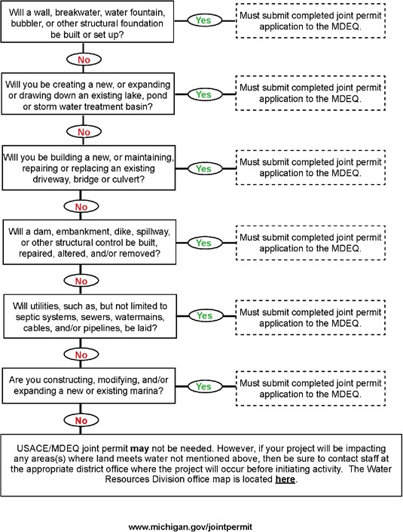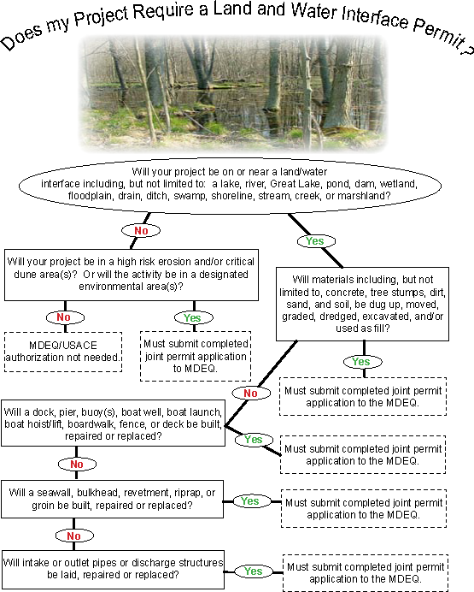
No

U. S. Army Corps of Engineers
The mission statement of the US Army Corps of Engineers Regulatory Program is:
“To provide strong protection of the Nation’s aquatic environment. This will be accomplished through: coordination with agencies and the public; fair, reasonable, and timely decisions; accurate and timely jurisdiction determinations; monitoring, compliance and enforcement of permit laws, regulations and policies.”
Projects which involve development in rivers, harbors, flood zones, wetlands, or the Great Lakes will generally fall under the jurisdiction of the Army Corp of Engineers, which works jointly with the Michigan Department of Environmental Quality on several of their permitting activities.
Monroe County falls under the jurisdiction of the Detroit District.
US Army Corps of Engineers Detroit District Regulatory Office :
800-493-6838
www.lre.usace.army.mil

The Regulatory Sourcebook contains detailed information on project requirements and permitting:
www.lre.usace.army.mil/Portals/69/docs/regulatory/Source_Book/Sourcebook_Outline_v9_23_JAN_2013.pdf
The Joint Permit Application for work in Inland Lakes and Streams, Great Lakes, Wetlands, Floodplains, Dams, High Risk Erosion Areas and Critical Dune Areas is available here:
www.michigan.gov/documents/deq/deq-wrd-jpa-application_353994_7.pdf

6. Zoning/Special Approval/Site Plan Review
The Michigan Zoning Enabling Act (PA 110 of 2006, as amended) gives local units of government the authority to regulate land use and development within their boundaries as does the general police powers authority of municipalities. These regulations are contained within a community’s zoning ordinance and are used by communities to limit certain types of uses to specific areas, as well as to control specific aspects of developments which may significantly impact the community. These regulations are generally developed to further the public health, safety and welfare, and to serve as a tool to implement a community’s master plan.
It is important for developers to be aware of the different types of local regulations that may affect a project. Gaining permission to move forward may take multiple approvals. The local approval process is generally limited to the following, although each municipality has its own specific regulations and approval procedures:
- Zoning
- Special Use Approval
- Site Plan Approval
- Construction Plan Approval
- Other site development requirements

Zoning
Each of the 24 local units of government (cities, villages and townships) in Monroe County have their own zoning maps and ordinances which divide communities into various zoning district classifications, each district allowing only certain uses. The zoning map is based on the adopted community Master Plan. Each zoning ordinance spells out exactly which land uses are permitted in a particular zoning district, and in addition, provides requirements for density and site development, by specifying the size of required yards, spacing between buildings, height, and site coverage.
In order to meet the constantly changing land use needs of communities it sometimes becomes necessary to change zoning boundaries. The process of altering the zoning configuration is referred to as rezoning or amendment to the existing zoning. Keep in mind, any rezoning should be in concert with the adopted Master Plan for each community. If a use is proposed for a site which is zoned properly than no rezoning is necessary, but if a use is not permitted within the district then it becomes necessary to request a rezoning to a district which permits the proposed use. The rezoning process is outlined as follows and proceeds along the steps illustrated below. It is highly recommended that an applicant meet with the local government to determine
exactly which uses are permitted within a site’s zoning district and which districts allow particular uses.
Contract Zoning
Pursuant to the Zoning Enabling Act, an owner of land may voluntarily offer to a community in writing, certain restrictions on the use and development of the land as a condition to a rezoning of the land. Often such conditions include an agreement not to develop or allow certain uses which might otherwise be permitted within the requested zoning classification. A community may approve the conditions offered by the applicant and further may establish a time period during which the conditions apply to the land. A community may not require a landowner to offer conditions as a requirement for rezoning. Many communities address the process for requesting a conditional zoning (as it is often called) in its zoning ordinance. The agreement of the parties setting for the conditions to which the rezoning is subject as well as the term and other conditions of the rezoning are reduced to a written agreement and recorded with the Register of Deeds Office so that future owners are on notice of the limiting conditions.

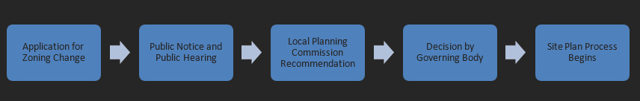
The Rezoning Process

Application for Zoning Change
The rezoning process begins at the local government center where the property owner obtains a Zoning Change or Amendment Application. The form is completed, and the appropriate fees are paid at the time the application is submitted: The property owner(s) of record must also sign the application if the request to rezone is being made by another individual. The fees for zoning changes vary and can be based upon the total number of acres involved. A list of current fees for all categories of land use applications is provided with the application.
Public Hearing and Public Notice
When the application is filed, a public hearing is scheduled and a notice that a request for rezoning has been received is published in the local newspaper. This notice of public hearing must, by state law, be published not less than fifteen (15) days prior to the date of the public hearing. In addition, the law states that a copy of the public hearing
notice must be mailed or given to all owners of property and occupants within 300 feet of the subject property as well as other entities or bodies which have registered with the community to request notices.
The public hearing process allows members of the community who may have an interest in the rezoning request an opportunity to make comments about the proposal. The applicant is also allowed an opportunity to speak regarding the proposed zoning change. The Planning Commission will also review, at the public hearing, any written comments that have been received regarding the application. Usually the public hearing is followed by the next step, the Planning Commission’s recommendation, at the same meeting.
Planning Commission Recommendation
After hearing from citizens and from the applicant, the local Planning Commission will make a recommendation to their community’s elected officials regarding their assessment of the proposed zoning change. Note that the Planning Commission only makes a recommendation and that the final decision is up to the governing body (City or Village Council or Township Board ). Often, a community’s planning consultant or planning staff will prepare a fact-based analysis of the request. This analysis will identify surrounding land uses, existing zoning, and will compare the requested zoning to the existing master plan land use map. This information, along with public input during the hearing, will assist the local Planning Commission in making a recommendation to the Township Board, or Village or City Council.
Criteria that will be evaluated by the Planning Commission include compatibility with surrounding land uses, the full range of land uses permitted in the proposed district, the capability of the site to support this range of permitted uses, and the proposed district’s conformity with the community’s future land use plan. Although the applicant can present specific development plans for the property, the decision to recommend rezoning will be based solely on the technical merits of the request, as specific plans such as architectural designs or planned public improvements are always subject to change and are not binding during the rezoning process.
Governing Body Final Action
The final decision in the rezoning process is by the governing body. The governing body will consider the recommendation of its planning commission and will make a decision whether or not to approve the request. In effect, the governing body is amending the zoning map, which is in effect, an amendment to a community’s zoning ordinance. If the request is granted, the zoning change takes effect seven (7) days after publication of the amendment or such later date as may be specified in the notice. In the case of a City and of a Charter Township, the adoption or amendment of an ordinance requires two readings before it can be officially approved.

Special Approval Uses
Under Michigan zoning law, communities may designate specific uses of land as “special land uses.” Special uses are generally those uses which have a strong potential to impact surrounding uses and the approval process is designed to insure that such uses are compatible with adjacent uses of land, the natural environment, and the capacities of public services and facilities affected by the land use. If an applicant is requesting permission to develop a site as a designated special land use, it becomes necessary for the community to conduct a review separate from a rezoning review. As in the case of a rezoning request, it is important to consult with the local government’s zoning official in order to determine if a special approval is necessary for a proposed land use.
The special use approval process is as follows:
The Special Use Approval Process


Application for Special Land Use
The local zoning ordinance specifies the procedures, supporting materials, and standards for granting a special land use request. Generally, communities will have an application form and application fees which are paid at the time of application. A simple plot plan or, in some cases, a detailed site plan may be required based on the nature of the request and on the individual community’s requirements.
Public Notice of Special Land Use Request
After the application is filed, and all appropriate fees are paid, a notice of a request for a special land use is published in the local newspaper. In addition, the public notice must be mailed or given to the applicant and all property owners within 300 feet of the subject parcel. The public notice must indicate that a public hearing may be requested by any property owner in the community or by an occupant of a property within 300 feet of the subject parcel.
Public Hearing (if requested)
If requested by a member of the public or by the decision-making body itself or if mandated by a community’s zoning ordinance, a public hearing is held on the request. The public hearing process allows members of the public to make comments regarding the proposal, as well as the applicant. The public body will also review, at the public hearing, any written comments that have been received regarding the application.
Action by Designated Body
Under Michigan zoning law, each community has the authority to designate the body which makes the discretionary decision regarding special land uses, which can be either the planning commission, the governing body, or a designated official. A request for a special land use approval may be denied, approved, or approved with conditions. The decision is required to be incorporated in a statement of findings and conclusions which specifies the basis for the decision and any conditions imposed. A community is required to approve a request for a special use if the request is in compliance with the standards and conditions contained within the zoning ordinance.

Site Plan Review
Most Michigan communities require a “site plan review” prior to the issuance of a building permit for residential developments and commercial and industrial land uses. Communities have the authority to require the submittal of plans and drawings for review in order to assure that a proposed development is in compliance with applicable zoning standards, local ordinances and state and federal regulations and statutes. Communities are required to approve site plans if they contain the required information and are in compliance with the relevant standards and requirements.
The site plan review process for each community is specified in their ordinances. Each community differs slightly in their required information and in their approval process. In general, the ordinance contains a list of required information and outlines the approval process. In most cases site plan review is conducted by the local planning commission. Some communities have a two-part process, with a preliminary review conducted by the planning commission and final approval granted either by the planning commission or by the governing body. Some communities have site plan review conducted by an authorized official such as a zoning administrator or building official, while other communities have authorized officials grant approval only for certain types of development. In some communities, a special land use approval and site plan approval can be granted concurrently.
Prior to completion of a site plan, developers are encouraged to schedule a pre- application conference with the local and county reviewing agencies. Most communities welcome these meetings as a way of streamlining the development process. The purpose of this meeting is to guide developers through the site plan development and review process.
The following is a typical site plan review process and the type of information that communities generally require (Each community will have its own requirements):
1. The developer obtains and completes a Site Plan Application and Checklist. A completed form along with a specified number of copies of the site plan is submitted. Upon submittal, the site plan will be reviewed by the proper local agency. Required
application fees must be submitted to the local agency prior to sending the site plan out for review.
2. Upon submittal of a completed site plan, the Planning Commission may approve, approve with conditions, or deny approval.
a. If approved, the applicant may continue the final site plan review process to final plan review. Many communities combine both preliminary and final site plan approval except for complex site plans.
b. If approved with conditions or denied, the applicant must revise the final site plan in accordance with the conditions established by the Planning Commission during final plan review.
3. The following information is usually required to be included on the site plan in accordance with the ordinance requirements of the local agency:
• Name, address and telephone number of applicants.Date of site plan preparation.
• North arrow and two (2) benchmarks.
• General location map.
• Proof of ownership or option to purchase.
• Property address and parcel number.
• Scale of not less than 1" = 30' if subject property is less than three acres or
• 1" = 100' if property is three acres or more.
• Plans prepared and submitted on sheet size of 24" x 36".
• Name, address, phone and Michigan registration number of plan preparer.
• Location of the following:
- Existing structures on site and within 100' of the site.
- Complete topography with a maximum contour interval of 2' both on site and 100' from the site.
- Existing natural resources and features including vegetation, wetlands, soil types, drains, and water courses and 100-year flood elevations (must identify FEMA community panel number on plan).
- Type of development.
- Location, use, and number of structures, units, offices, parking spaces, employees, building height, gross and net square footage, and building elevations (floor plan).
- Completion schedule, development plans and total project area.
- Existing zoning on site and surrounding parcels.
- Lot frontage requirements.
- Building setback requirements.
- Calculation of usable floor space.
- Open space requirements and lot coverage requirements, if applicable (see specific zoning ordinance requirements).
- Square footage requirements, if applicable.
- Location of existing and proposed electric, natural gas, telephone, railroad, cable TV and other utility cables, and any easements for those utilities.
- Location of commercial pipelines, electrical transformers, and fire protection devices, including on site hydrants and standpipes.

Other Site Development Regulations
Most communities have within their zoning ordinance, regulations pertaining to signs, lighting, landscaping, parking lot development, architectural guidelines, buffering, and similar requirements which are generally intended to preserve community character, protect surrounding land uses, and promote the public health, safety and welfare. These guidelines and standards tend to vary from community to community, but in general are clearly stated within the municipal zoning ordinance. Note that some communities have “overlay” zones that affect developments within only certain portions of the community, such as a downtown area or a historic district. In addition, communities may have general standalone police powers ordinances that address matters such as detailed engineering design standards, lighting, subdivisions and condominium development requirements, land divisions and more.
Many communities also have special requirements for particular types of developments. For example, a community zoning ordinance might have certain requirements that apply only to gas stations, drive-through restaurants, or outdoor storage facilities. It is important to study the municipal zoning code and consult with the relevant local officials and county/state agencies in order to assure a smooth approval process. These agencies include but are not limited to:
• Monroe County Drain Commissioner
• Monroe County Road Commission
• Michigan Department of Transportation
• Monroe County Health Department
• Environment, Great Lakes, and Energy
• Army Corps of Engineers
• Applicable Agencies Administering Water and Sewer Approval

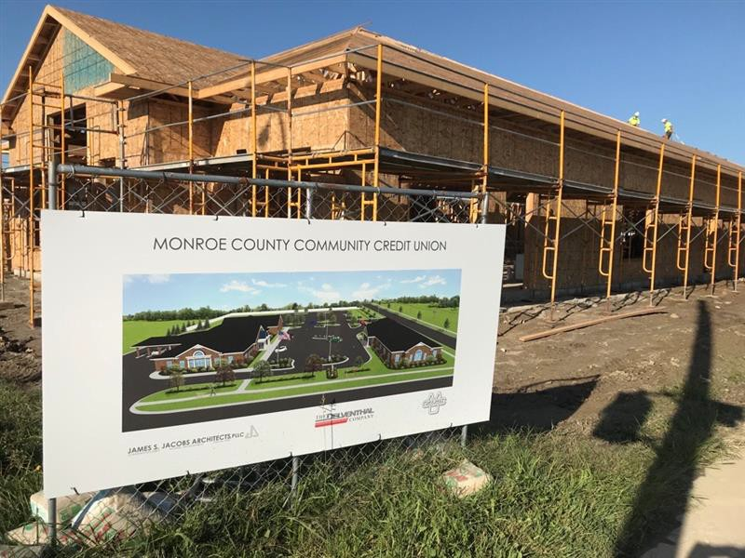

7. Strategies for Successful Development

- Agencies are run by people, somebody just like you. Think about how you would like to be approached if you were in their seat trying to uphold a complex set of standards, codes and policies that in most cases they had no control in creating.
- Going to them prepared with as much information about what you are seeking to accomplish with clear questions as early as possible in your development process will help to identify any major roadblocks or hurtles that must be addressed. If the information is confidential, please state that, or use hypothetical information.
- Make sure you understand all the agencies that will need to review and approve your project and obtain copies of their standards, applications and checklists. Many of these are referenced in this book or are available on their websites. Review this information and ask for a preliminary meeting as soon as possible to gain their thoughts and input early. This will acquaint them with your project and gives you a chance to hear their concerns to better address them or see if there are any red flags before it is too late or costly to turn back. If fees are charged, they will be well worth the expense for the information gained, if you are prepared with enough information to gain valuable input from them. Go to the preliminary meeting with as much information as possible so that a comprehensive preliminary analysis can be accomplished. (A project narrative with employee count, hours of operation, business description are suggested)
- Make every attempt to address all items on the local agency checklists for approval, even if it is as simple as marking it not applicable (N/A,) or by adding a simple note using their wording with the appropriate answer.
- If timing is critical to the success of your project make sure you select a site with little or no special approvals needed. If there are approvals needed, make sure you fully understand the timeline and what is needed from you and your design professionals to stay within this projection. (They will ask and require revisions otherwise)
- For most medium to large-scale projects it is advisable to obtain the assistance of the municipality to help open the lines of communication and identify any areas of concern prior to site selection or at least pursuit of final purchase. The place to start is with the area's economic development director or planning director. In most cases these individuals can be contacted through the building or engineering departments at the governing bodies' office. Also, contacting the BDC (Business Development Corporation) to assist in navigating the process can be very helpful. Don't let the name drive you away, the BDC is there to assist both large and small development of any kind. (Understand your design professionals timeline to prepare and develop adequate plans for review)

- Most important of all is to have a clear picture of your goals, desires and needs. This means having a good business plan, a well-defined project program and the ability to convey it simply.
- It is also critical that you contact utility providers early in your process. With proper notice, utilities may be able to save you time and money. For large power users, or those with special needs, contact the Monroe County BDC. They can access the utilities’ economic development teams to assist you.
The following are some questions that might be helpful to ask while meeting with these entities.
- What zoning districts are appropriate for my use?
- What is the zoning of the subject property?
- Are there any special approvals that will need to be sought?
- Is there an administrative review process? (Requires same information, just less restrictions on meeting timelines)
- Is it possible to have a preliminary meeting with the planner, engineer and building official?
- Do you have an approval checklist to guide us through your process?
- What is the normal timeline for approval? (Ask for submittal deadlines)
- Are there any funding incentive programs to assist in the development of our project, i.e. OPERA tax credits, Brownfield programs, local grants such as DDA facade improvement or site improvement grants, joint state and federal development funds, etc.?
- Are there professional Architectural and Engineering Design firms that you could suggest that are familiar with your development process that could assist us with our project?

8. Utility Service Areas & Maps
The Monroe County area is fortunate to have invested in an extensive and modern system of public improvements to foster economic development. The following pages provide a brief overview of the infrastructure available in Monroe County. For more detailed information on exact service areas, capacities, and availability, be sure to contact the individual municipalities, utilities or other service providers.

Water
Most of the urbanized areas of Monroe County are served by public water systems. The City of Monroe and Frenchtown Township share a water intake from Lake Erie, although each operates their own water treatment plant. Northern Monroe County is served by the Detroit Metropolitan water system, while southern Monroe County is served by South County Water, which purchases water in bulk from the Toledo system. Milan has its own water system and Dundee and Petersburg, although they once had their own systems, are now both connected to the Monroe system. Areas outside of the public water service areas are generally served by private wells.
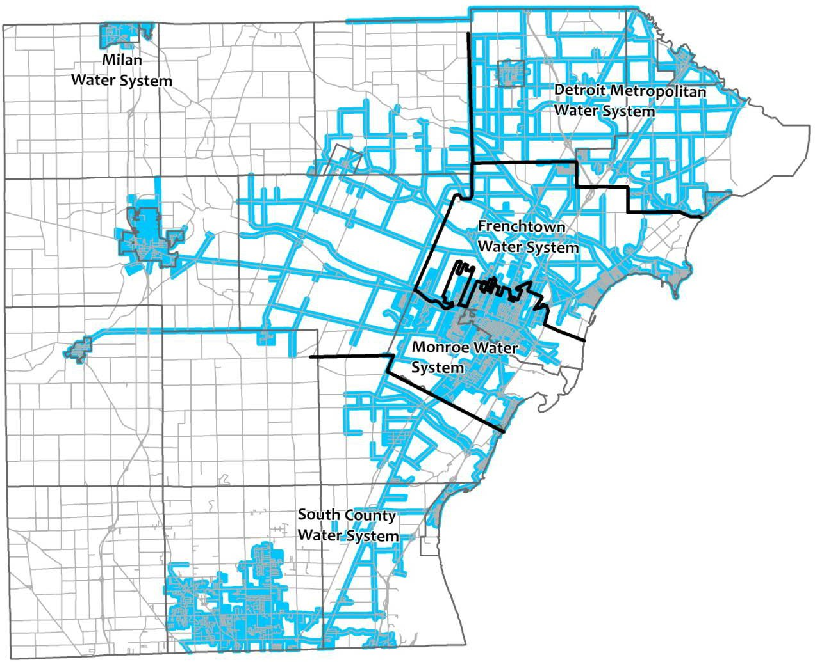
Public Water Service Area

Sewer / Sanitary
Most of the urbanized areas of Monroe County are also served by publicly operated sanitary sewers. The map below indicates the areas of the county served by municipal wastewater treatment systems. Locations outside of these service areas generally rely on on-site septic systems for sewage disposal.

Sanitary Sewer Service Areas
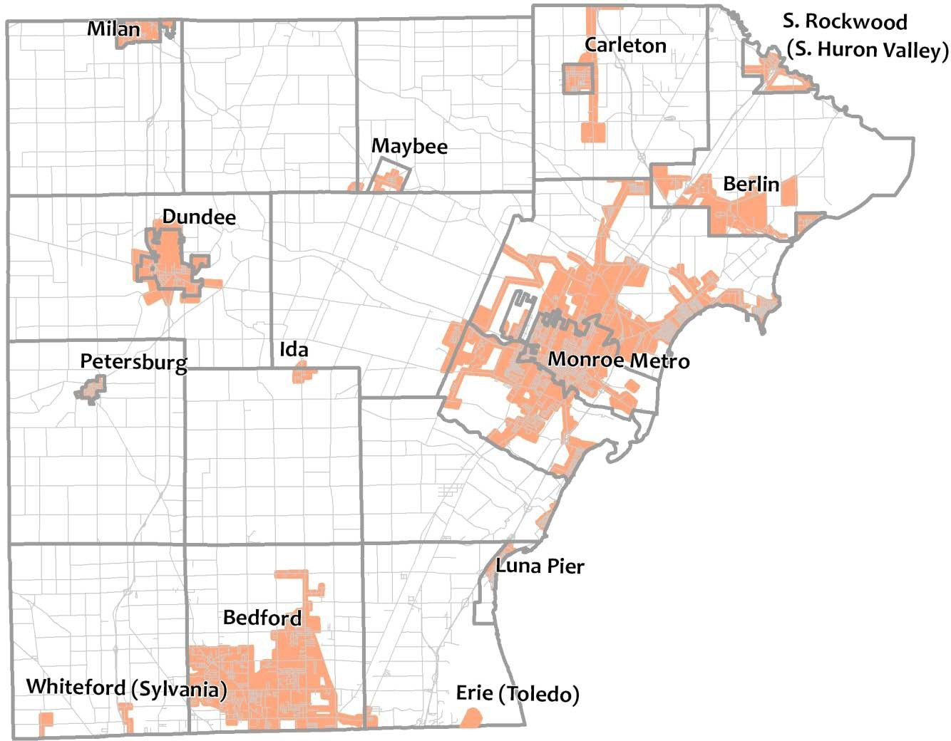

Telephone & Internet
Internet coverage is readily available throughout the majority of Monroe County communities. Major cable providers are Comcast and Charter Communications in the northern half of the county while Buckeye Cable provides service in the southern sections of the county. In addition to Internet access these companies provide voice phone service and television. Merit Network provides internet and network connectivity and other related services to education, library, government and non- profit organizations.
ATT and Frontier provide traditional telephone coverage throughout the majority of Monroe County along with some smaller providers. They also offer Internet, television and voice over internet protocol (VoIP) service in the majority of their service delivery area. There several larger Internet pipelines (backbones) running both north and south and east and west through Monroe County. Exact locations and size details are not made public do to security concerns but should you require a direct connection to the backbone, the Monroe County Business Development Corporation will be happy to assist in directing you to the service provider nearest your site.
Major service providers for wireless service include AT&T, Sprint and Verizon along with several smaller companies located in the area. Cell coverage is good to excellent in the majority of the county for the major service providers.
AT & T | www.ATT.com
Buckeye CableSystem | www.BuckeyeCableSystem.com
Comcast | www.Comcast.com
Frontier Communications | www.Frontier.com
Merit Network Inc. | www.merit.edu
Telesystem | www.telesystem.us
Verizon Communications | www.Verizon.com
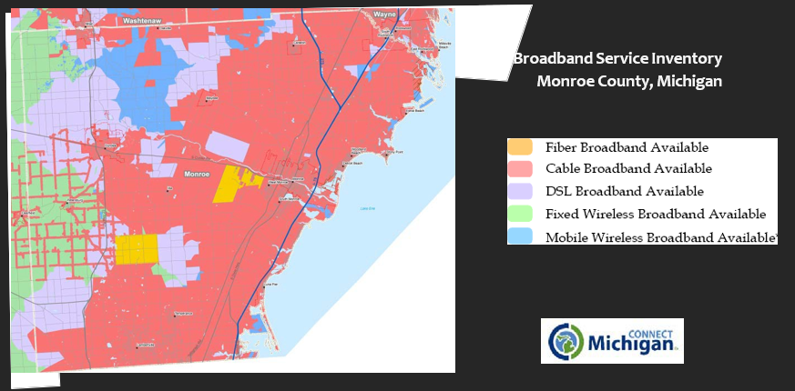

Natural Gas & Electric
Monroe County is served by three natural gas franchises and by 2 electric utilities. All of the public utility companies work closely with the economic development community to provide high quality service at competitive rates. With three electric power generating facilities within its borders, Monroe County is able to meet the needs of even the most power-hungry types of industrial developments.
Public Utility Providers
Consumers Energy (CMS Energy) | 800-477-5050 | www.ConsumersEnergy.com
DTE Energy (Mich Con) | 800-477-4747 | www.DTEEnergy.com
Michigan Gas Utilities | 800-401-6402 | www.MichiganGasUtilities.com

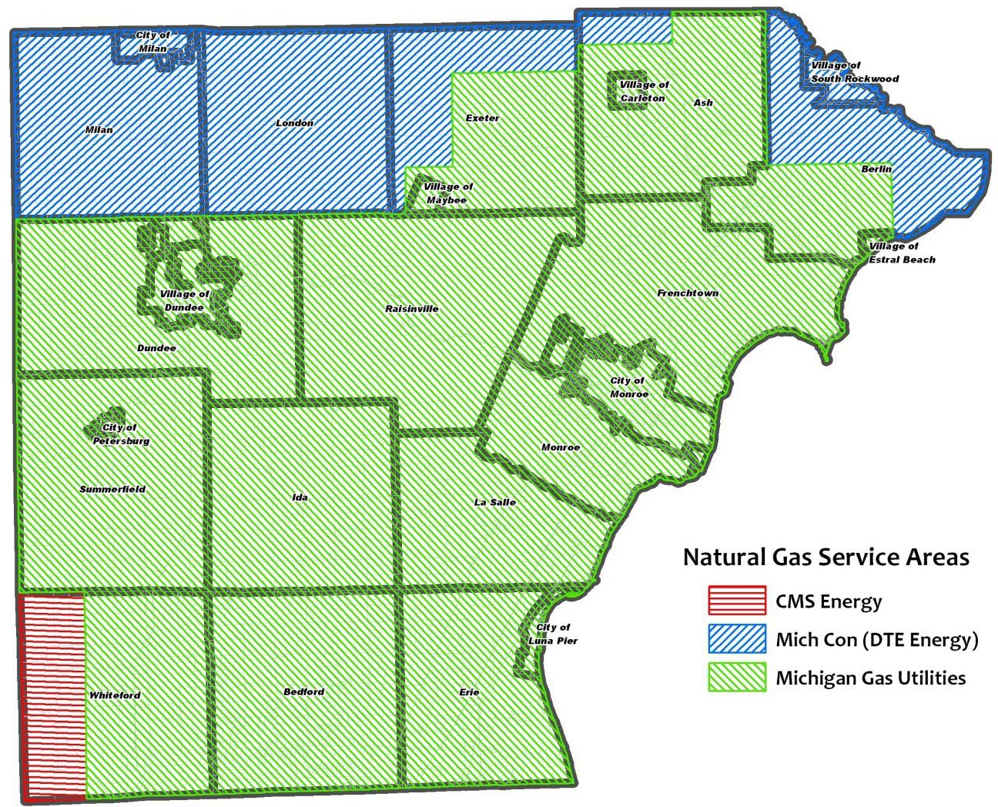

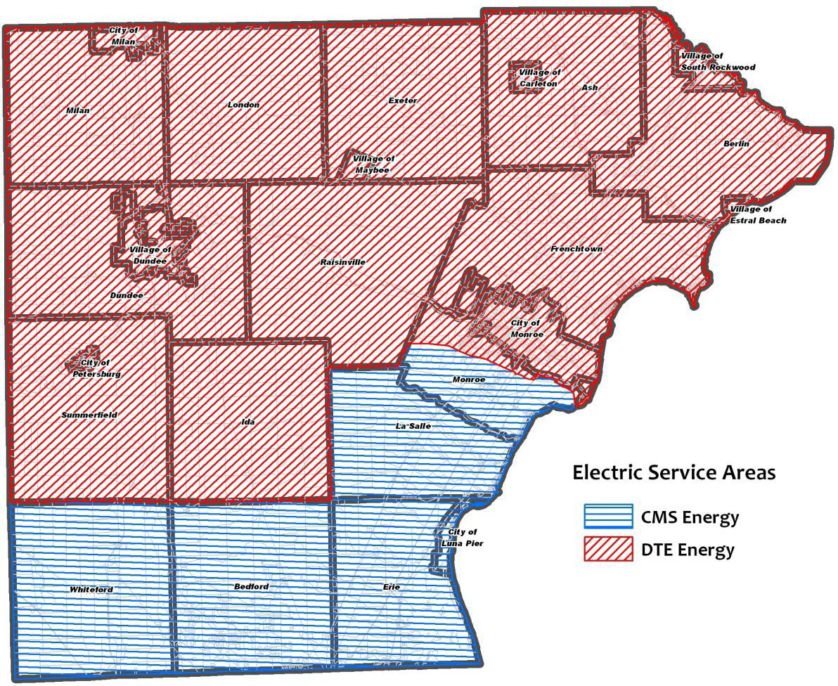

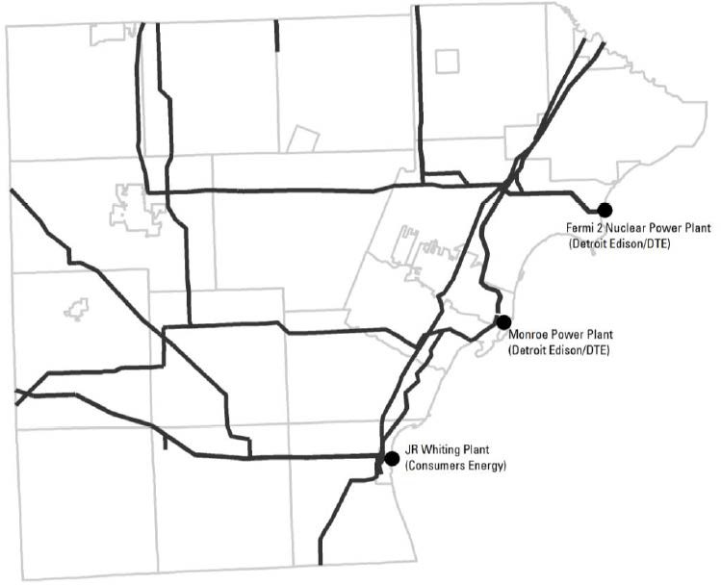
Power Plants and Major
Transmission Lines

9. Transportation Systems
Of the many advantages of doing business in Monroe County, one of the greatest is the available transportation network. An extensive rail system, a Great Lakes Port, a local general utility airport with easy access to a major international airport, and a road transportation system with federal, state, and local roads gives Monroe County exceptional access to goods, materials, markets, and labor force.

Rail Transportation
The map below illustrates the extensive rail freight network available to business and industry in Monroe County:
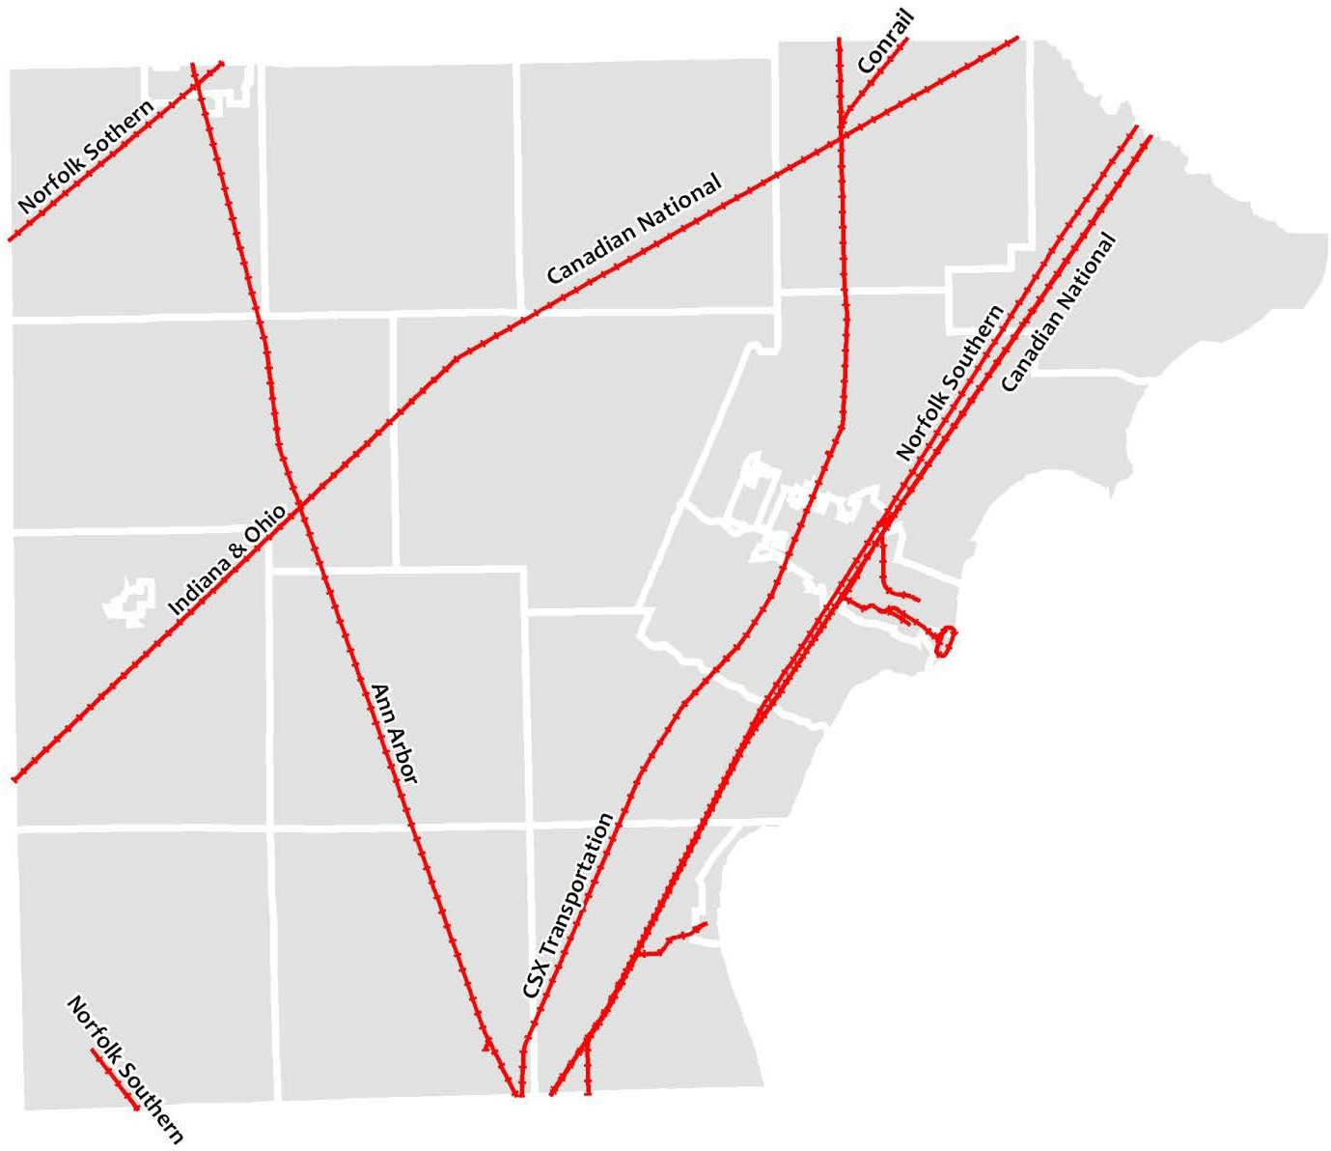

Monroe County Rail Contacts
Ann Arbor Railroad (Watco) | Kenneth Morgan General Manager  4058 Chrysler Dr, Toledo, OH 43608  Phone: (208) 260-0351  Email: kenneth.morgan@watco.com
Canadian National (CN) Rail | LaShelle Pearson Manager, Business Development – Michigan, Lower Peninsula  17641 S. Ashland Ave Homewood, IL 60430  Phone: (715) 295-4436  Email: lashelle.pearson@cn.ca
CSX Transportation | Adam Hess Director of Industrial Development  501 S CR 800 E Avon, IN 46123  Office: (317) 267-4981 Cell: (720) 270-4470 Email: adam_hess@csx.com
Norfolk Southern (NS) Corp. | Dayne Tate Senior Industrial Development Manager 9229 Delegates Row, Ste. 130 Indianapolis, IN 46240  Phone: (317) 819-7672  Email: dayne.tate@nscorp.com
Conrail (Consolidated Rail Corp.) | Jeffrey Russello Service Delivery Specialist  330 Fellowship Rd., Ste. 300 Mt. Laurel, NJ 08054  Phone: (856) 231-2280 Email: jeffrey.russello@conrail.com
Indiana & Ohio Railway | Sarah Pawlanta Director Sales & Marketing  2856 Cypress Way Cincinnati, Ohio 45212  Phone: 513-860-1000  charles.mcbride@gwrr.com  (connects with Ann Arbor Railroad & CN Rail at Diann)

State and Federal Highway System
Monroe County is connected to the Interstate Highway System through I-75, as well as the I-275 corridor serving the greater Detroit metropolitan area. In addition, U.S. and State highways connect Monroe County to all major regional metropolitan areas. Detroit, Ann Arbor, and Toledo are each less than one hour from anywhere in Monroe County, as are the two international border crossings into Canada.
Monroe County’s local road system provides an extensive and valuable network, including designated all-season routes that are exempt from seasonal load and speed restrictions. The most current MCRC All-Season Truck Route map can be found on the Road Commission’s website.
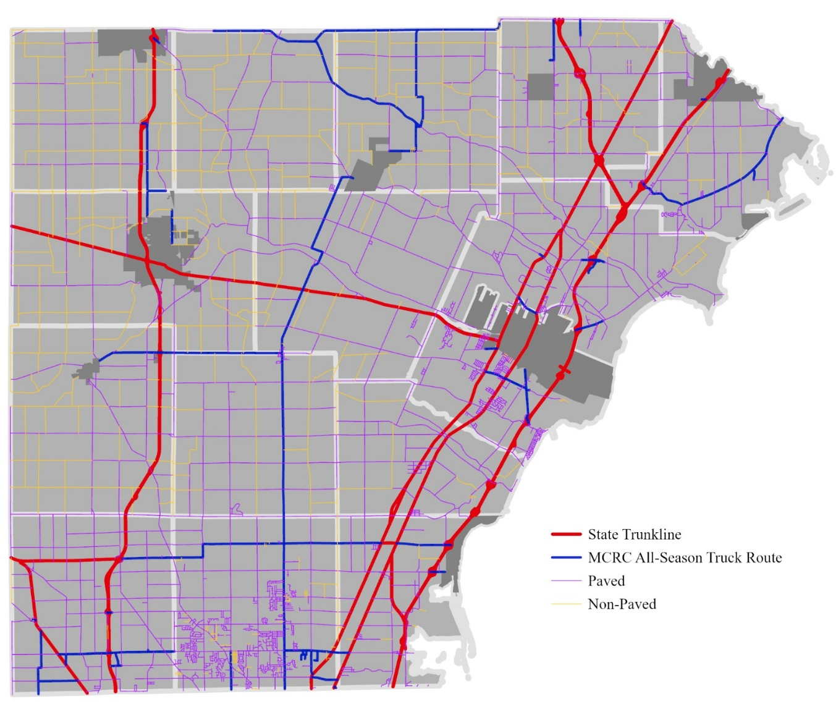

Class A, Paved and Unpaved Roadways
Monroe County’s local road system provides a valuable network of township, city and county roads. Specific roads are designated as “Class A” roads, which have been built to specific standards, making them exempt from seasonal load and speed limitations.
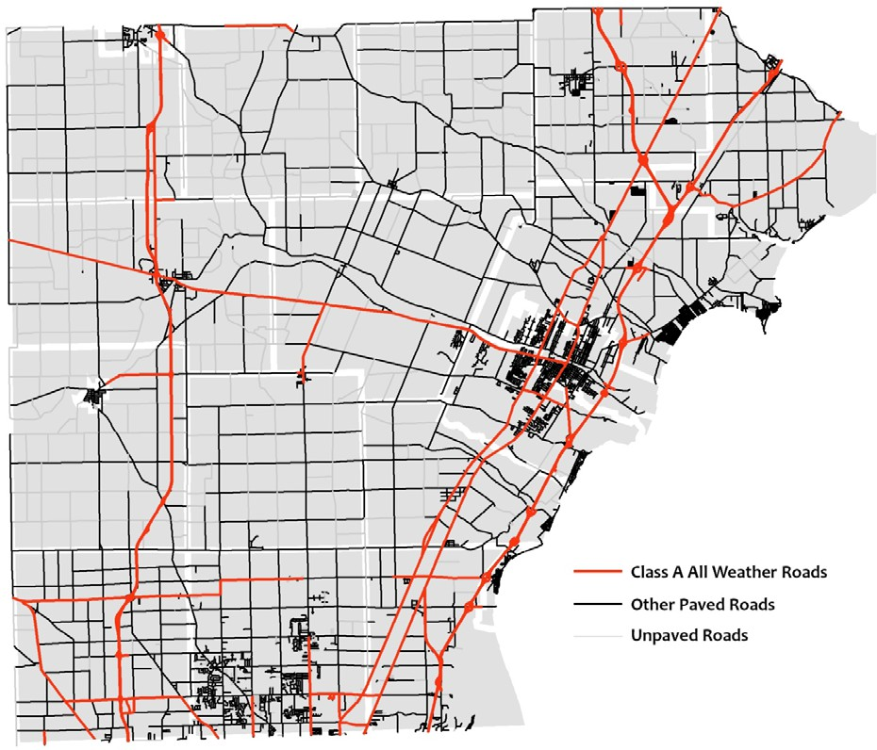

Truck Route

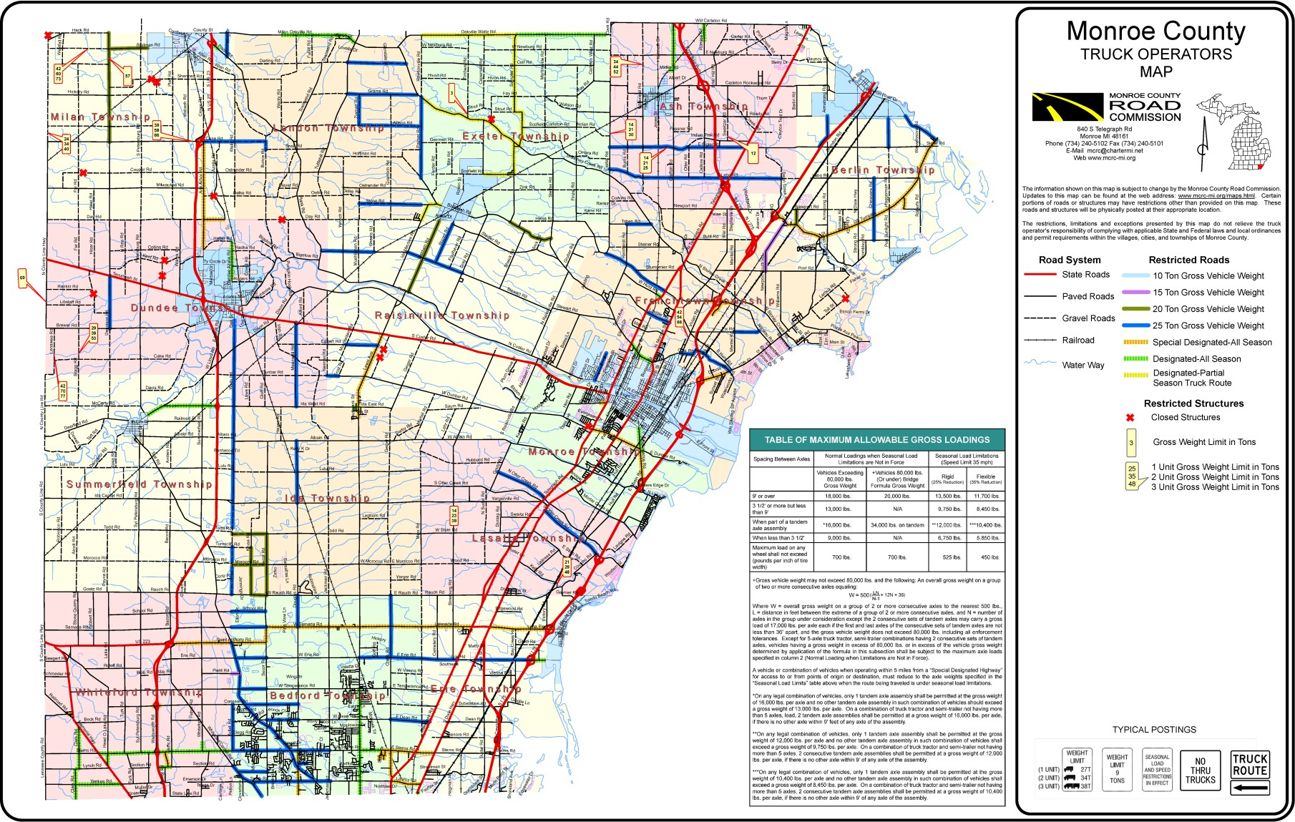

A higher resolution version of this map is available at: http://www.mcrc-mi.org/images/MAPS_Truck_Operator_Map_1.pdf

Regional Transportation Network
Monroe County is well served by an extensive road system and strong connections to the surrounding region. Combined with access to nearby airports and Great Lakes ports, this connectivity creates minimal shipping constraints and supports a wide range of business and industrial operations
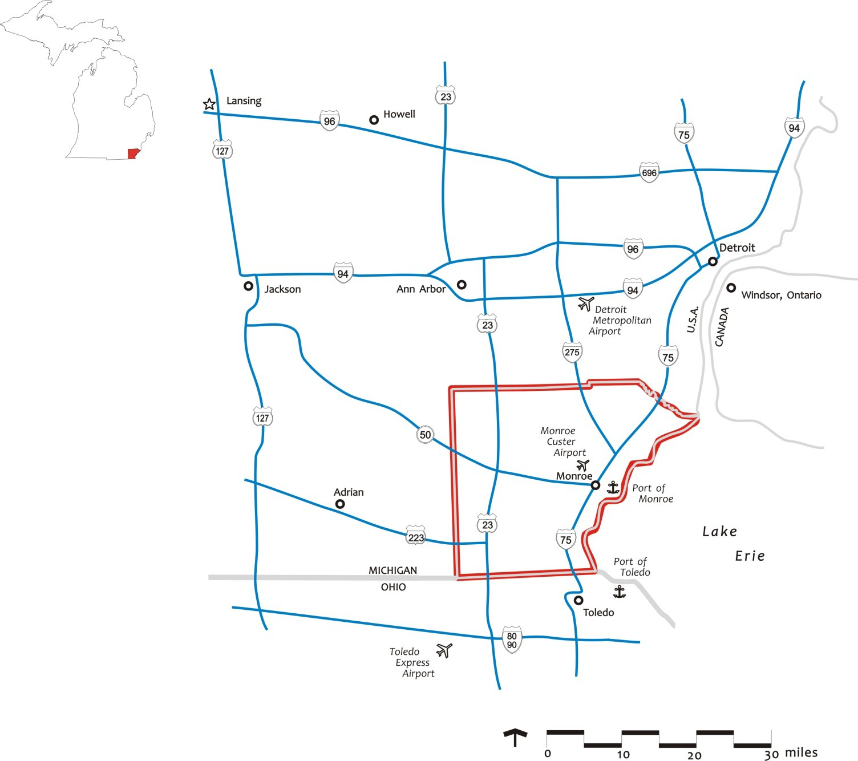

10. Workforce / Talent Development

Monroe County Community College
Monroe County Community College is a public, two-year comprehensive community college supported by tax monies from Monroe County, educational funds from the state of Michigan and student tuition. The Monroe County Community College District was formed on June 29, 1964, by the electors of Monroe County. On July 3, 1964, the district was given statutory authority under the provisions of Michigan Act 188 of the Public Acts of 1955 to function as a community college. MCCC offers occupational certificate and degree programs, as well as transfer programs to baccalaureate institutions. With a credit enrollment of approximately 2,700 students and another 1,000 enrollments annually in Lifelong Learning and contract training, this North Central Accredited, comprehensive community college is a strong asset serving the educational needs of both local residents and businesses. Two MCCC locations serve the residents of Monroe County. The 210-acre main campus is located in Monroe Township at 1555 S. Raisinville Rd. just outside the city of Monroe and is centrally located in Monroe County with easy access to Detroit and Toledo. MCCC’s second facility, the Whitman Center, is located in Bedford Township at 7777 Lewis Ave., about 15 miles south of the Main Campus and approximately 5 miles north of the Michigan-Ohio border and the adjacent City of Toledo. Additional information may be obtained by visiting the MCCC website at www.monroeccc.edu, or by contacting the main campus at (734) 242-7300.

Training and Development
Monroe County Community College
The Corporate and Community Services Division (CCS) is responsible for the contract, design and delivery of all non-credit courses/programs to address the needs of area employers. Courses for academic credit are also coordinated and delivered to area employers under contract through the CCS Division. Customized training is delivered to companies at their facility, as well as, at the main campus and the Whitman Center. Training schedules are flexible and can accommodate all shift hours.
A wide variety of business and industry training topics are offered throughout the year through the office of workforce development. The current training calendar is available on the website at https://www.monroeccc.edu/business-industry-training-schedule. Advance notice of upcoming training sessions are also regularly distributed via email to a list of previous attendees and area companies. To learn more about business and industry training at Monroe County Community College contact Barry Kinsey, director of workforce development, at bkinsey@monroeccc.edu or by calling him at (734) 384-4124.
MCCC is also a member of the MIOSHA Training Institute and regularly offers informative health and safety seminars based upon up-to-date industry standards to improve the workplace. To review a current catalog of the health and safety training available at MCCC visit www.monroeccc.edu/ccs/4639-SafetyCatalog.pdf.
MCCC’s Lifelong Learning Class Schedule (non-credit courses/programs), also promotes the community college as a source of training for job seekers and area employers. The current Lifelong Learning Class schedule is available at the college website - https://www.monroeccc.edu/LL, or by calling 734-384-4127.
MCCC is also aggressive in seeking state/federal funding sources for employee training/retraining programs and other efforts that support local economic development. Currently, the College can assist with training costs for employers that are adding new jobs located within Monroe County through the Michigan New Jobs Training Program (MNJTP). A brief overview and application form for MNJTP, as well as information on current training grant opportunities are available by visiting the college website at https://www.monroeccc.edu/training-grants.
For more information regarding customized employee training programs and grant opportunities contact Barry Kinsey, Director of Workforce Development at 734-384- 4124, or by email at bkinsey@monroeccc.edu.
Michigan Works! – Monroe County Employment & Training Department
Training: As a Southeast Michigan Community Alliance (SEMCA) service provider, the Michigan Works! Monroe County Employment & Training Department (MCETD) works collaboratively with community and regional partners to provide workforce services at no cost to Monroe County job seekers and employers.
The MCETD offers services such as career counseling, interest inventories, on-the-job training, and workshops. Services to employers include job posting and recruitment, free interview and job fair space and rapid response services.
Job seekers learn how to post searchable resumes on the Pure Michigan Talent Connect at https://www.mitalent.org/ Likewise, employers can post job openings and recruit potential employees online through the PMTC. Additional information and assistance is available by contacting Ms. Stacey McCoy, MCETD Director, at 734-240-7950, or by email at Stacey.mccoy@mcetd.us

Employment Agencies
Monroe County Community College
Employee Recruitment: The Corporate and Community Services Division can assist employers with the recruitment of qualified part-time and full-time job candidates through its Workforce Development Office. The College provides free job postings, and employers can review resumes of potential candidates by registering at www.collegecentral.com/monroeccc. Job candidate resumes may include current students, alumni and community residents. For additional information or assistance, please contact Mr. Barry Kinsey, Director of the Workforce Development Office at 734-384-4124, or by email at bkinsey@monroeccc.edu.
Monroe County Employment & Training Department
Employee Recruitment: The MCETD operates the One Stop Service Center, a central hub for service delivery and referral, which includes the Pure Michigan Talent Connect, a job search and posting site accessible by job seekers and employers. The Pure Michigan Talent Connect website can be accessed at www.mitalent.org. For further information on assistance and services available to employers from the MCETD, contact Ms. Stacey McCoy, Director at 734-240-7950, or via email at Stacey.mcccoy@mcetd.us

Schools and Colleges
Monroe County Community College
See general college description in earlier Section 2. Getting Started. Students at MCCC fulfilling the general education and specific degree requirements may earn an Associate of Arts Degree (AA), an Associate of Science Degree (AS), an Associate of Applied Science Degree (AAS), or an Associate of Fine Arts Degree (AFA). MCCC also offers nearly 30 career/occupational certificate programs. For general degree and certificate program information, visit the college website at www.monroeccc.edu. Click on the Academics tab and select Areas of Study. Specific information regarding degree programs or college entrance requirements may be directed to Omaira Ortiz, director of enrollment management, at (734) 384-4226, or by email at oortiz@monroeccc.edu.
Community Services: MCCC also makes classrooms, computer labs, conference rooms and the La-Z-Boy Center, Meyer Theater available to area employers for meetings, conferences and special events. MCCC’s rental information brochure may be reviewed on the college website at www.monroeccc.edu/facilities-rental. Food service, audio visual and other facility rental arrangements may be made by contacting Sarah Rorke at (734) 384-4242 or srorke@monreccc.edu.

Monroe County Educational Technology Millage
In 1997, the local Boards of Education of the nine public school districts in Monroe County requested that the Monroe County Intermediate School District's Board of Education hold an election to establish a countywide millage for educational technology initiatives to support curriculum goals in the schools, across all grades K-12. Monroe County voters approved the millage, which is distributed to each local public school district based on a per-pupil allocation formula. Voters overwhelmingly renewed the millage in 2001, 2006, 2011, 2016 and 2021. To date, Monroe County is the only county in the state that has passed an enhancement millage dedicated to educational technology. Additional information regarding the technology millage is available through Dr. Stephen McNew, Superintendent at 734-242- 5799 ext. 1000, or through the ISD website at www.monroeisd.us.

University Research Corridor
In addition to our great community college and the wonderful 4-year institutions that are located within our boarders it should also be noted that Monroe County is strategically situated within the University Research Corridor (URC). What is the URC you ask? It is best explained by looking at their vision statement. The University Research Corridor is an alliance of Michigan’s three leading research institutions: Michigan State University, the University of Michigan and Wayne State University. Each features complete graduate and undergraduate education, as well as professional degrees in medicine, business and the law. Its research laboratories produce hundreds of patents each year and its hospitals develop innovative medical treatments that save lives. In addition to the URC universities, we have the University of Toledo in close proximity to Monroe County. The University of Toledo has degrees in engineering, law and medicine.

11. Quality of Life
Quality of life is central to what makes Monroe County a place people choose. Families, employers, and entrepreneurs are drawn to a community defined by strong schools, accessible faith and civic spaces, and a culture rooted in connection and belonging.
Located along the western shoreline of Lake Erie, Monroe County offers abundant access to outdoor recreation and natural assets. Sterling State Park—the only Michigan state park on Lake Erie—provides shoreline access, camping, fishing, and miles of trails for walking and biking. The Detroit River International Wildlife Refuge and River Raisin water trails support conservation, birding, boating, and environmental education, making outdoor recreation a defining feature of daily life in the county.
Arts, culture, and community life remain vibrant throughout Monroe County. Institutions such as the River Raisin Centre for the Arts offer year-round performances and educational programming, while local parks and recreation systems host seasonal events, farmers markets, concerts, and community gatherings that bring residents together and strengthen civic pride.
Monroe County is also home to the River Raisin National Battlefield Park, a nationally significant site commemorating the Battles of the River Raisin during the War of 1812. Operated by the National Park Service, the park preserves a pivotal chapter of American history while serving as an important driver of heritage tourism. Visitors from across the region and beyond are drawn to Monroe County to experience the battlefield, contributing to downtown activity, local businesses, and the county’s broader visitor economy. As Michigan’s only National Battlefield Park, it represents a distinctive cultural and economic asset for the region.
Education and community enrichment further contribute to the quality of life. Monroe County Community College provides post-secondary and workforce-focused educational opportunities, while schools, libraries, and community organizations offer lifelong learning, recreation, and enrichment programs for residents of all ages.
With more than 100 designated historic sites, access to water and green space, a growing dining and retail scene, and a strong network of cultural and educational institutions, Monroe County offers a quality of life that blends small-town character with regional accessibility. Together, these assets create a community rooted in history, connected through shared experiences, and positioned for continued vitality.

