WELCOME TO MADDEN’S
MASE 2026 BEST PRACTICES CONFERENCE

- Madden Inn & Golf Club
- Front Desk
- Vending, ATM, Shopping, Business Center,
Fitness Center, Outdoor & Indoor Pool
- 19th Hole, Fairways, & Lobby Café

- O’Madden Pub (bar open: 8pm-1am)
- Karaoke: Wednesday & Thursday (8p-11p)

- Madden Bros Market
- Open Thursday & Friday: 7am-2pm
- Coffee, Sandwiches, Snacks, ATM, Souvenirs

- Wilson Bay Lodge
- Breakfast: Wednesday – Friday

4. Town Hall Conference Center
- Registration: Wednesday - Friday
- Reception & Dinner: Wednesday & Thursday
- General Session: Thursday & Friday
- Exhibit: Thursday (downstairs)
- Breakouts: Thursday & Friday (Sibley and Pillsbury)
- Lunch: Thursday
- Bingo: Thursday

5. Golf Villa Meeting Rooms
- New Directors Program: Wednesday (Room: A)
- Breakouts: Thursday & Friday (AB, C, & D)

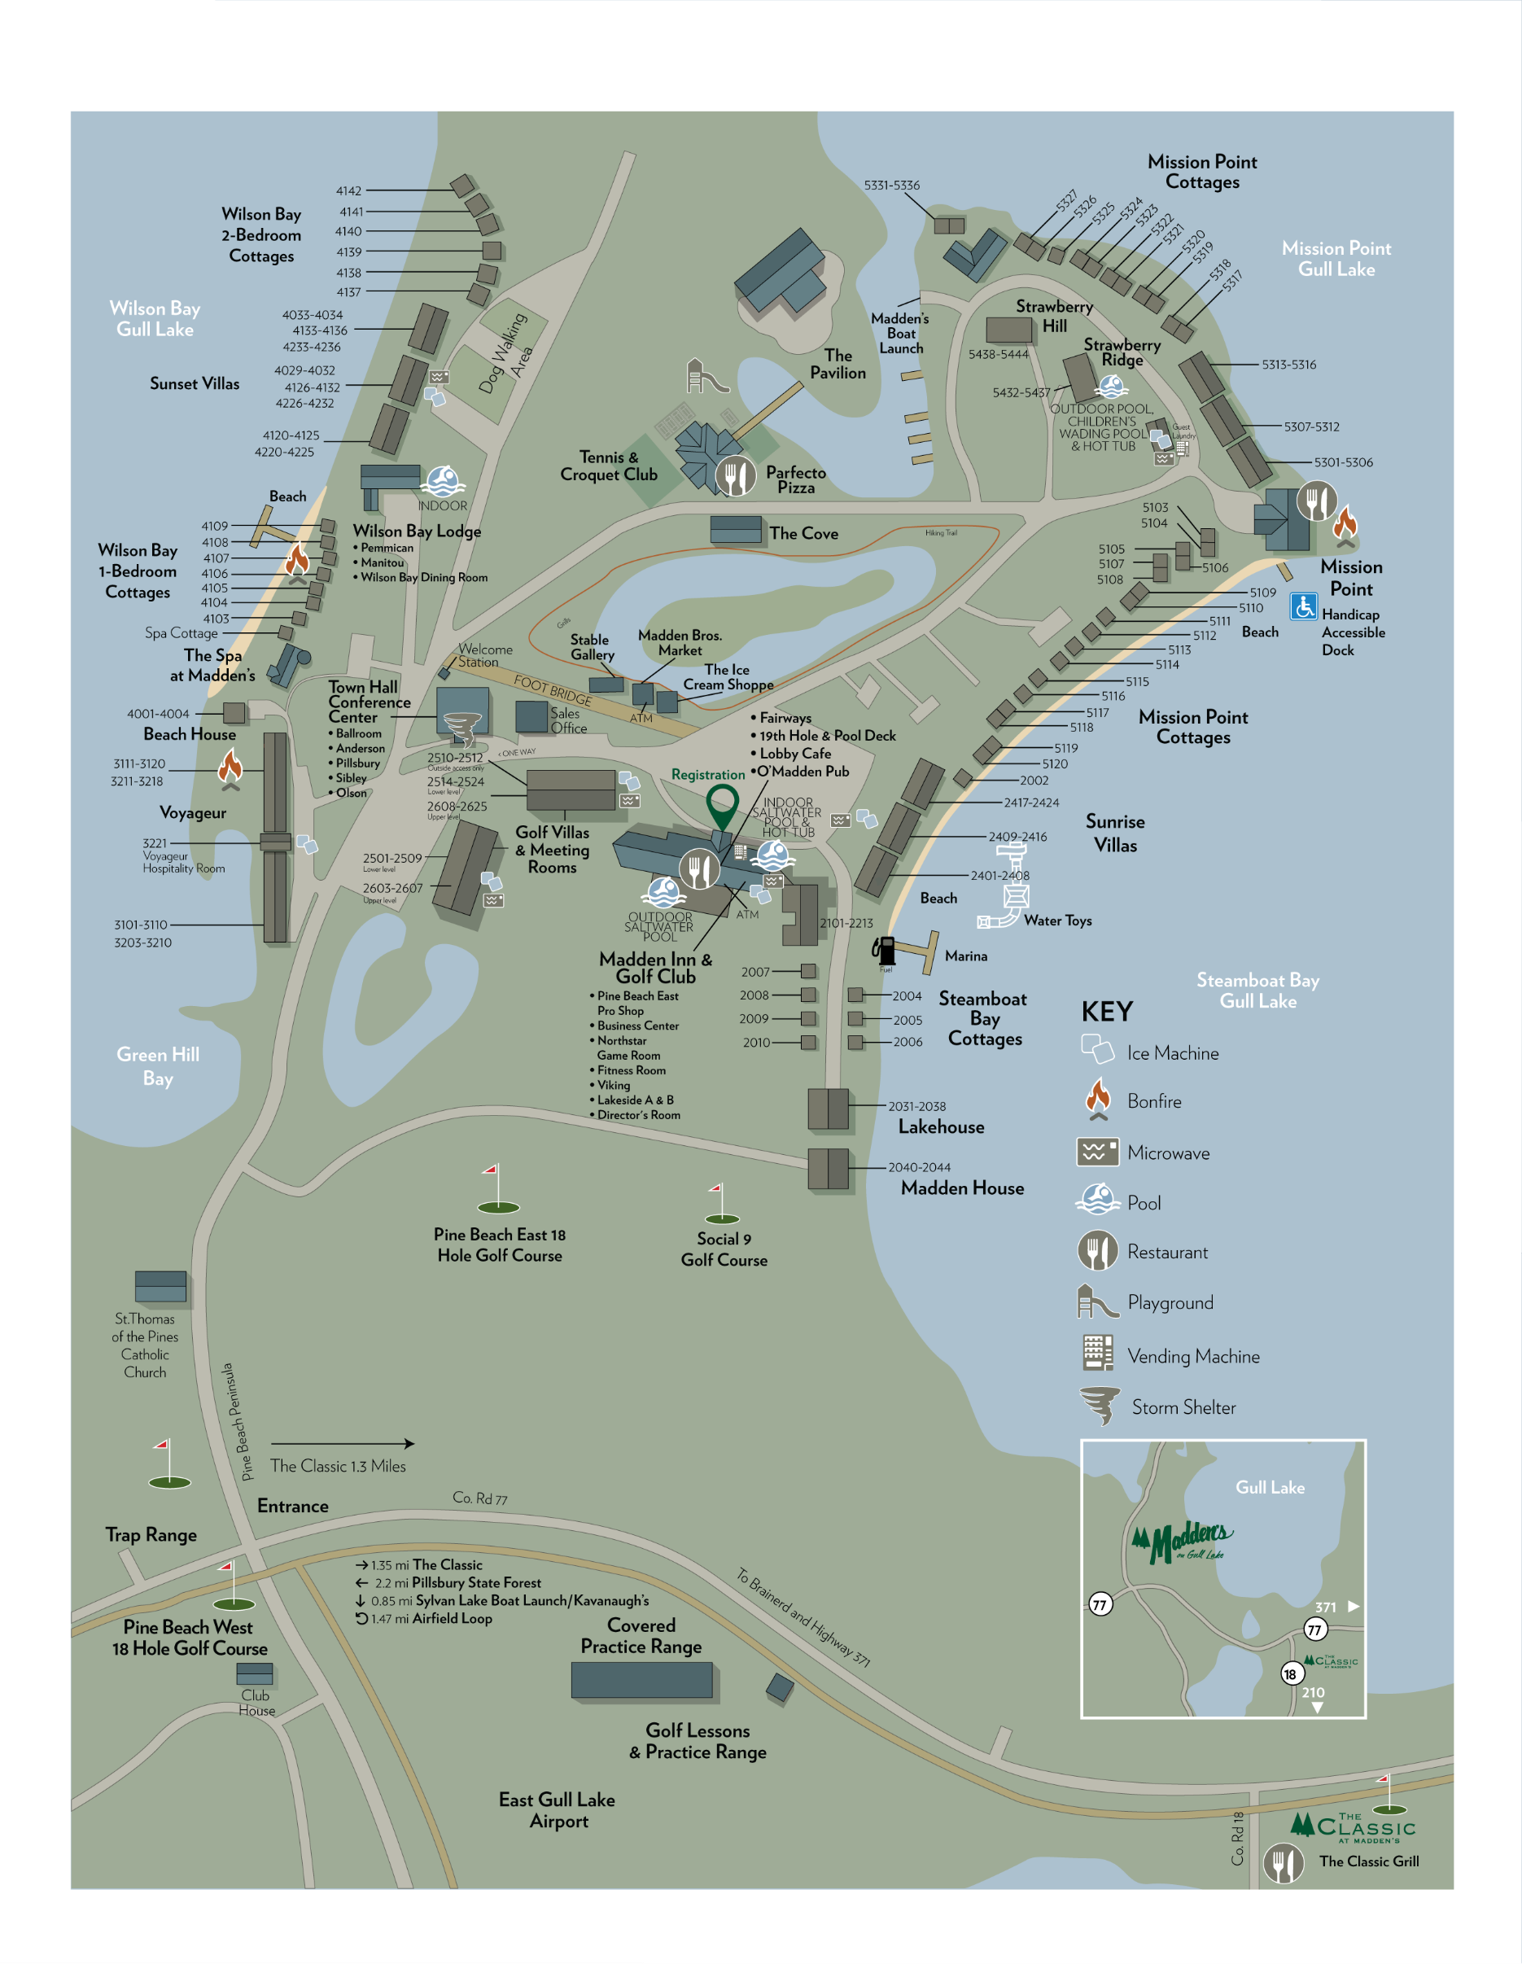
3

=
2
5
1

4

