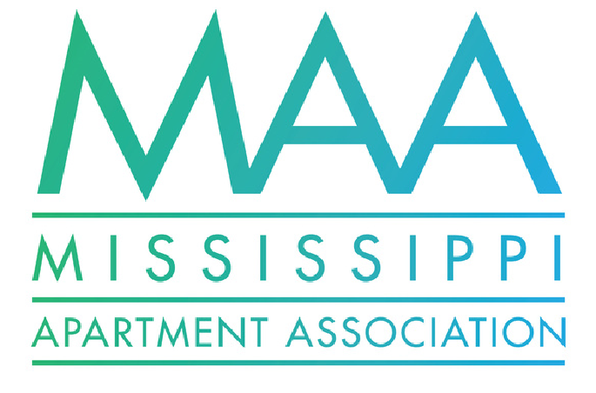 MONTHLY EMAIL NEWSLETTER



JULY 2023

August, 17, 2023

Pine Belt

Collections &

Budgeting Best

Practices Lunch

& Learn

August 23, 2023

2023

Leadership

Lyceum

September 19-

21

st

October 10-11th

Certified

Apartment

Manager and

Supplier Classes

MAA HIGHLIGHTS

ANNUAL SUMMER SOCIAL

THANK YOU TO DYNANIC NATIONAL

FOR PROVIDING US WITH A

GREAT MEAL AND TO

LAKESHOREPOINTE FOR HOSTING US!

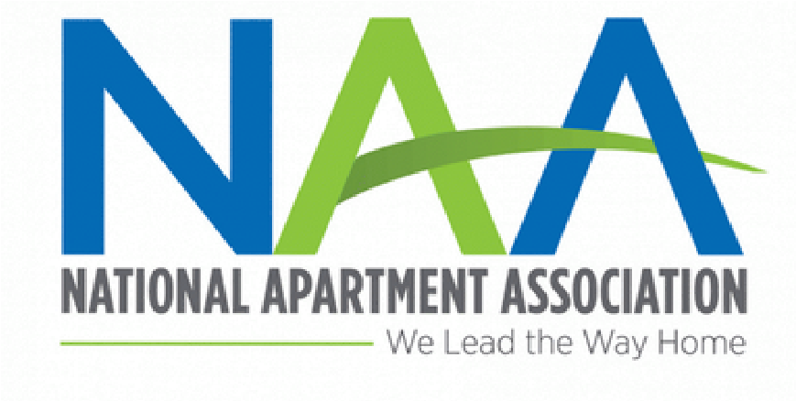

Jul

y

Partner S

potli

g

ht

601-992-9933

meghan@msaptassoc.org

cadie@msaptassoc.org

Text MAA to 601-724-7157

www.msaptassoc.org

**Contact Us**

As a united voice of the rental housing industry we educate and advocate for members

and community interests.

**Member Directory**

2023

Apartment Housing Outlook

[l](https://www.naahq.org/industry-insider)

NAA Releases Annual Menta

Health Surve

[y](https://www.naahq.org/industry-insider)

Result

[s](https://www.naahq.org/industry-insider)

HUD’s New Ins

pection Standards in Effec

[t](https://www.naahq.org/industry-insider)

[g](https://www.naahq.org/industry-insider)

as Summer Be

[g](https://www.naahq.org/industry-insider)

in

[s](https://www.naahq.org/industry-insider)

Rent Growth Coolin

**NAA Free Webinar this month:**

[**l**](https://www.naahq.org/webinars)

**perature Contro**

**Thermostat & Tem**

**Solutions for Rental Housin**

[**g**](https://www.naahq.org/webinars)

**Facilitie**

[**s**](https://www.naahq.org/webinars)

***NAA Industr***

***y***

***Insider:***