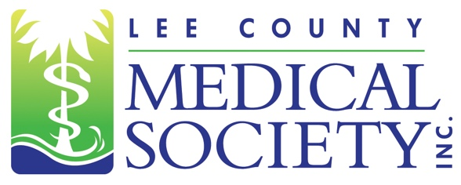
NEWS FOR IMMEDIATE RELEASE
Contact: Julie Ramirez, Executive Director
jramirez@lcmsfl.org
(239) 936-1645

Lee County Medical Society Installs 2025 Board of Directors

Fort Myers, FL (February 6, 2025) – The Lee County Medical Society (LCMS) is pleased to announce it officially installed its 2025 Board of Directors surrounded by LCMS members and guests on January 30, 2025. Newly inducted Board President Gamini Soori, MD, an oncologist at Florida Cancer Specialists and Research Institute, announced his presidential priorities for the upcoming year which include increasing physician membership; expanding community outreach; and advocating for the mental health and well-being of all healthcare providers in the county.

“The Society is poised to play an integral role in helping the public learn about the physician community,” said Dr. Soori. “With more residents moving to Lee County each year, I want to make sure community awareness and outreach is a priority this year because access to primary care physicians, specialists and new state-of-the-art technologies can have a significant impact on health outcomes for residents in Lee County.”

The 2025 LCMS Board of Directors Executive Committee is: President Gamini Soori, MD; President-elect Asif Azam, MD; Treasurer Arie Dosoretz, MD; Secretary Magali Van Den Bergh, MD; and Past President Scott Caesar, MD.

LCMS would also like to recognize its 2025 Directors and Members at Large: Fadi Abu Shahin, MD; Lucia Huffman, MD; Diana Khalil, MD; Andres Laufer, MD; Kristina Mirabeau-Beale, MD; Jordan Taillon, MD; and Ex Officio members: Amber Jandik, MD and Vivek Singh, MD. Also assisting the Board is Executive Director Julie Ramirez, CAE.

Lee County Medical Society is a professional organization of over 800 physician members practicing in Lee County, Florida. Its mission is to advocate for physicians and their relationships with patients; promote public health and uphold the professionalism of the practice of medicine. Since 1927, the Society has been a trusted source of health policy leadership in Lee County. The Society also provides programs to educate physicians of all specialty areas while encouraging professional integrity and unity. In 2020, the Society transitioned to a permanent virtual office. For more information, go to www.lcmsfl.org.

