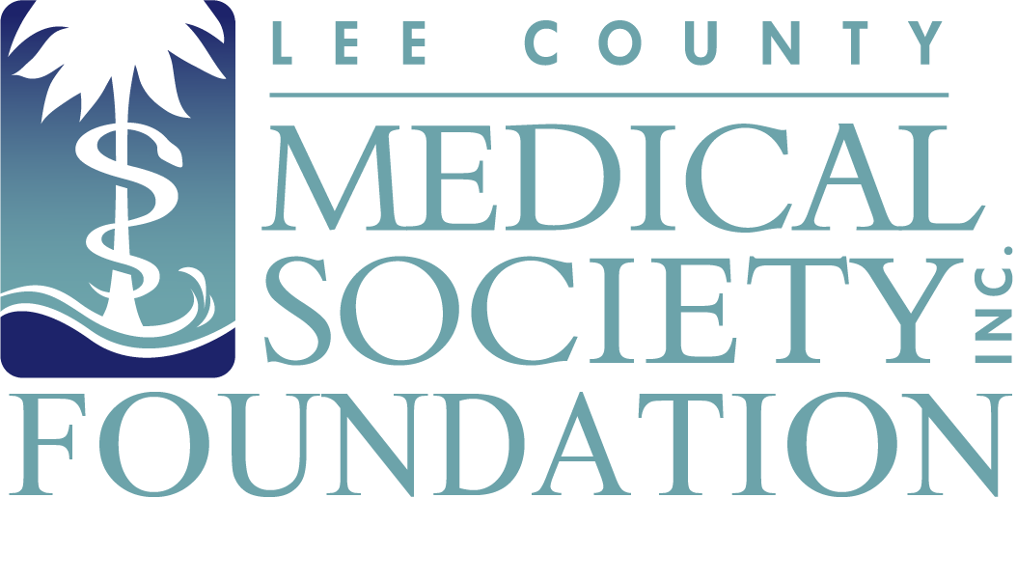
NEWS FOR IMMEDIATE RELEASE
Contact: Julie Ramirez, Executive Director
jramirez@lcmsfl.org
(239) 936-1645

Lee County Medical Society Foundation
to Honor Community Health Leaders on October 10, 2024

Fort Myers, FL (September 18, 2024) – The Lee County Medical Society (LCMS) Foundation will hold its 12th Annual Medical Service Awards to recognize local physicians and medical professionals for their outstanding contributions to healthcare in Lee County on October 10, 2024, at Forest Country Club. Members of the medical community and the public are invited to give praise to the eight award recipients. The event includes dinner, a tribute video, and awards ceremony. Proceeds will benefit the LCMS Physician Wellness Program, a free and confidential mental health counseling program to combat burnout and improve the lives of LCMS physician members.

12th Annual Medical Service Awardees:

- Dr. Peggy Mouracade will be awarded the Citizenship & Community Service Award for providing public service leadership above and beyond the call of duty as a practicing physician.
- Dr. Natalia Spinelli will be awarded the Health Education Award in recognition of her professional and public health education activities.
- Dr. Rebekah Bernard will be awarded the Leadership & Professionalism Award for reflecting the ideal professional characteristics of a practicing physician and being a leader in medicine within the community.
- Dr. Justin Casey will be awarded the Rising Star Award for exemplifying leadership, being a role model for others who have under 10 years of professional medical experience and bringing new technologies and talents to the area.
- Dr. Jim Rubenstein will be awarded the Lifetime Achievement Award for his substantial contributions to our medical community and for being a lifelong role model in the field of medicine.
- Aileen Fiallo, PA, will be awarded the Non-Physician Award of Appreciation for her exemplary and lasting impact to medicine above and beyond the call of duty.
- Ralph Laughton, JD, CSA, CDP, will be honored with the Distinguished Layperson’s Service Award for his keen leadership, initiative and hard work that contributed to improved access to medical and human services following Hurricane Ian.
- Dr. Keith Miller will be presented with the WeCare Award, which honors volunteer providers who support and deliver remarkable service and commitment to WeCare clients in Lee County.

“It is my pleasant duty as president of Lee County Medical Society to formally announce and congratulate all eight recipients of the 12th Annual Medical Service Awards,” said LCMS President Scott Caesar, MD. “Each awardee, through their vigorous and active devotion to the highest standards in health care, have set a high bar for us to emulate. We are honored these fine citizens call Lee County home and deserve our recognition for providing exceptional care, leadership and compassion to everyone they serve in our community.”

LCMS Foundation would like to thank its Premier event sponsor Florida Cancer Specialists and Research Institute. The Annual Medical Service Awards is a public service event of the Lee County Medical Society Foundation, the charitable arm of the Lee County Medical Society, which is a professional organization of over 800 physician members practicing in Lee County, Florida. The Foundation supports the charitable efforts of physician members with an aim to improve the quality of life of its members and the public. Proceeds from Foundation events fund the Physician Wellness Program, which provides free psychological counseling to physicians so they can address normal life difficulties and avoid burnout. This event is open to the public. Tickets are $100/per guest and can be purchased at www.lcmsfl.org/annual-medical-service-awards.org.

